Учебно-практическое пособие на английском языке по теме «Страноведение»

ФИО разработчика: Ефимова Алена Сергеевна.
Должность: преподаватель английского языка.
Наименование образовательного учреждения: Государственное областное автономное профессиональное образовательное учреждение «Липецкий металлургический колледж».

Аннотация

Данное учебно-практическое пособие по дисциплине ОУД.03 «Английский язык» предназначено для студентов 1 курса, обучающихся по программе среднего профессионального образования по профессиям технического профиля.
Данное учебно-практическое пособие представляет собой сборник текстов на английском языке с тренировочными упражнениями на тему «Страноведение» и включает в себя 6 тематических блоков: страны и континенты; Россия, США, Великобритания, Канада, Австралия.
Главная цель учебно-практического пособия заключается в совершенствовании навыков, знаний и умений студентов и мотивации студентов к углубленному изучению иностранных языков.
В задачи данного пособия входит формирование практического интереса к изучению иностранных языков и расширение возможностей применения знаний учащихся по иностранному языку.
Учебно-практическое пособие «Сборник профессионально-ориентированных текстов с упражнениями» для специальностей:
13.02.11 Техническая эксплуатация и обслуживание электрического и электромеханического оборудования (по отраслям)
13.02.07 Электроснабжение (по отраслям)
22.02.01 Металлургия черных металлов
18.02.12 Технология аналитического контроля химических соединений
22.02.05 Обработка металлов давлением
15.02.12 Монтаж, техническое обслуживание и ремонт промышленного оборудования (по отраслям)
15.02.03 Техническая эксплуатация гидравлических машин, гидроприводов и гидроавтоматики
09.02.01 Компьютерные системы и комплексы
09.02.07 Информационные системы и программирование
38.02.01 Экономика и бухгалтерский учет (по отраслям)
38.02.03 Операционная деятельность в логистике

РАССМОТРЕНА
Председателем ЦК
языковедческих дисциплин
от «____» ______________ 2022 г.
_______________ В.В. Лаврина
УТВЕРЖДАЮ
И.о. зам. директора
по учебной работе
_______________ Л.Н. Красникова
«____» ______________ 2022 г.

Организация-разработчик:
Государственное областное автономное профессиональное образовательное учреждение «Липецкий металлургический колледж»

Разработчик:
ГОАПОУ «Липецкий металлургический колледж», преподаватель английского языка Ефимова А.С.

2021-2022 учебный год
Пояснительная записка
Пособие предназначено для обучающихся 1 курса по программе среднего профессионального образования по специальностям:
13.02.11 Техническая эксплуатация и обслуживание электрического и электромеханического оборудования (по отраслям)
13.02.07 Электроснабжение (по отраслям)
22.02.01 Металлургия черных металлов
18.02.12 Технология аналитического контроля химических соединений
22.02.05 Обработка металлов давлением
15.02.12 Монтаж, техническое обслуживание и ремонт промышленного оборудования (по отраслям)
15.02.03 Техническая эксплуатация гидравлических машин, гидроприводов и гидроавтоматики
09.02.01 Компьютерные системы и комплексы
09.02.07 Информационные системы и программирование
38.02.01 Экономика и бухгалтерский учет (по отраслям)
38.02.03 Операционная деятельность в логистике
Целью данного пособия является формирование умения читать нa английском языке и переводить тематическую литературу; формирование лексических и грамматических навыков говорения по теме «Страноведение». Кроме того, пособие также может быть использовано для обучения навыкам и умениям говорения на темы данных специальностей, что соответствует установкам рабочей программы.
Задачи пособия включают:
- сформировать и развить лексические и грамматические навыки говорения;
- научить студентов работе со словарем;
- сформировать навыки работы со словарем;
- расширить кругозор сьудентов;
- замотивировать студентов на более углубленное изучение английского языка.
Настоящее издание пособия составлено в соответствии с его отраслевым назначением.
Работа с пособием, которую рекомендуется начинать в рамках первого курса профессионального модуля, предусматривает:
- накопление студентами активного словаря-минимума, включающего термины и общую лексику;
- формирование основ потенциального словаря;
- тренировку синтаксических структур, типичных для специальной литературы.
Тексты пособия отобраны из оригинальной и переводной литературы. По языковому уровню они делятся на две группы:
- к первой группе относятся элементарные тексты, построенные на простых по синтаксису предложениях;
- ко второй – оригинальные тексты с присущими специальной литературе синтаксическими и морфологическими особенностями.
Все тексты пособия объединяет единая смысловая направленность. они расположены в определенной логической последовательности по модулям: «Страны и континенты», «Россия», «Соединенные штаты Америки», «Соединенное королевство Великобритании и Северной Ирландии», «Канада», «Австралия».
Пособие состоит из тематических текстов с тренировочными упражнениями различной сложности. Каждый текст построен на активной лексике и серии тренировочных упражнений. Также, пособие включает небольшие тексты, содержащие пассивную лексику и служащие для обучения работе со словарем.
Каждая часть пособия предназначена для вводного курса, повторения и, впоследствии, закрепления пройденного материала и включает:
- обзорные упражнения на повторение грамматических явлений, характерных для специальной литературы;
- тексты для дополнительного чтения с заданиями, рассчитанными на активизацию мыслительной деятельности обучающихся.
CONTENTS:

Unit 1. Countries and continents | 6
Unit 2. Russia | 11
Unit 3. The United States of America | 14
Unit 4. The United Kingdom of Great Britain and Northern Ireland | 22
Unit 5. Canada | 26
Unit 6. Russia | 29

UNIT 1
CONTINENTS AND COUNTRIES

- How did continents get their names?

There are generally considered to be seven continents in the world: Africa, Europe, North America, South America, Asia, Antarctica, and Oceania. North America and South America are sometimes considered to be one continent known simply as The Americas. Similarly, Europe and Asia are sometimes grouped together to form Eurasia. There have been many discussions on the number of continents in the world, but few discussions about how the continents were named in the first place.

Africa
This name can be attributed to the Romans who referred to what is present-day Tunisia [tjuːˈnɪziə] as “Africa terra.” Africa terra can be translated to mean “land of the Afer” (singular). There are several theories about the origin of the word “Afer.” Specialists say that it originates from the Greek or Latin language. The name began expanding to include a larger area than Tunisia when several provinces such as Tripolitania (a former Libyan province) were added to the Diocesis [diocesis] of Africa. Further spreading of the name was facilitated by the Europeans during the middle ages in a time when they were seeking to increase their knowledge of Africa.

Europe

The origins of this name come from the Latin word “Europa,” which traces its origins to the Greek language. One school of thought argues that the name traces back to ancient Greek mythology. In Greek myth, Europa was the daughter of a Phoenician [fɪˈniʃn] king by the name of Agenor [˄ʤɪˈneər] or Phoenix [ˈfiːnɪks]. Europa fell in love with Zeus [zjuːs] and had three sons.
Another theory, as suggested by Ernest Klein, suggests that the name originates from the Sumerian root “Ereb.” Ereb translates to “darkness” or even “descent.” Ernest argues that Sumerians used that name to refer to the relative position Europe had to Mesopotamia, Anatolia, the Levantine Coast, and the Bosporus. Therefore, the word “Ereb” would be used to refer to Europe as a land where the sun sets or a more generic name of “Western Land.”
Greeks have used the word “Europe” to refer to Greece, that is, the area they inhabited. In modern times, what they called Europe translates to the area between Former Yugoslavia and Turkey. Over time, it came to refer to the whole of Europe as it is known today.

Oceania
The origin of this name is fairly simple. Oceania stems from the English word “ocean” which refers to a large water body. However, it ultimately comes from the Greek word “Okeanos” which means a great water body (sea or river) surrounding the earth.

Asia
This name comes from Ancient Greek. Initially, it was used to refer to the eastern bank of the Aegean [iːˈʤiːən] Sea but was later used to refer to the region of Anatolia. Before its extensive use, the Romans used it to refer to the Lydian area. The deeper meaning could have been from the Aegean word “Asis” meaning muddy or the Semitic “Asu” meaning light or rising.

America
North and South both share the name America. Some suggest that the name originates from Italian traveler Amerigo Vespucci. Cartographers chose to honor him since he was first to believe that the whole region was a continent. Eventually, North America adopted the name. Another person posited that the name originated from Amerike or ap Meryk, according to a manuscript he saw but there is little evidence to support the theory.

Vocabulary:
To expand – расширяться
Province – провинция/район
To facilitate – способствовать/упрощать
Middle age – средневековье
To seek – пытаться
Generic – зд.: обобщенный
Inhabitate – необитаемый
Fairly – достаточно
Ultimately – в конечном счете
Muddy – грязный/мутный

- Answer the following questions:
- Where did the word “Europa” come from?
- How many continents are there in the world?
- What’s the meaning of the world “Ereb”?
- What language does the word “Okeanos” come from?
- What does the word “Asis” mean?
- What did Amerigo Vespucci believed?

- Say in few words how each continent got its name (8-10 sentences).

- Continents and capitals

- Complete the sentences according to the map bellow:

- Read the following statements and decide which country it refers:

Asia | 1) the richest continent (has more money than others) | 8) the longest river - Nile is in… | 15) seals and penguins live in…
Europe | 2) Indian Navajo (Navaho) people lived in… | 9) monkeys, tigers and elephants live in… | 16) the great Barrier Reef is in …
Africa | 3) the smallest country in the world is in … | 10) Spanish language is the official in… | 17) koalas and kiwi-birds live in…
Oceania | 4) the highest mountain Everest is in… | 11) has 90% of world’s ice | 18) has many national parks and geysers
South America | 5) the largest city is Sao Paolo | 12) jaguars and anacondas live in… | 19) Greenland island is in…
North America | 6) elephants, cheetahs and giraffes live in… | 13) the biggest continent | 20) no people live in … only expeditions (1000 people)
Antarctica | 7) Gobi desert is in… | 14) the second longest river Amazon is in… | 21) has the coldest climate

- Match the country with the flag:
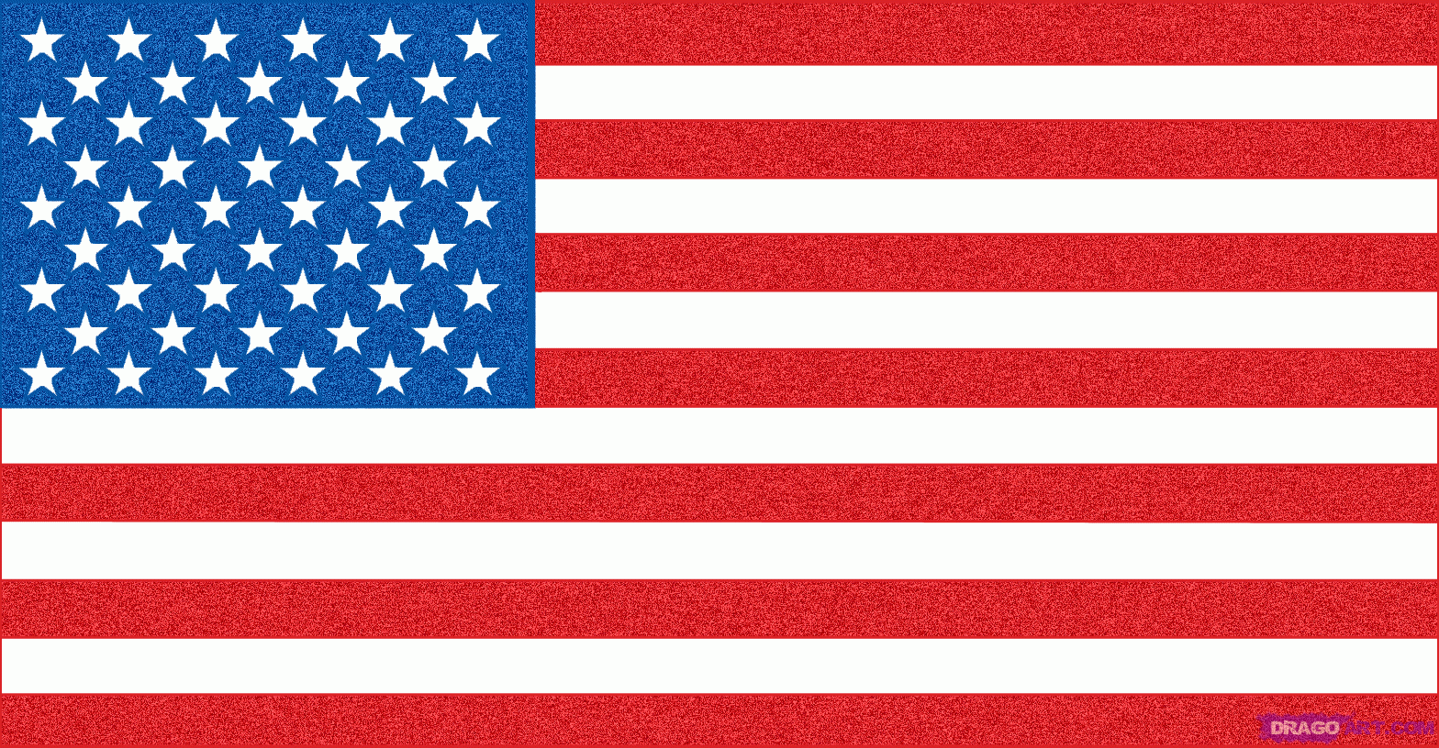 | 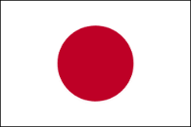 | 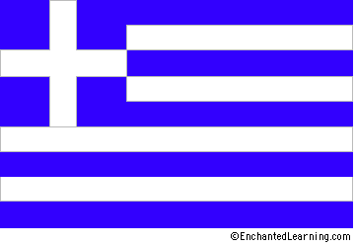 | 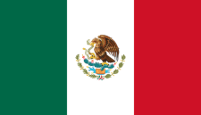 | 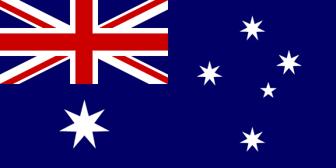
a) | b) | c) | d) | e)
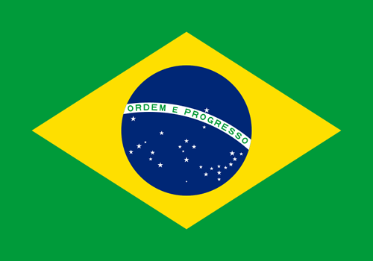 | 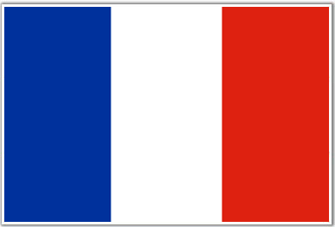 | 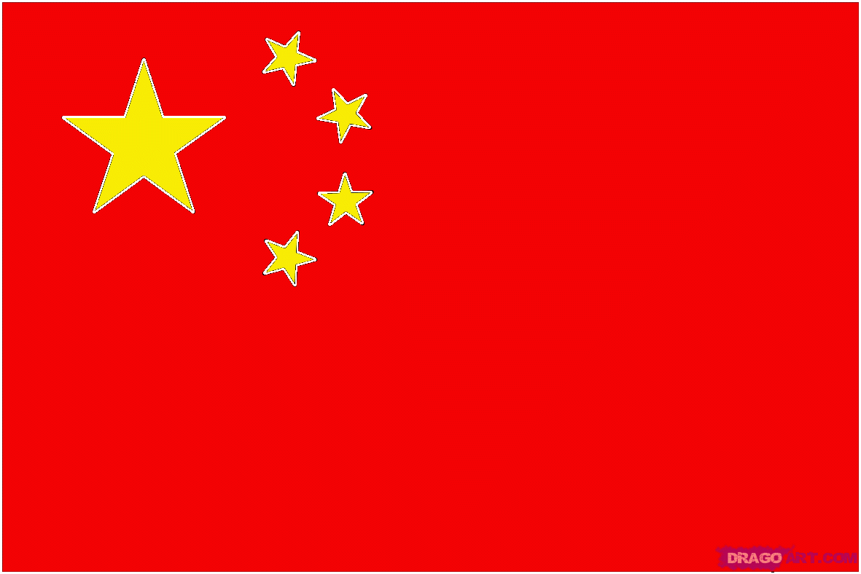 | 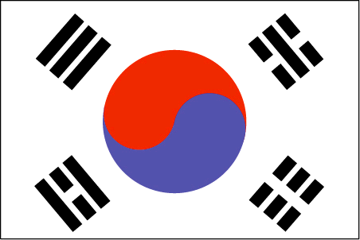 | 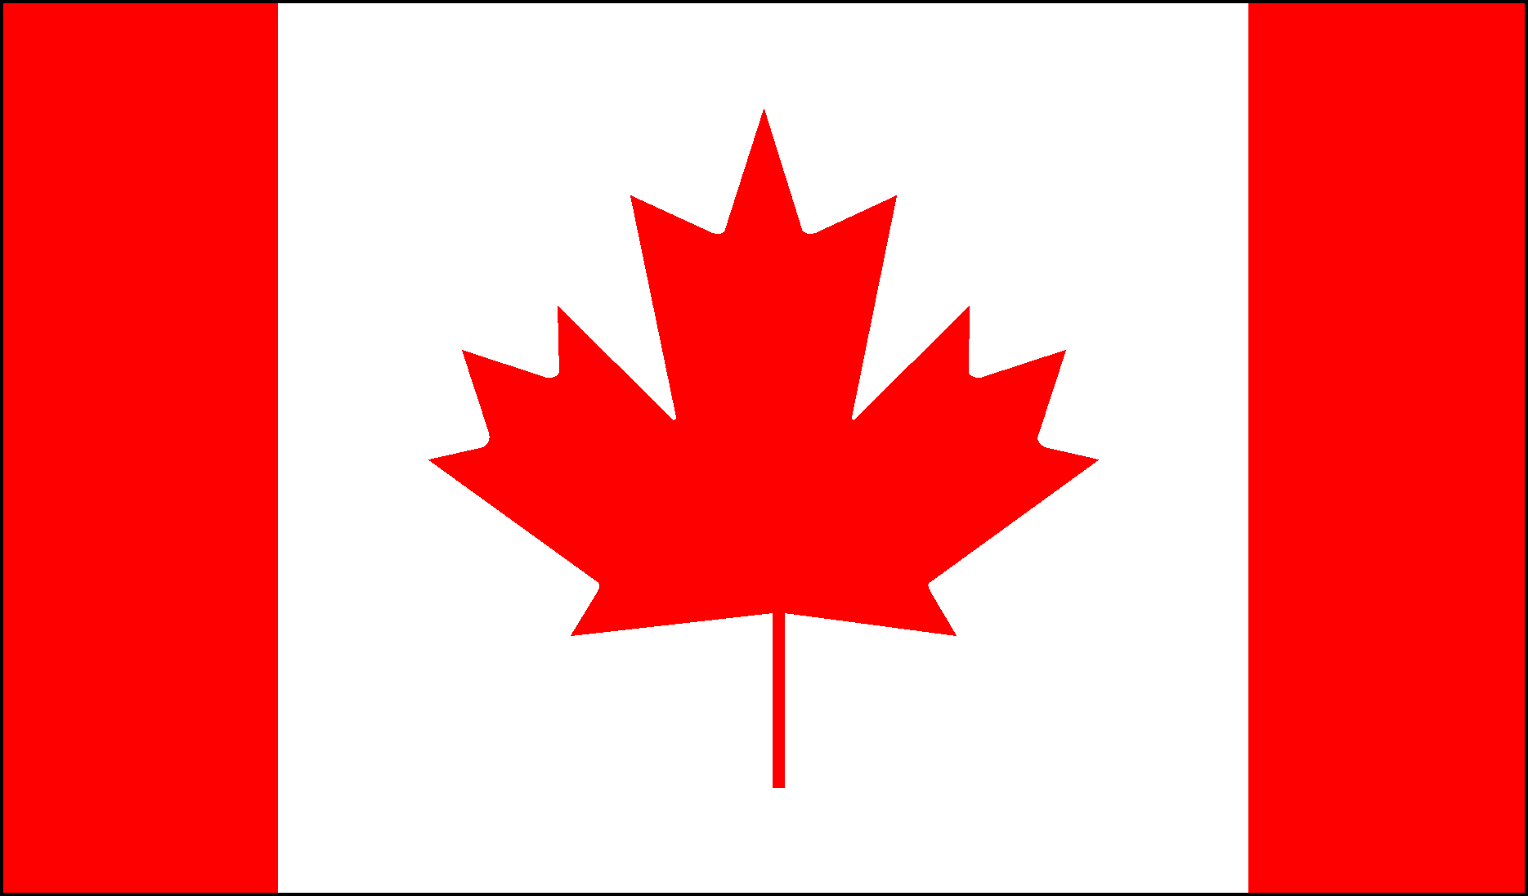
f) | g) | h) | i) | j)
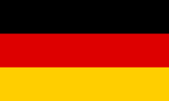 | 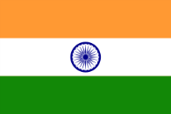 | 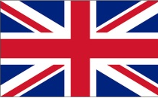 | 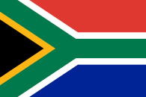 | 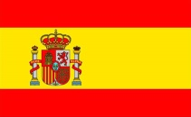
k) | l) | m) | n) | o)

- Japan | - France | - USA | - Canada | - UK
- India | - Australia | - South Africa | - Germany | - Mexico
- Brazil | - South Korea | - China | - Greece | - Spain

- Match the landmarks with the country:
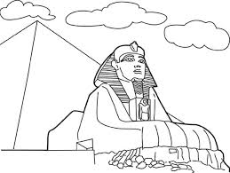 | 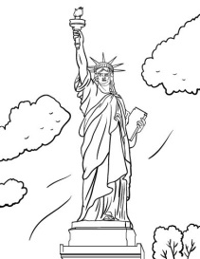 | 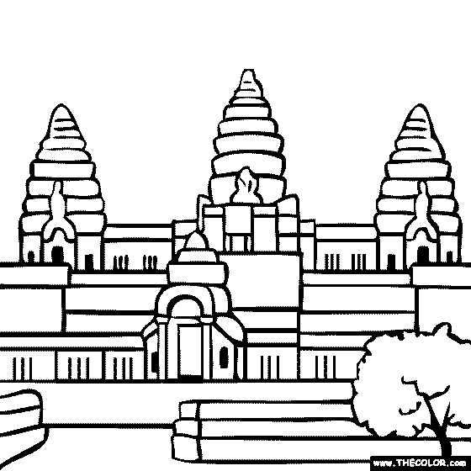 | 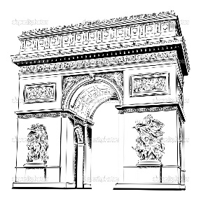
a) | b) | c) | d)
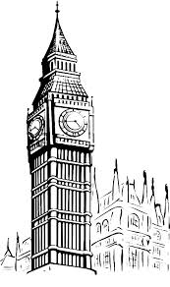 | 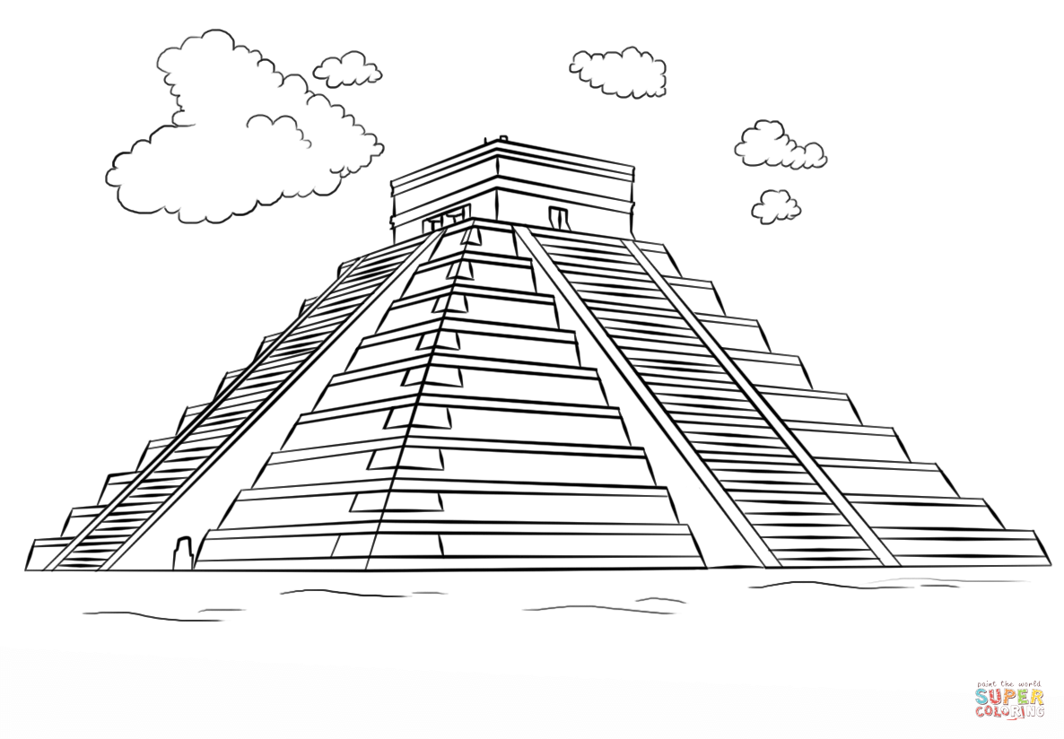 | 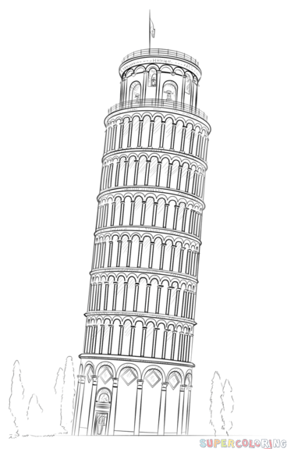 | 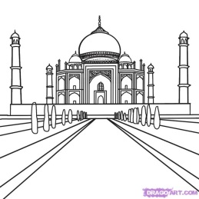
e) | f) | g) | h)
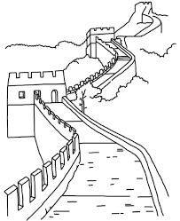 | 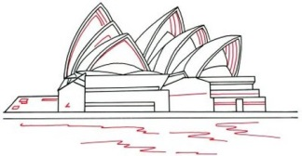 |  | 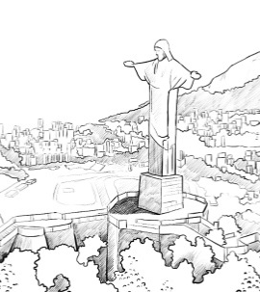
i) | j) | k) | l)

USA | Egypt | India | UK | Japan | Australia
Cambodia | China | France | Mexico | Italy | Brazil

- Fill in the missing letters:
- UK = L _ N D _ N
- Japan = T _ K Y _
- France = P _ R _ S
- Germany = B _ R L _ N
- Italy = R _ M _
- USA = W _ S H _ N G T _ N
- Australia = C _ N B _ R R _
- China = B _ _ J _ N G
- Egypt = C _ _ R _
- India = N _ W D _ H L _

- Put the countries into the correct continent:

China Brazil India Canada France Egypt Germany
Japan UK Kenya Mexico Spain Peru South Korea
USA Norway South Africa Nigeria Vietnam Argentina

Africa | Europe | North America | South America | Asia

- Unjumble the letters to answer the questions:
- In Italy they like to eat … . ( E P A T S G H T I )
- In Canada the speak English and … . ( C H E F R N )
- In Australia you can see many … . ( G O O N A K R A S )
- The country with the most people is … . ( N A I C H )
- Egypt is famous for … . ( P M R A S Y I D )

UNIT 2
RUSSIA

Russia is one of the largest countries in the world. It occupies about one-seventh part of dry land. It is situated in Europe and Asia. Its total area is over 17 million square kilometers.
The population of Russia is about 150 million people. 83 per cent of the population are Russians. 70 per cent of the population live in cities.
The country is washed by seas and oceans, by the Arctic Ocean in the north and the Pacific Ocean in the east. There are many rivers in Russia. The largest rivers are the Volga in Europe and the Yenisei and OB in Asia. All rivers flow in the seas. The deepest lakes are the Baikal and Ladoga.
Russia has one-sixth of the world’s forests. They are concentrated in the European north of the country, in Siberia and in the Far East.
There are different types of climate on the territory of the country. It is very cold in the North even in summer. The central part of the country has mild climate: winters are cold, springs and autumns are warm or cool, summers are hot and warm. In the South the temperature is usually above zero all year round, even in winter. Summer is really hot. The climate of Siberia is continental: summers are hot and dry, winters are very cold.
Some parts of our country are covered with mountains and hills. Here are three main mountains chains in Russia. The Caucasus is a range of mountains, which extend from the Black Sea to the Caspian Sea. The highest mountain is the Caucasus. The highest mountain in Caucasus is Mount Elbrus. The Urals extend from the Arctic Ocean to the steppes. This mountain chain divides the European and Asian parts of Russia. The Urals are famous for their valuable minerals. There are 150 volcanoes in Kamchatka, 30 of which are active.
The Russian Federation is very rich in mineral resources, such as oil, natural gas, coal, iron, gold and others.
Today Russia is one of the world's largest grain products and exporters. It produced 78 % of all its natural gas, 60 % of steel, 80 % of timber and 91 % of oil. So, today Russia becomes greatest industrial country.
Russia borders on fourteen countries including the former republics of the USSR, which are now independent states. Russia borders with Estonia, Latvia, Finland, Poland, China, Mongolia, Korea, Japan, Kazakhstan and so on.
Russia is a parliamentary republic. The Head of State is the President. The legislative powers are exercised by the Duma.
Today the state symbol of Russia is a three coloured banner. It has three horizontal stripes: white, blue and red. The white stripe symbolizes the earth, the blue one stands for the sky, and the red one symbolizes liberty. A new national emblem is a two-headed eagle.
Moscow is the capital of our country. It was founded in 1147. It is a wonderful city. There are many sights in Moscow. You can see many museums, art galleries, theatres, churches and monuments in our capital. People of our country are proud of the Moscow Kremlin. There are also many big beautiful cities in Russia.
A lot of holidays are celebrated in Russia. The New Year holiday is very popular, especially with children. There is a firtree in every house. The presents are supposed to be sent by Father Frost and the Snow Maiden.
The Russian Christmas is celebrated on the 7th of January. The holiday is connected with the wonderful birth of Jesus Christ as it is described in the Holy Bible.
Easter is a very popular holiday in Russia in commemoration of the resurrection of Jesus. Easter has no fixed date. People nowadays greet each other on the Easter day by the words "Christ is risen!" And the expected answer is "He is risen indeed!" People also paint eggs and give them to one another as a symbol of eternal life.
On February, 23, which is Day of the Defenders of the Motherland Russia, people honour those who are serving in the Armed Forces and those who have served in the past.
International Women's Day is celebrated every March, 8. On this day, women in Russia are presented with gifts and thanked for their work, love and devotion.
Every May, 9, Russia celebrates the Victory Day commemorating victory over Nazi Germany, while remembering those who fell in order to achieve it.
There are different sporting societies and clubs in Russia. Many of them take part in different international tournaments and are known all over the world. A great number of world records have been set by Russian sportsmen: weightlifters, tennis players, swimmers, figure skaters, high jumpers. Our sportsmen also participate in the Olympic Games and always win a lot of gold, silver and bronze medals.

- Find the equivalents in the text:
- Россия занимает около 1/7 части суши.
- 70 % населения страны живет в городах.
- Россия омывается Северным ледовитым океаном на севере и Тихим океаном на востоке.
- Все реки впадают в моря.
- Эта горная цепь разделяет европейскую и азиатскую части России.
- Российская федерация очень богата минеральными ресурсами такими, как: нефть, природный газ, уголь, железо, золото.
- Россия – крупный мировой производитель и экспортер зерна.
- Белая полоса на флаге символизирует землю, голубая – небо, красная – свободу.
- В Москве можно посетить много музеев, картинных галерей, театров, церквей и памятников.
- Пасха – очень популярный праздник в России.

- Complete the sentences and translate them:
1. Russia is one of … .
2. The population of Russia is … .
3. The largest rivers are … .
4. They are concentrated in … .
5. The central part of the country has … .
6. There are 150 volcanoes … .
7. Russia is a parliamentary … .
8. A new national emblem is … .
9. Moscow is … .
10. There is a firtree … .
11. People also paint eggs … .
12. On February, 23, … .
13. On this day, women … .
14. Our sportsmen also participate … .

- Answer the questions:
1. Where is Russia situated?
2. How many per cent of the population is Russians?
3. What are the deepest lakes in Russia?
4. What is the climate of Siberia?
5. How many mountain chains are there in Russia? Name them.
6. What mineral resources is Russia rich in?
7. What countries does Russia border?
8. Who is the Head of State in Russia?
9. When was Moscow founded?
10. When is the Russian Christmas celebrated?

- Say if the sentences are True or False:
1. The country is washed by seas and oceans, by the Arctic Ocean in the south and the Pacific Ocean in the west.
2. The Head of State is the Queen.
3. A great number of world records have been set by Russian sportsmen.
4. It has three horizontal stripes: white, green and red.
5. There are many sights in Moscow.
6. On February, 23, which is Day of the Defenders of the Motherland Russia, people honour only those who are serving in the Armed Forces.
7. The central part of the country has mild climate: winters are cold, springs and autumns are warm or cool, summers are hot and warm.

- Translate from Russian into English:
1. 8 Марта мужчины дарят женщинам подарки.
2. Россия экспортирует нефть, природный газ, уголь, железо, золото и другие минеральные ресурсы.
3. Леса России сконцентрированы на севере и востоке страны.
4. Люди красят яйца на Пасху и дарят их друзьям и родственникам.
5. Русские спортсмены выиграли большое количество медалей на Олимпийских играх.
6. Двуглавый орел и трехцветный флаг – символы России.
7. Эстония, Польша и Латвия – бывшие республики СССР.
8. В России на Новый Год люди покупают ёлку.
UNIT 3
THE UNITED STATES OF AMERICA

Pre-reading tasks – do you know American history?

- Answer the questions:
- What is the capital of the USA?
- What is the population of the USA?
- What territory does it cover?
- What oceans is this country washed by?
- Is the United States a democratic federal republic?
- Who is the Head of State?
- How many states does the USA comprise?
- When did the present-day American history start?
- Who struggled Native Americans?
- Where do the central lowland lie?

- Match the events with years they happened in:
abolishing of slavery | the 21st century
the beginning of struggling for independence | 1865
the beginning of American history | 1775
the beginning of the Civil War | the 17th century
settlers coming to the new lands | 1861
the USA has got the leading power | 1607

- Say if the following statements are true or false:
- The Civil War started in 1861.
- Natural resources include mineral water and gold.
- The influence of the USA was growing during the 19h-20h centuries.
- The territory of the USA is about 9, 330, 000 square kilometres.
- The president is elected every five years.
- The United States borders on Canada in the north and on Mexico in the south.
- The climate is temperate all over the country.
- The USA is not a democratic federal republic.
- The struggle for independence ended in 1783.
- Slavery was abolished in 1865.

INTERESTING FACTS ABOUT THE COUNTRY
  - Geographical position

1. Read the text. Find all the geographical names in bold on the map (picture).
The United States of America is also called the USA, US, United States or sometimes America. The USA is in the central part of North America. It borders on Canada and Mexico. It is washed by the Atlantic Ocean, by the Pacific Ocean and by the Gulf of Mexico. The capital of the USA is Washington.
The territory of the USA consists of three separate parts
- the USA proper
- Alaska
- The Hawaii.
The area of the country is about 9,400,000 km2. Its population is about 324 million people. The US is the 4th largest country in the world by land area and 3rd by population.
The USA is a country of mountains, valleys and deserts. The highest mountains are the Appalachian Mountains, the Cordilleras, the Rocky Mountains and the Sierra Nevada Mountains in California. The tallest mountain the US is Mt McKinley, located in the state of Alaska.
The Great Lakes are in the north-east of the country. They are Lake Ontario, Lake Huron, Lake Erie, Lake Superior, Lake Michigan. The largest rivers of the USA are the Mississippi and the Missouri. The most populated city in the US is New York City, followed by Los Angeles and Chicago.
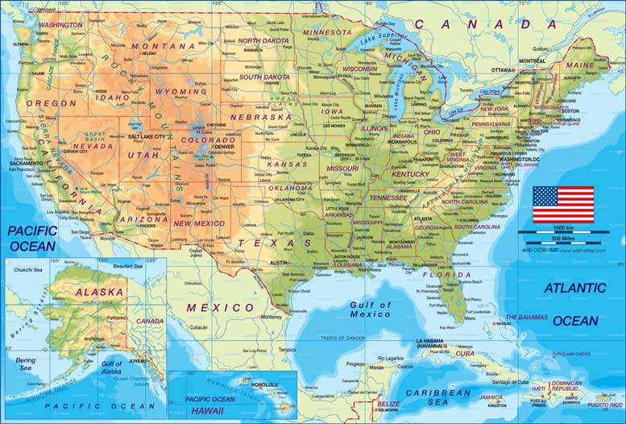
Picture . The map of the USA

2. Finish the following sentences:
- The longest river in the USA is …
- One of the largest cities in the USA is …
- The USA borders on … in the South.
- The USA borders on … in the North.
- The highest mountain in the USA …
- The … of the country is about 324 million people.
- The … of the country is about 9,400,000 km2.
- The most northern state of the USA is …

3. Answer the questions.
- What is the capital of the USA?
- Which are the highest mountain ranges?
- Where are the Great Lakes situated?
- Which are the largest rivers?
- The most populated city in the US is NYC, isn’t it?

  - States and symbols

1. Read the text. Find the 5 largest states on the map. What are their capital cities?
The USA is a federal republic. It consists of 50 states. The five biggest states are: Alaska, Texas, California, Montana and New Mexico. The capital city – Washington – is situated in a special district — the District of Columbia.
One of the national symbols of the country is the flag. It is also called STARS AND STRIPES. There are 50 stars on the flag – one for each state. There are also 13 stripes. The 13 stripes represent the 13 original colonies of the US.
The national bird of the USA is the Bald Eagle. The National mammal is the bison – just like in Belarus. The national flower is the rose like in England, and the national tree is an oak.

2. Study the infographics. Answer the questions:
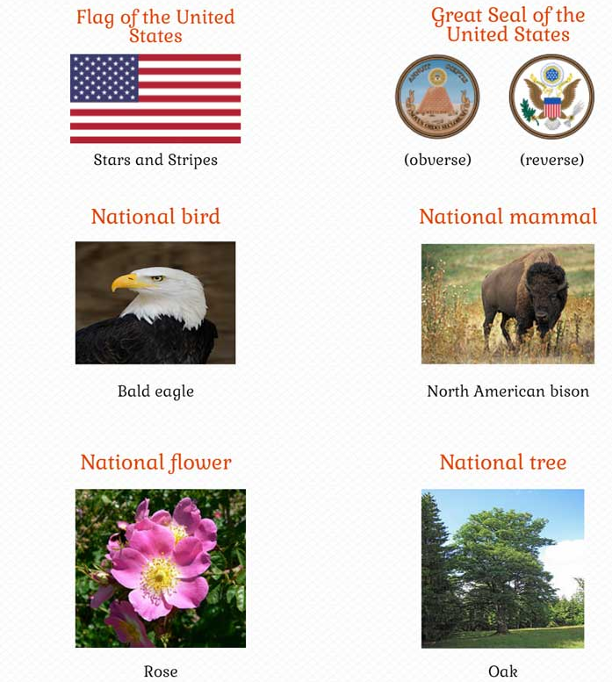
- How is the national US flag called?
- What do the 50 stars on the flag stand for?
- What do the 13 stripes stand for?
- What does the USA have in common with Belarus and with England?
- What is the national tree of the USA?
- What is the national bird of the USA?

  - Holidays

1. Read the passage and complete the table. The first is done for you:
Holiday | Date | What do people do | Is it a national holiday?
New Year's Day | January, 1st | Have parties, go to clubs, meet their friends, greet the New Year in. | YES
New Year's Day, January, 1st.
People stay awake until after midnight on December 31st. They have parties, go to night clubs, meet their friends. Many people greet the New Year in.
Valentine's Day, February, 14th:
Valentine's Day is not a national holiday. Banks and offices do not close, but many people celebrate Valentine's Day. They exchange cards and spend their time together with the loved ones.
Washington's Birthday, February, 22nd.
George Washington's Birthday is not a national holiday. It's a great day for shoppers. Many shops have sales marked by unusual bargains. People usually go shopping on this day.
Easter.
People celebrate Easter on the first Sunday after the first full moon between March, 22, and April, 25. Pupils usually have spring vacation at this time. Easter is a church holiday, and many people go to churches on this day. People give each other eggs.
Memorial Day, May, 30th:
Memorial Day is a national holiday. Schools, banks and offices close for the day. On that day, Americans honor the soldiers who gave their lives in past wars. Schools, clubs and churches decorate the cemeteries. They put up the flags on the graves of the army, navy and airmen.
Independence Day, July, 4th:
Independence Day is a national public holiday. On this day, in 1776, America signed the Declaration of Independence. People have picnics and parties and meet their friends on this day.
Halloween, October, 31st:
On this day Americans just have a nice holiday. It is not a national holiday. Children dress up as ghosts and witches and go out into the streets to beg. They go from house to house and say: «Trick or treat!».
Thanksgiving Day, the fourth Thursday in November:
In the USA Thanksgiving Day is a national holiday. All members of the family gather at the house of their parents. The family has a large traditional dinner, usually with turkey, cranberry sauce and pumpkin pie.
Christmas Day, December, 25th:
It is usually a one-day official holiday. Christmas is a family holiday. Schools and colleges close between Christmas and New-Year's Day. People stay at home and spend the time with their families.

2. Do you think these statements are true or false? Correct the false statements:
- The United States of America is also called the USA or the UK.
- The capital of the USA is EDINBURG.
- The Great Lakes are in the north-east of the country.
- The USA consists of 13 big states and 50 small states.
- The national flag of the USA is also called UNION JACK.
- The national bird of the USA is the Bald Eagle.
- Independence Day is a national public holiday.
- Alaska was bought from Russia in 1867.
- Most of the world's tornadoes occur in the USA.
- English is the most commonly spoken language in the US, followed by Spanish.
- The first man to walk on the moon was American George Washington.
- The most popular sports in the US are American football, baseball and basketball.

3. Choose your favorite holiday and write few words about it.

- General information about the country

The United States of America (the USA) is one of the greatest countries in the world. It is situated on the North America continent and is washed by two oceans: the Pacific and the Atlantic Oceans. The USA boarders with Canada in the North and Mexico in the South.
This great country has a lot of mountains, rivers and lakes. The main mountains of the USA are the Appalachian Mountains and the Cordilleras. Among the longest rivers there are the Mississippi, the Missouri, the Ohio, the Columbia and the Colorado.
The climate of the country is different in different parts of the country. In the southern part it is subtropical and continental and in the North it is arctic with very cold weather in winter.
America has fifty states and one independent District of Columbia where the capital of the country is situated. The capital of the USA is Washington D.C. It stands on the Potomac River in the eastern part of the country.
The main cities of this country are located at the Pacific and Atlantic coasts. New-York is the largest city of the country in population. Other large cities are Boston, Chicago, Philadelphia, Detroit, San Francisco, Los Angeles and Atlanta.
The USA is a country with a highly developed economy, good industry and agriculture. The main industrial centres are Chicago and Detroit, with their greatest automobile company "General Motors".
There are many farms in the USA (in Texas for example) with various agricultural products like grains, fruit and vegetables. Numerous fields are located especially in the South.
The USA is a country with many interesting customs, traditions and holidays. It is one of the most beautiful and interesting countries in the world.

1. Say if the following statements are True, False or Not stated:
- The USA is situated on the South America continent.
- It is washed by three oceans.
- The Columbia is one of the longest rivers of the USA.
- The weather is cold in winter in the North of the USA.
- Washington, D.C. is situated in the state Washington.
- Miami is the largest city in population.
- George Washington is the founder of the USA.
- Texas is the agricultural state.
- There are only two large cities in the USA.
- “General Motors” is the most famous company in the world.

2. Answer the questions:
- Where is the USA situated?
- What oceans are washed the USA?
- What countries does the USA border with?
- What is the climate in different part s of the country?
- What is the capital of the USA? Where is it situated?
- What are the main mountains and the rivers?
- Where are the main cities located? What is the largest?
- The USA is a country with a highly developed economy, good industry and agriculture, isn’t it?
- Is it one of the most beautiful and interesting countries in the world?
- Would you like to visit the USA? Why?

3. Read the letter written by Mark to his friend John:

Moscow
Russia
January 2017
Dear John,
Thanks for your letter. It was great to hear from you.
First of all, let me inform you about my upcoming trip to the USA. The trip will take place in April. I’m going to visit your country as a tourist. I’ve already read a lot of books about American attractions, your customs and traditions and want to see it my own eyes. My journey begins with your hometown New York. I know it’s the largest city of the country in population. Can you meet me at the airport? It would be great to see each other.
I’m sorry I have to stop now. It’s time to do my homework in English.
Hope we’ll see you soon.
Best wishes,
Mark

Write a letter to your pen-friend informing about your upcoming trip to the USA.
Follow the rules of making a letter. Write 80 – 100 words.

4. Read the information about the USA and make a summery. Fill in the table “Fact File” below the text:
The United States of America is the fourth largest country in the world (after Russia, Canada and China). It occupies the southern part of North America and stretches from the Pacific to the Atlantic Ocean. It also includes Alaska in the north and Hawaii in the Pacific Ocean. The total area of the country is about nine and a half million square kilometers. The USA borders on Canada in the north and on Mexico in the south. It also has a sea-boarder with Russia.
The USA is made up of 50 states and the District of Columbia, a special federal area where the capital of the country, Washington, is situated. The population of the country is about 250 million.
If we look at the map of the USA, we can see lowlands and mountains. The highest mountains are the Rocky Mountains, the Cordillera and the Sierra Nevada. The highest peak is Mount McKinley which is located in Alaska. America’s largest rivers are the Mississippi, the Missouri, the Rio Grande and the Columbia. The Great Lakes on the border with Canada are the largest and deepest in the USA.
The climate of the country varies greatly. The coldest regions are in the north. The climate of Alaska is arctic. The climate of the central part is continental. The south has a subtropical climate. Hot winds blowing from the Gulf of Mexico often bring typhoons. The climate along the Pacific coast is much warmer than that of the Atlantic coast.
The USA is a highly developed industrial country. It is the world’s leading producer of copper and oil and the world’s second producer of iron ore and coal. Among the most important manufacturing industries are aircraft, cars, textiles, radio and television sets, armaments, furniture and paper.
Though mainly European and African in origin, Americans are made up from nearly all races and nations, including Chinese and native Americans.
The largest cities are: New York, Los Angeles, Chicago, Philadelphia, Detroit, San- Francisco, Washington and others.
The United States is a federal union of 50 states, each of which has its own government. The seat of the central (federal) government is Washington, DC. According to the US Constitution the powers of the government are divided into 3 branches: the executive, headed by the President, the legislative, exercised by the Congress, and the judicial. The Congress consists of the Senate and the House of Representatives. There are two main political parties in the USA: the Republican and the Democratic.

The Country | The United …..
The national flag, the state
emblem and other symbols
Its size, area
It occupies
It borders on
The capital,
important cities
It is made up of
People
Its landscape/ relief
The climate
The industry
The political system
Some interesting facts

UNIT 4
THE UNITED KINGDOM OF GREAT BRITAIN AND NORTHERN IRELAND

1. Choose the correct answer for each question:
1. Which one is the official name of the country?
a) England
b) Great Britain
c) The United Kingdom of Great Britain and Northern Ireland

2. What channel separates the UK from the continent?
a) North Channel
b) English Channel
c) St. George’s Channel

3. What seas is the UK washed by?
a) North Sea
b) Irish Sea
c) Caribbean Sea

4. How many countries does the UK consist of?
a) 3
b) 4
c) 2

5. Match the country of the UK and its capital:
- England
- Wales
- Northern Ireland
- Scotland
  - Belfast
  - Edinburgh
  - London
  - Cardiff

6. Which is the highest mountain in the UK?
a) Cape Horn
b) Ben Nevis
c) Everest

7. What are the most important rivers for the UK?
a) the Thames
b) the Ohio
c) the Severn

8. Who rules Britain officially?
a) the Queen
b) Prime Minister
c) the King

9. How many chambers does the British Parliament have?
a) 3
b) 5
c) 2

10. The capital of the UK is:
a) Dublin
b) London
c) Newcastle

11. Who rebuilt St. Paul’s Cathedral?
a) Edward the Confessor
b) Lord Mayor
c) Sir Christopher Wren

12. Traditionally London is divided into … parts.
a) 6
b) 4
c) 3

13. The Tower has served as …
a) citadel
b) palace
c) prison

14. What is Buckingham Palace famous for?
a) It is the biggest museum in London
b) It is the Queen’s official London residence.
c) There are memorials to Wellington and Nelson.

15. Match the name of the famous English writer and his work:
1) J. Swift
2) R. Burns
3) J. London
4) G. Chaucer
a) “The Canterbury Tales”
b) “Martin Eden”
c) “My heart’s in the Highlands”
d) “Gulliver’s Travels”

16. What holiday do the English celebrate on October, 31?
a) Boxing day
b) Halloween
c) Thanksgiving day

17. For breakfast Englishman always have …
a) porridge
b) haggis
c) omelet

18. Who sits in the British Parliament on a wool-sack covered with red cloth?
a) the Queen
b) the Lord-Chancellor
c) Prime Minister

19. According to the tradition the faces of Big Ben are light when …
a) New Year comes
b) the weather changes
c) the Parliament works

20. What park is the most famous in London?
a) Kensington Gardens
b) St. Jame’s Park
c) Hyde Park

2. Read the text and translate it in the written form:
The United Kingdom of Great Britain and Northern Ireland is situated on two large islands called the British Isles. The largest island is Great Britain, which consists of three parts: England, Scotland and Wales. The smaller island is Ireland and there are about five thousand small islands.
The country's shores are washed by the Atlantic Ocean, the North Sea and the Irish Sea. The English channel separate Great Britain from the continent.
The total area of the U.K. is 244.000 square kilometers with a population of 56 million. It is one of the most populated countries in the world. The greater part of the population is urban. About 80 percent of people live in numerous towns and cities. More than seven million people live in London area. Very often the inhabitants of The United Kingdom and Northern Ireland are called English.
The surface of the British Isles varies very much. There are many mountains in Scotland, Wales and northwest of England but they are not very high. Ben Nevis in Scotland is the highest mountain. Scotland is also famous for its beautiful lakes.
The mountains in Great Britain are not very high. There are many rivers in Great Britain, but they are not very long. The Themes is the deepest, the longest and the most important river in England.
The United Kingdom is a highly developed industrial country. It produces and exports machinery, electronics, textile. One of the main industries of the country is shipbuilding.

3. Fill in the gaps with the words from the text:
- The United Kingdom of Great Britain and Northern Ireland is situated on ... .
- The largest island is ..., which consists of three parts ... .
- The smaller island is ... .
- ... separate Great Britain from the continent.
- It is one of the most ... countries in the world.
- The greater part of the population is ... .
- More then ... people live in London area.
- Very often the inhabitants of the United Kingdom and Northern Ireland are called ... .
- ... of the British Isles varies very much.
- ... in Scotland is the highest mountain.
- Scotland is also famous for ... .
- There are many ... in Great Britain, but they are not very long.
- ... is the deepest, the longest and the most important river in England.
- The United Kingdom is a highly developed ... country.

2. Say if the following statements are True or False:
- The United Kingdom of Great Britain and Northern Ireland is situated on four large islands.
- The largest island is Great Britain.
- Great Britain consists of three parts: England, Germany, Wales.
- The smaller island is Ireland and there are about seven million small islands.
- The country's shores are washed by the Indian Ocean, the Black Sea and the Irish Sea.
- The population of Great Britain is 46 million.
- It is not the most populated countries in the world.
- The greater part of the population is urban.
- The inhabitants of the United Kingdom and Northern Ireland are called English.
- There are not many mountains in Scotland, there are many rivers.

3. Make the sentences using the following words:
- and, island, which, parts, the, England, largest, consists, Great, Britain, three, and, Scotland, is, of, Wales.
- high, Great, Britain, the, very, in, mountains, not, are.
- country, the, a, developed, Kingdom, highly, industrial, is, United.

4. Correct the mistakes according to the text:
- The smallest island is Great Britain, which consists of two parts: Scotland and Wales.
- More than seventeen thousand people live in London area.
- The surface of the British Isles doesn't vary very much.
- There are many rivers in Great Britain, and they are very long.
- The United Kingdom isn't a highly developed industrial country.
- One of the main industries of the country is machine building.

UNIT 5
CANADA.
  - GENERAL INFORMATION

Canada is one of the most developed countries in the world. Canada is an independent federative state. It consists of ten provinces and two territories.
It is situated on the North American continent. The country is washed by the Pacific Ocean in the west, by the Atlantic Ocean in the east and by the Arctic Ocean and its seas in the north. About 2 percent of the Canadian territory is covered by glacier ice.
The eastern parts of the country are mainly valleys and plains. The western territories are occupied by the Cordilleras.
The main Canadian islands are Newfoundland, Victorian Island, Baffin Island and others. There are a lot of rivers and lakes in Canada. The largest rivers are the Nelson, the Ottawa, the Mackenzie and the Yukon.
In size Canada is the second in the world after Russia. Its area is almost 10 million km2. The capital of Canada is Ottawa, which is situated on the bank of the Ottawa River. It is famous for its beautiful parks. It is also known as the city of bridges.
The most developed industries are timber, mining, chemical, meat and milk and food industries. Canada grows wheat, barley, flax, potatoes, vegetables and fruit. Fishing is also one of the prosperous industries.
Official languages of Canada are English and French. Canada is a founding member of the United Nations. It has been active in a number of major UN agencies.

1. Read these geographical names:
- Canada
- the North American continent
- the Pacific Ocean
- the Atlantic Ocean
- the Arctic Ocean
- Canadian islands
- Newfoundland [‘njuːfən(d)lənd]
- Victorian Island
- Baffin Island
- the Nelson, the Ottawa, the Mackenzie and the Yukon

2. Remember the words:

the most developed – наиболее развитый
provinces – провинции
territories – территории
the west – запад
the east – восток
percent – процент
is covered – покрыты
glacier ice – ледник
are occupied by – заняты
bank – берег
bridge – мост
timber – лесная промышленность
mining – горная промышленность
chemical – химическая промышленность
wheat – пшеница
barley – ячмень
flax – лен
prosperous – процветающий
founding member – основатель
United Nations – Организация Объединенных Наций
major UN agencies – основные учреждения ООН
3. Find 11 words in the chart below. Copy them out:
p | r | o | s | p | e | r | o | u | s
w | q | e | h | r | a | w | t | x | e
b | f | w | h | o | s | a | r | x | a
a | o | h | j | v | t | q | v | z | o
r | l | e | m | i | n | i | n | g | l
l | w | a | g | n | o | c | e | a | n
e | e | t | p | c | b | f | l | a | x
y | s | c | p | e | r | c | e | n | t
c | t | c | k | s | r | b | a | n | k

4. Make up sentences:
1) on the North American continent / is / it / situated.
2) a lot of / there are / in Canada / rivers and lakes .
3) of Canada / are / English and French / official languages.
4) consists of / Canada / ten / territories / and / provinces / two.

5. Answer the questions:
1. What does Canada consist of?
2. Where is it situated?
3. What oceans is Canada washed by?
4. What are there in the eastern part of the country?
5. What are the main Canadian islands?
6. What are the largest rivers?
7. What is the size of Canada?
8. What is its area?
9. What is the capital of Canada? Where is it situated? What is it famous for?
10. What are the most developed industries?
11. What are grown in Canada?
12. What are the official languages?

6. Fill in the missing words:

Largest / flax / continent / an / eastern / Ocean / parks / provinces / developed / western

Canada is 1) … independent federative state. It is one of the most 2) … countries. Canada consists of ten 3) … and two territories. It is situated on the North American 4) …. The country is washed by the Pacific 5) … in the west. The 6) … parts of the country are mainly valleys and plains. The 7) … territories are occupied by the Cordilleras. The 8) … rivers are the Nelson, the Ottawa, the Mackenzie and the Yukon. Ottawa is famous for its beautiful 9) …. Canada grows wheat, barley, 10) …, potatoes, vegetables and fruit.

7. Say if the following sentences are True or False:
1. Canada is the most developed country.
2. Canada consists of two provinces and ten territories.
3. It is situated on the South American continent.
4. The country is washed by the Arctic Ocean in the south.
5. The largest rivers are Newfoundland, Victorian Island, Baffin Island and others.
6. In size Canada is the first in the world.

8. Choose the correct answer:
1. Canada is surrounded by ___ oceans.
A. 1 B. 2 C. 3 D. 4
2. What is the capital of Canada?
A. Ottawa B. Québec C. Vancouver D. Montreal
3. Canada's national animal is the...
A. Grizzly bear B. Moose C. Beaver D. Eagle
4. Canada owns ___% of the world's forests.
A. 5 B. 10 C. 15 D. 20
5. Who were the first inhabitants of Canada?
A. American people B. Aboriginal people C. European people D. Eskimos
6. Ice hockey is the national winter sport of the country. What is the national summer sport?
A. Lacrosse B. Basketball C. Football D. Rugby
7. Niagara falls belongs to...
A. Canada B. The USA C. Both of them D. None of them
8. How big is the population of the country?
A. More than 10 million people B. More than 20 million people
C. More than 30 million people D. More than 40 million people
9. In 2010 the Winter Olympic Games were held in Vancouver. There was another occasion when Canada was a host for the games. When was it?
A. 1948 B. 1956 C. 1972 D. 1988
UNIT 6
AUSTRALIA
    - Australia’s unique history

Captain James Cook discovered Australia in 1770. He was sent to discover the huge land that many people believed was south of the equator. He landed south of present day Sydney I New South Wales. He claimed this part of the land for the King of England.
At this time England was having many social problems. Unemployment was high. Crime was one of the greatest problems. The government punished people by sending them to prison. England’s solution to crowded prisons was to send prisoners to the far colonies. They could work of their work off their prison sentences as labourers in the new colonies and eventually earn their freedom. Therefore, in 1788 Captain Arthur Phillip commanded eleven ships to Australia. About 750 of the 1000 people on the ships were convicts. These first settlers were greeted by the Aborigines, the first inhabitants of Australia. There were an estimated 300,000 Aborigines living I Australia at that time.
Great Britain claimed all Australia in 1827. In 1851 gold was discovered about 300 km west of Sydney. People rushed to the gold fields to find their fortunes. This attracted robbers called bushrangers. Ned Kelly was a famous bushranger. He was a very clever outlaw.
In1901 Australia became a nation within the British Empire under Queen Victoria’s rule. It was called the Commonwealth of Australia. Australia had a very limited constitution. Great Britain continued to make decisions regarding all of Australia’s foreign affairs.
In 1931 Australia gained independence from Great Britain.

- Answer the questions:
- Do you think Australia’s history is so unique? Can you think of another country with a similar history?
- What part of Australia’s history do you find unique or interesting?
- How long have Australia been a nation within the British Empire?
- Who discovered Australia?
- What was one of the greatest problems in England in 18th century?
- Who were the first settlers of Australia?
- Who were the first inhabitants of Australia?
- Why did people rush to Australia in the middle of the 19th century?

- Choose 10 words and word combinations from the list of vocabulary and make sentences.

- Pot the events of Australia’s history on a time line:

1770 1778 1851 1901 1931
Captain Cook
discovered
Australia

- Write out the verbs where the active and passive forms are used in the text. Translate them into Russian:

Active voice | Passive voice
discovered – открыли | was sent – был послан

- Fill in the blanks with the verbs using the above text:
- Captain Cook … land for the king of England.
- The English government … people by sending them to prison.
- Captain Arthur Philip … eleven ships to Australia.
- People … to the gold fields to find their fortunes.
- In 1931 Australia … independence from Great Britain.
- England … many social problems.
- Great Britain … all of Australia in 1827.
- Captain Cook … to discover the land that many people … was south of the equator.

- Choose one of the English-speaking countries and find information about its history. Use this information to make a presentation (8-10 slides).

- Geographical position

Australia is the smallest continent between the Indian and Pacific oceans. With the island state of Tasmania to the south, the contitent makes up the Commonwealth of Australia, a federal parliamentary state the total area is 7 686 810 sq.km. Australia’s capital is Canberra. Its largest city is Sydney, closely followed in population by Melbourne. There are five continental states in the nation (Queensland, New South Wales, Victoria, South Australia and Western Australia). The population of Australia is about 15 million people. There are only 40 000 aborigines. The first Europeans settled in 1788. There are more about 200 nationalities in Australia.

- Wild animals

Kangaroos live in Australia, Tasmania, New Guinea and New Zealand. Their strong legs and feet help them to hop and leap. Kangaroos usually have one young baby. The native birds of Australia are very interesting. The emu is the next tallest bird in the world after the ostrich.

- Sydney

Sydney is Australia’s largest city, chief port and main cultural and industrial center. Its main exports are wool, wheat, flour, sheepskins and meat, the chief imports are petroleum, coal, timber and sugar. The city was founded in 1788 as the first penal settlement of Australia. Its name was taken from a cave named for Captain Cook’s patron Viscount Sydney. Among its museums are the National Gallery of Art and the Australian Museum (natural history). The dramatic, modernistic Sydney Opera House complex was largely designed by Joem Wizen.

1. Fill in the gaps:
- … or wild dog, is the only killer among the native animals.
- … is the second tallest bird after the ostrich.
- The capital of Australia is … .
- The original inhabitans of Australia were … .

2. Answer the questions:
- What is the official language of Australia?
- How many nationalities are there in Australia?
- What is the main industrial centre in Australia?
- Where was the name “Sydney” taken from?
- What are the mail exports of Sydney?
- How many states does Australia include?
- Is Australia a country or a continent?
- What is the total area of Australia?
- What are the native birds of Australia?
- Where is situated the Opera House?

3. Choose the correct variant:
1. What is the capital of Australia?
a) Sydney b) Melbourne c) Canberra
2. When did Europeans settle in Australia?
a) 1488 b) 1788 c)1492
3. Which 2 animals can you see on the Australian coat of aims?
a) Kangaroo and Dingo b) Koala and Parrot c) Kangaroo and Emu
4. Which city is Australia’s oldest and largest?
a) Sydney b) Melbourne c) Canberra
5. Who are the Australian natives?
a) Eskimos b) Aborigines c) Indians
6. Who discovered Australia?
a) Christopher Columbus b) Captain Cook c) Lewis and Clark
7. Australia is not a(n):
a) island b) city c) continent
8. How many nationalities live in Australia?
a) 200 b) 50 c) 20
9. What is the official language in Australia?
a) French b) German c) English

- Australia Today

Australia is a continent, a country and an island all at the same time. It is the sixth largest country and the smallest continent in the world. Australia is located in the southern hemisphere. That is why it has summer when we have winter and it has winter when we have summer. It is interesting to know that January is the hottest month in Australia.
Australia is situated between the Pacific and the Indian Oceans. Australia is the world's driest continent. Huge areas of land are so dry that they are uninhabited. There are rainforests in the north, snowfields in the south-east, deserts in the centre and fertile croplands in the south and south-west. Australia is also the flattest continent after Antarctica.
Australia is a very urban country. About 70 per cent of the population live in the 10 largest cities. Most of the population is in the south-eastern corner of the country and only 15 per cent live in rural areas. Canberra is the capital of Australia. It is not the biggest city. Sydney and Melbourne are much larger. The state of Tasmania is separated from the continent of Australia. It is an island-state.
Australians love their wildlife. The Australian government pays a lot of attention to the preservation of the environment. In the past many trees had been cut down. The government plans that one billion new trees will have been planted. They have already planted 550 million trees.

1. Say if the following statements are True or False:
- Australia is a continent, a country and an island all at the same time.
- Australia is located in the northern hemisphere.
- Australia is situated west of Asia.
- Australia is the world's coldest continent.
- About 70 per cent of the population lives in the 10 largest cities.
- Canberra is the biggest city.
- The state of Tasmania is an island-state.
- The Australian government pays a lot of attention to the preservation of the environment.

2. Answer the questions:
1. Why is January the hottest month in Australia?
2. Why is Australia the world's driest continent?
3. Why does the Australian government pay a lot of attention to the preservation of the environment?
4. How many percent of Australian population live in cities?
5. What is the hottest continent in Australia?

3. Solve anagram puzzles:

- opulaption;
- ontcinnet;
- siaa;
- bernacra;
- ustaarlia;
- lasind;
- esedrt;
- caeon;
- orldw;
- courynt
- banru;
- reaa.

- Nikolai Miklouho-Maclay

Nikolai Miklouho-Maclay (1846-1888) was an outstanding Russian scientist, humanist and traveler. He was also an anthropologist and zoologist. He is widely known in Russia and abroad.
In 1871 Miklouho-Maclay went to New Guinea, where he spent 15 months. The people of New Guinea remember the first European who stepped on their land and lived among them as their devoted friend. The bay where he lived has been named “Maclay Coast”. Stamps have been printed in his honour and there are many legends about him among Papuans.
Nikolai Miklouho-Maclay won the trust and admiration of the local people in New Guinea. And, in spite of the fact that he caught malaria in New Guinea and was very ill, he wrote, “… in no other corner of the globe where I have had to live during my wanderings, have I ever felt such an affection as to the cost of New Guinea.”
Miklouho-Maclay was often diverted from his scientific work by his campaign against white injustice. He became concerned for the native people of the Pacific through his anthropological studies and was disturbed be the consequences of their contact with whites.
His continuing ill-health forced Maclay to the more temperate climate of Australia. He came to Sydney in 1878, where he took part in the intellectual and scientific life of the city. He became interested in the well-being of the native Aboriginal people in Australia and sought protection from them. He also proposed the establishment of a marine biological station in Sydney and worked there for several years. Miklouho-Maclay was married in 1884. His two sons were born in Sydney.
Miklouho-Maclay eventually returned to Russia to supervise the publication of his works. His diaries, letters and documents have been written about him. There is a collection of his papers in Sydney. The rest of the scientific and ethnographic material is now housed in Russia.
Miklouho-Maclay died in Russia in 1888 at the age of 42. The Institute of Ethnography in St. Petersburg is named in his honour and many streets in Russia and the Ukraine are named after him. In honour of the 150th anniversary of Miklouho-Maclay’s birth a bronze sculpture was brought to Sydney from Russia.
After his death Miklouho-Maclay’s wife returned to Sydney. Now, his grandsons live in Australia with their families.

- Say if the following sentences are True or False:
- Nikolai Miklouho-Maclay spent one year and three months in New Guinea.
- Miklouho-Maclay was concerned for the native people of Sydney.
- Miklouho-Maclay returned to Russia because his ill-health forced.
- Nikolai Miklouho-Maclay worked at a marine biological station for several years.
- Miklouho-Maclay had three children.
- After Miklouho-Maclay’s death his wife returned to New Guinea.
- Miklouho-Maclay was born in Russia.
- Maclay’s diaries, letters and documents have never been published.

- Fill in the gaps with words and word-combinations from the table:

outstanding admiration supervise consequences in honor
devoted in spite of affection concerned eventually

- Maclay … returned to Russia where he died in 1888.
- … the fact that he was ill, he continued his campaign against white injustice.
- His … to New Guiney was so strong that he decided to return there at least for one week.
- Captain James Cook was an … British explorer and cartographer.
- Streets in Russia and the Ukraine are named … of Nicolai Miklouho-Maclay.
- He returned to the university to … the publication of his memoirs.
- … of white injustice were serious and fatal.
- Nicolai Miklouho-Maclay won the … of local people and became their … friend.
- He was … and disturbed by the consequences of white injustice.

Grammar focus – Passive voice

- Copy out all verbs from paragraphs 5, 6, 7 and 8, translate them and identify time form and voice – Active or Passive.

- Choose the correct form of the verb – in Active or Passive form:
- At the station they will (meet, be met) by a man from the travel agency.
- She will (meet, be met) them in the hall upstairs.
- The porter will (bring, be brought) your luggage to your room.
- Your luggage will (bring, be brought) up in the lift.
- You may (leave, be left) your hat and coat in the cloakroom downstairs.
- They can (leave, be left) the key with the clerk downstairs.
- From the station they will (take, be taken) straight to the hotel.
- Tomorrow he will (take, be taken) them to the Russian Museum.

- Transform the following sentences from Active into Passive voice:

Example: We learn English – English is learnt by us.

- The teacher sent Peter home.
- They told me about the accident.
- We will find our pets.
- Next year we will learn French.
- The teacher asked her a question.
- I take my dog out every day.

