Шадринский филиал
ГБПОУ «Курганский базовый медицинский колледж»

Методические рекомендации
для самостоятельной работы студентов
по английскому языку
по теме «Скелетная система человека»
(«The Human Skeletal System»)
4 часа

Шадринск 2019

Автор-составитель: Вениаминова Ирина Павловна, преподаватель Шадринского филиала ГБПОУ «Курганский базовый медицинский колледж»
Рецензент: Чайко Лариса Александровна, преподаватель Шадринского филиала ГБПОУ «Курганский базовый медицинский колледж»

Данные методические рекомендации предназначены для самостоятельной работы студентов медицинского колледжа 2 курса, для специальностей «Сестринское дело», «Акушерское дело», «Лечебное дело». Рекомендована лексика по теме, которую необходимо освоить, представлены тексты для чтения, перевода, даны упражнения на закрепление лексики и для лучшего усвоения темы, а также творческие задания.

1. Read the text. Find and write out the underlined words and word combinations in the first form. Write the transcription and translation of these words.

Skeletal System
The skeletal system includes all of the bones and joints in the body. Each bone is a complex living organ that is made up of many cells, protein fibers, and minerals. The skeleton provides support and protection for the soft tissues that make up the rest of the body. The skeletal system also provides attachment points for muscles to allow movements at the joints. New blood cells are produced by the red bone marrow inside of our bones. Bones act as the body’s warehouse for calcium, iron, and energy in the form of fat. Finally, the skeleton grows throughout childhood and provides a framework for the rest of the body to grow along with it.

Skeletal System Anatomy
The skeletal system in an adult body is made up of 206 individual bones. These bones are arranged into two major divisions: the axial skeleton and the appendicular skeleton. The axial skeleton runs along the body’s midline axis and is made up of 80 bones in the following regions:
- Skull
- Hyoid
- Auditory ossicles
- Ribs
- Sternum
- Vertebral column

The appendicular skeleton is made up of 126 bones in the folowing regions:
- Upper limbs
- Lower limbs
- Pelvic girdle
- Pectoral (shoulder) girdle
Types of Bones
All of the bones of the body can be broken down into four types: long, short, flat, irregular.
- Long. Long bones are longer than they are wide and are the major bones of the limbs. Long bones grow more than the other classes of bone throughout childhood. Examples of long bones include the femur, tibia, fibula, metatarsals, and phalanges.
- Short. Short bones are about as long as they are wide and are often cubed or round in shape.
- Flat. Flat bones vary greatly in size and shape. The frontal, parietal, sphenoid, and occipital bones of the cranium – along with the ribs and hip bones – are all examples of flat bones.
- Irregular. Irregular bones have a shape that does not fit the pattern of the long, short, or flat bones. The vertebrae, sacrum, and coccyx of the spine are irregular bones.
Parts of Bones
The long bones of the body contain many distinct regions due to the way in which they develop. At birth, each long bone is made of three individual bones separated by hyaline cartilage. Each end bone is called an epiphysis while the middle bone is called a diaphysis. The epiphyses and diaphysis grow towards one another and eventually fuse into one bone. The region between the epiphysis and diaphysis is called the metaphysis.
Skull
The skull is composed of 22 bones that are fused together except for the mandible. These 21 fused bones are separate in children to allow the skull and brain to grow, but fuse to give added strength and protection as an adult. The mandible remains as a movable jaw bone and forms the only movable joint in the skull. The bones of the superior portion of the skull are known as the cranium and protect the brain from damage. The bones of the inferior and anterior portion of the skull are known as facial bones and support the eyes, nose, and mouth.
2. Translate the text.
3. Answer the questions:
- What does include the skeletal system?
- What is made up each bone of?
- What are the main tasks of skeleton?
- Where are produced the new blood cells?
- How many bones has the skeletal system of any adult body?
- What major divisions has the skeletal system of the human body?
- What regions has the appendicular skeleton?
4. Translate into English:
- Наша пища должна включать белки.
- Скелет обеспечивает поддержку организма и защиту его внутренних органов и мягких тканей.
- Клетка – это хранилище питательных веществ.
- В скелете человека есть несколько отделов.
- Верхние и нижние конечности – это части скелета верхних и нижних конечностей.
- У человеческого организма есть мышцы, которые обеспечивают движения в суставах.
5. Write the names of the cranium bones:
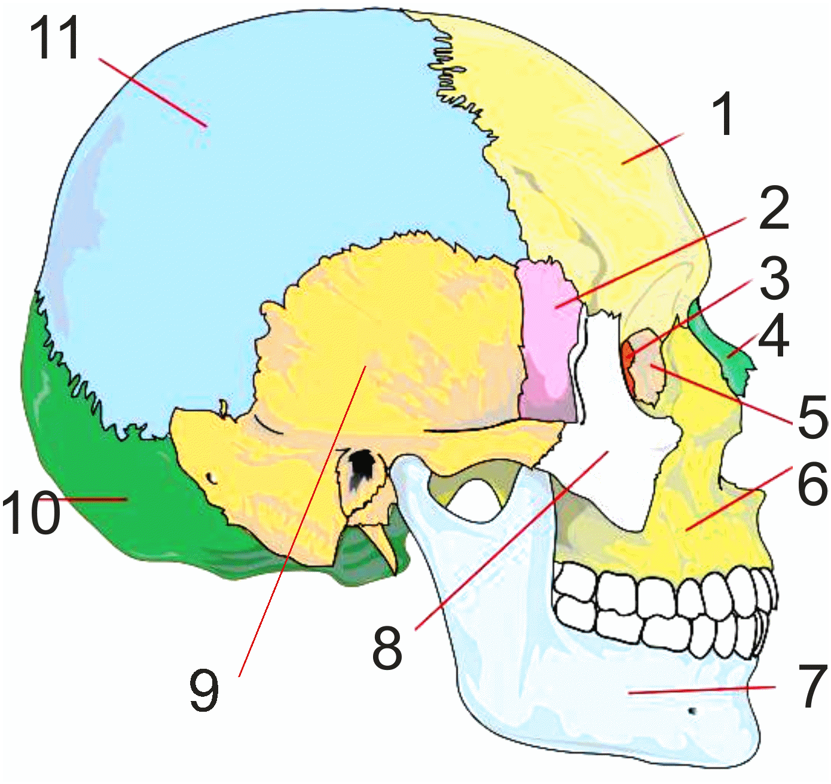
6. Tell the Russian names of following bones:
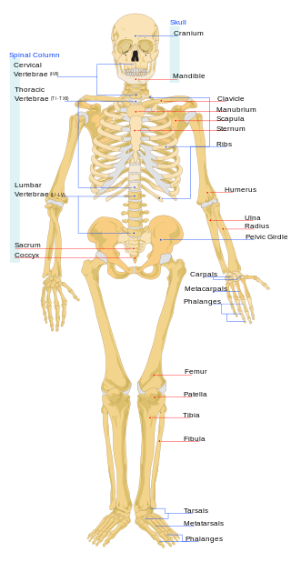
7. Do the crossword for “Skeletal system”.

