ГОСУДАРСТВЕННОЕ АВТОНОМНОЕ ПРОФЕССИОНАЛЬНОЕ ОБРАЗОВАТЕЛЬНОЕ УЧРЕЖДЕНИЕ РЕСПУБЛИКИ БАШКОРТОСТАН
«САЛАВАТСКИЙ МЕДИЦИНСКИЙ КОЛЛЕДЖ»

ЗАДАНИЯ С ВИЗУАЛИЗАЦИЕЙ
по учебной дисциплине Иностранный язык
Специальности 31.02.01 Лечебное дело,
34.02.01 Сестринское дело,
31.02.02 Акушерское дело
Тема «Страноведение»

Преподаватель: Л.В. Янгулова

2017 г.
IN THE ENGLISH WORLD
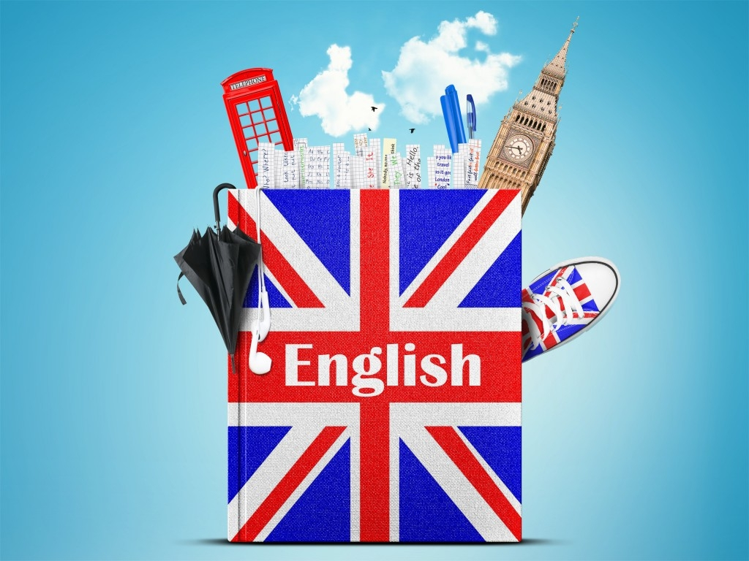

- The name of the queen Elizabeth’s son

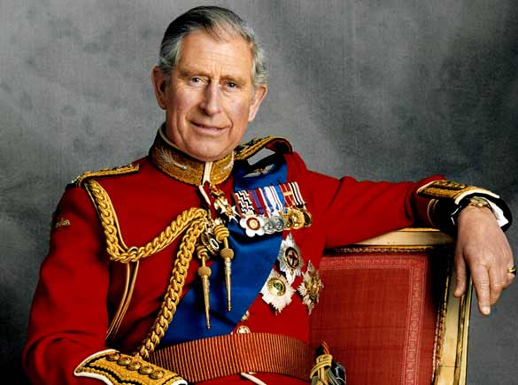
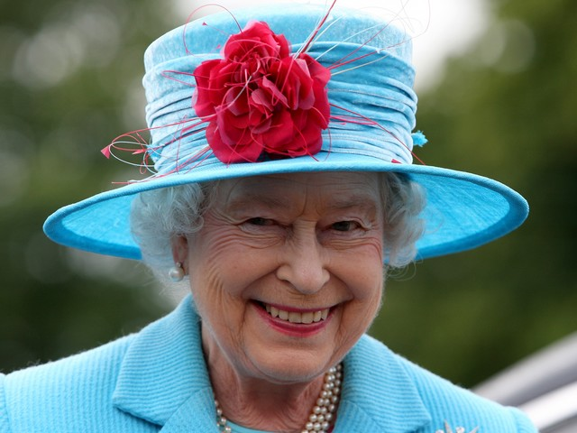
A. Tom B. Charles C. Michael

2. The name of the British flag
A. Striped Thomas B. Golden Bird C. Union Jack
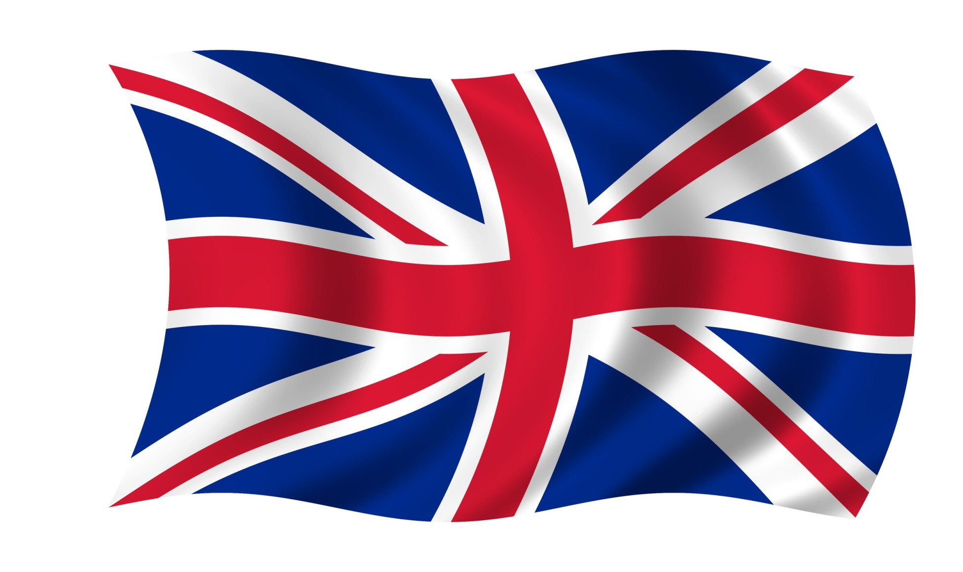

- The game which was found by English nuns (монахини).

A. Polo B. football C. basketball

4. Who discovered America?
A. Columbus B. Ch. Dickens C. Мiklukho-Маclay
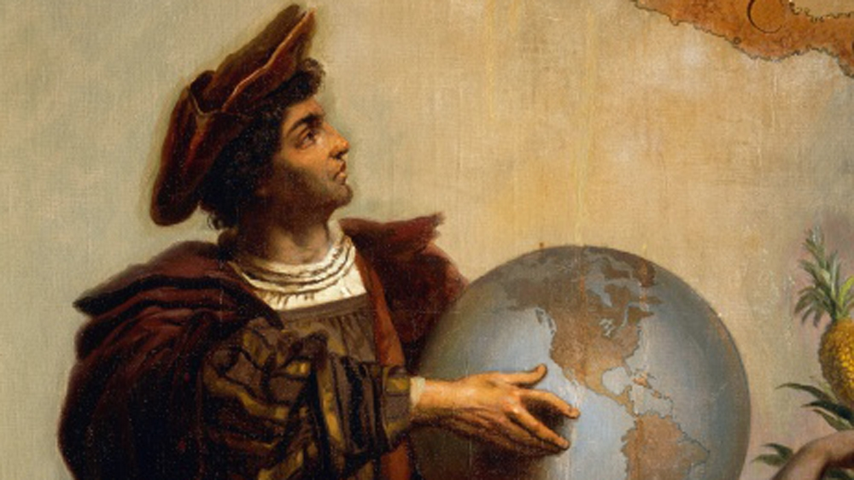

5. The most popular English poet and dramatist.
A. W. Shakespeare B. R. Burns C. Ch. S. Chaplin
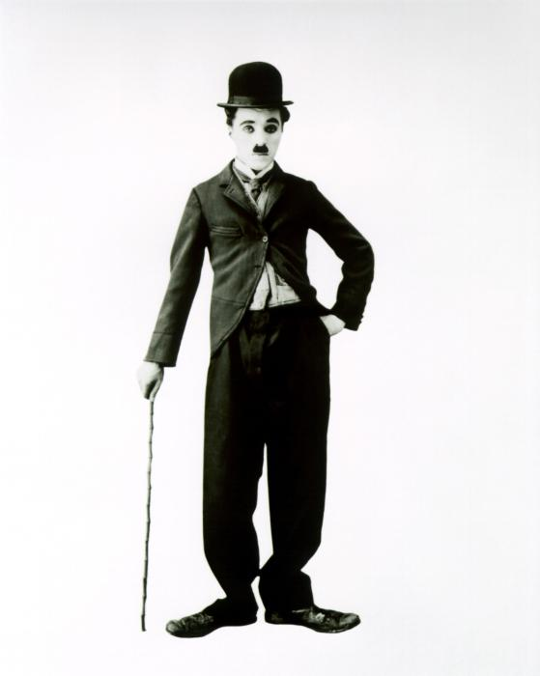
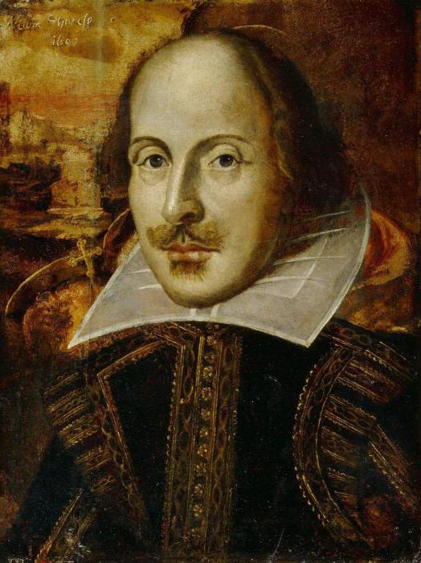
6. The most prestigious price in cinematography of the USA.
A. Oscar B. Teffi C. Nika

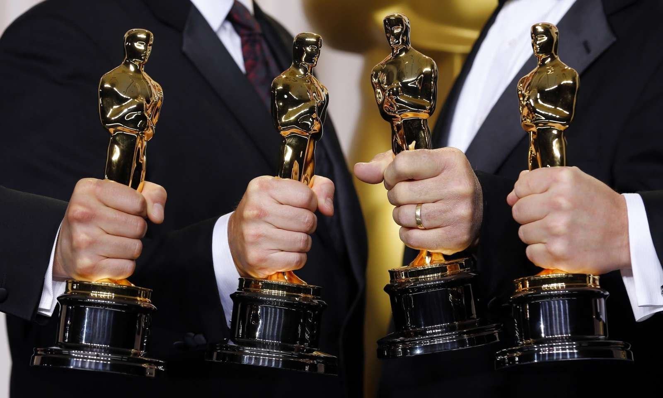

7. One of the most popular way of traveling in America.
A. by plane B. on foot C. hitch-hiking
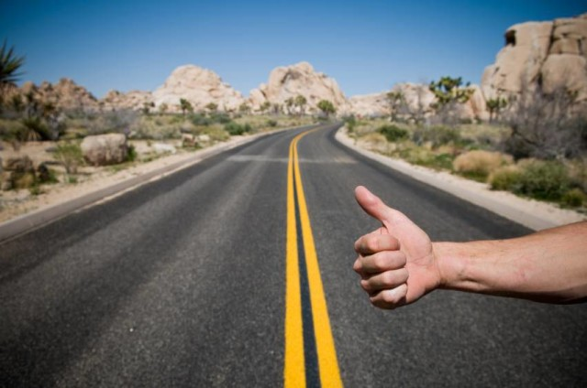

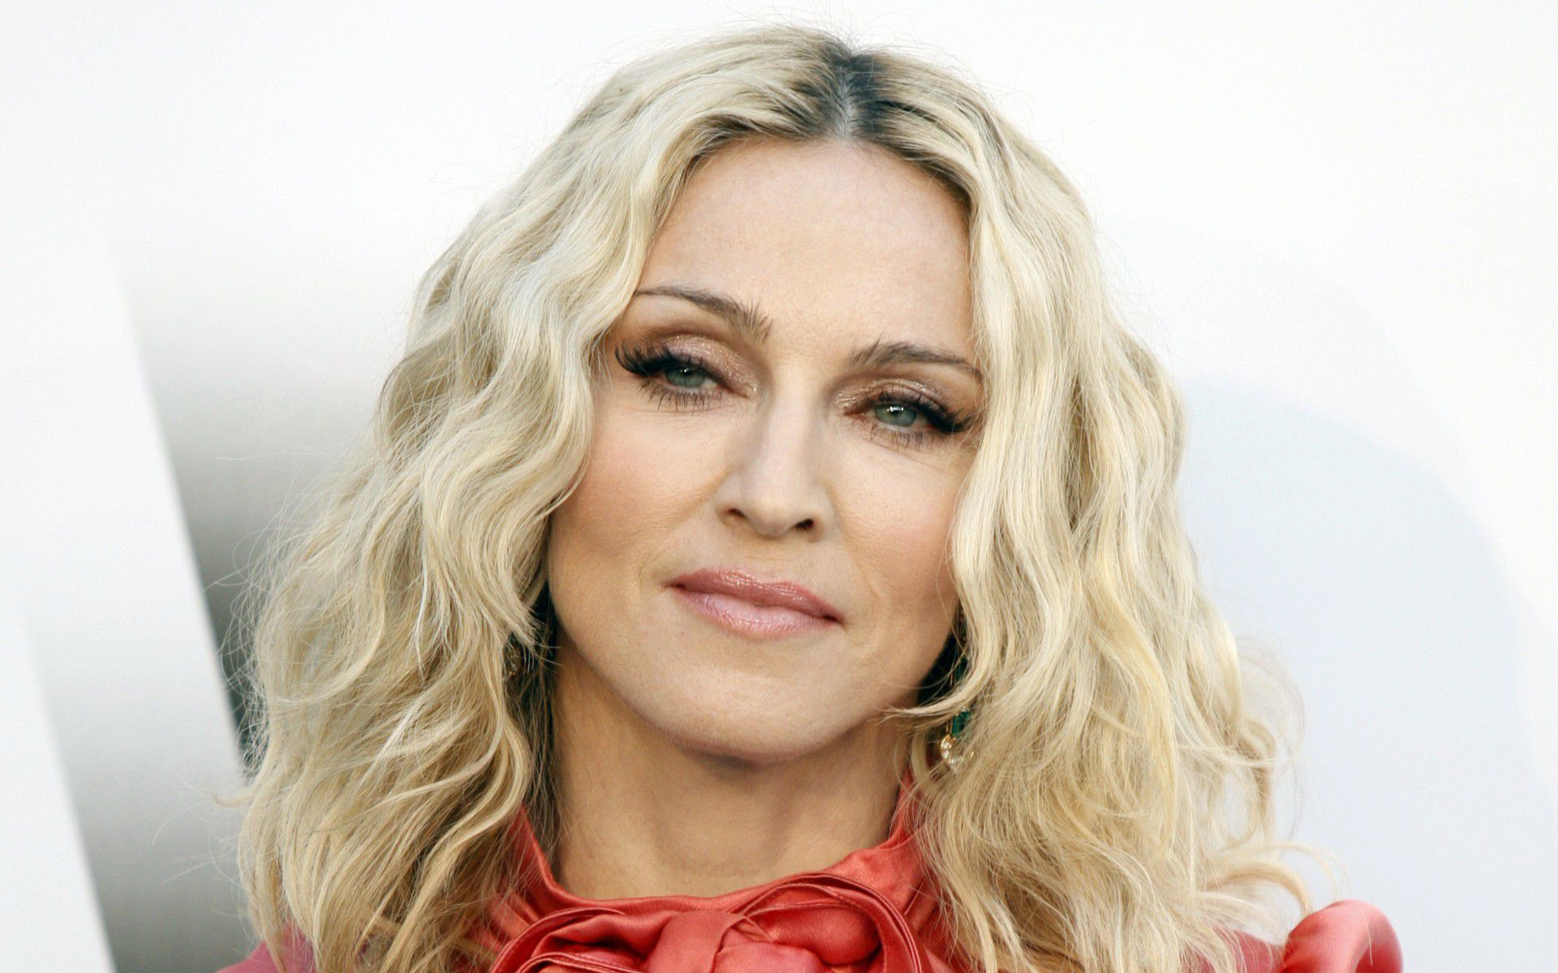
8. Where does singer Madonna live?
A. N. Y. B. London C. Washington

9. When was America discovered?
A. 1497 B. 1066 C. 1272
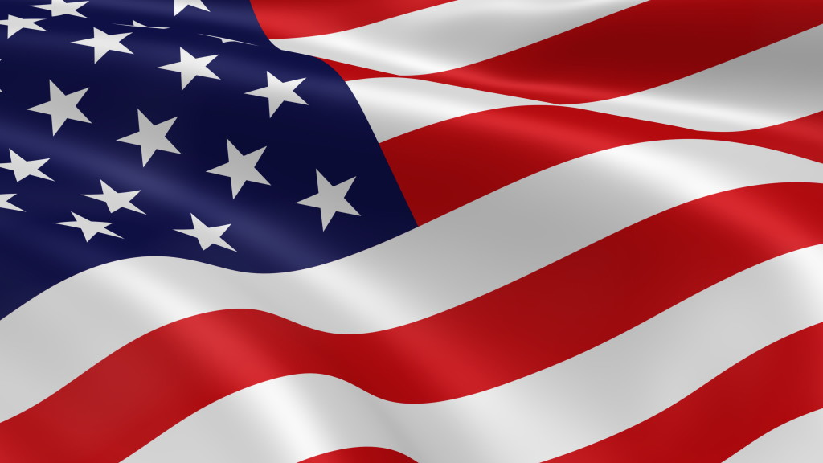

10. When Ch. Columbus discovered America, what ship did he sale? (name)
A. Mayflower B. Donald Trump C. Pocahontas
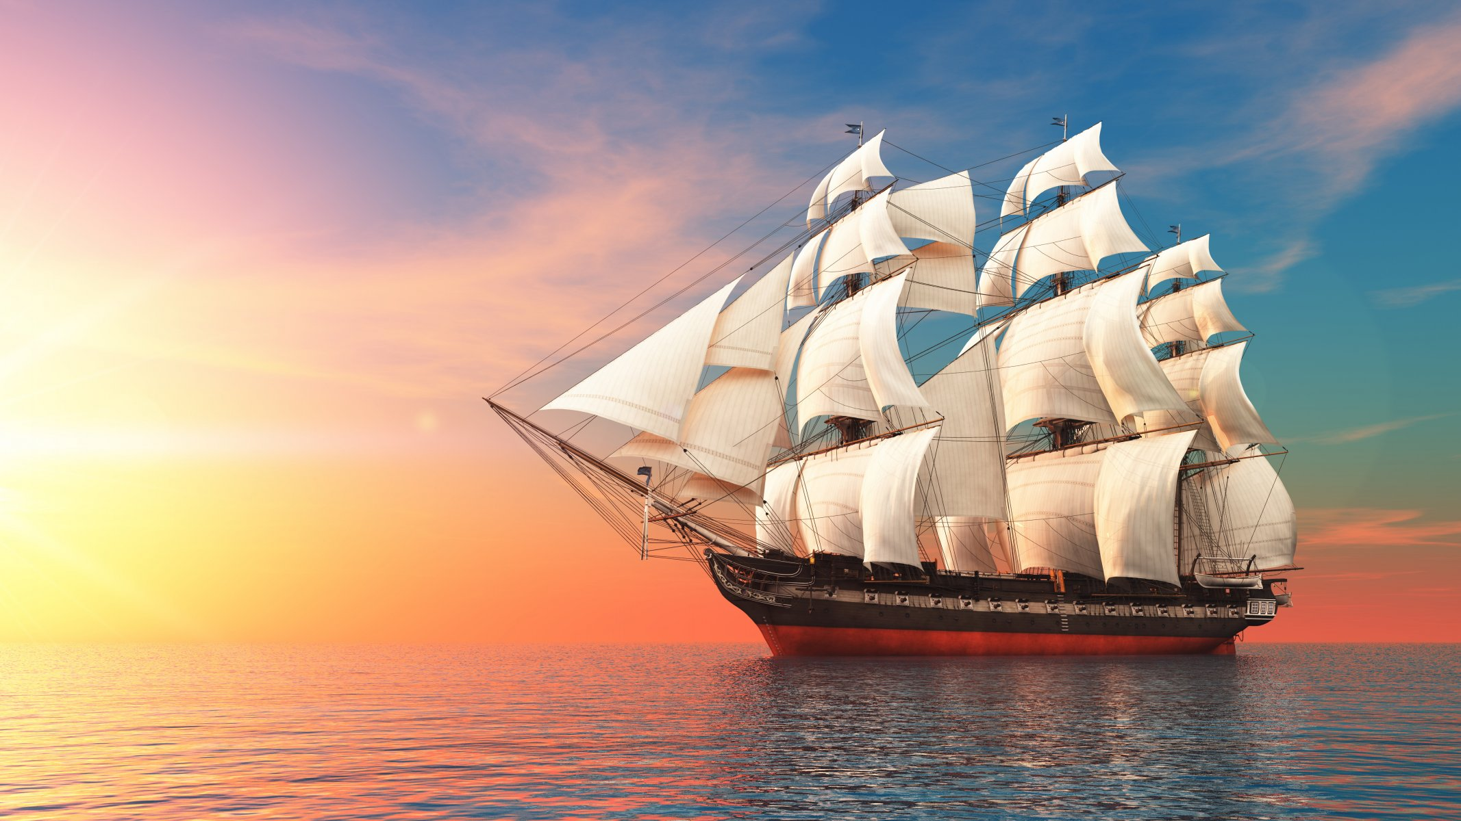

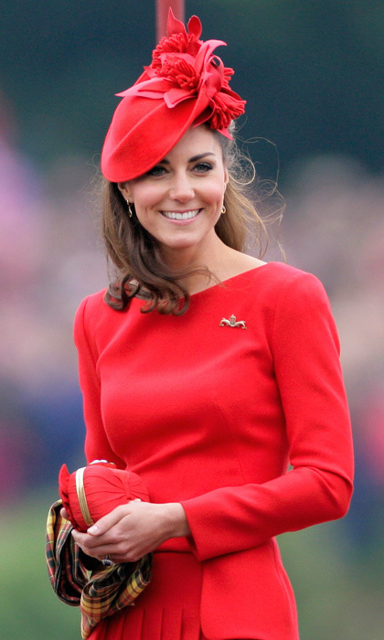
11. Who or what it is?

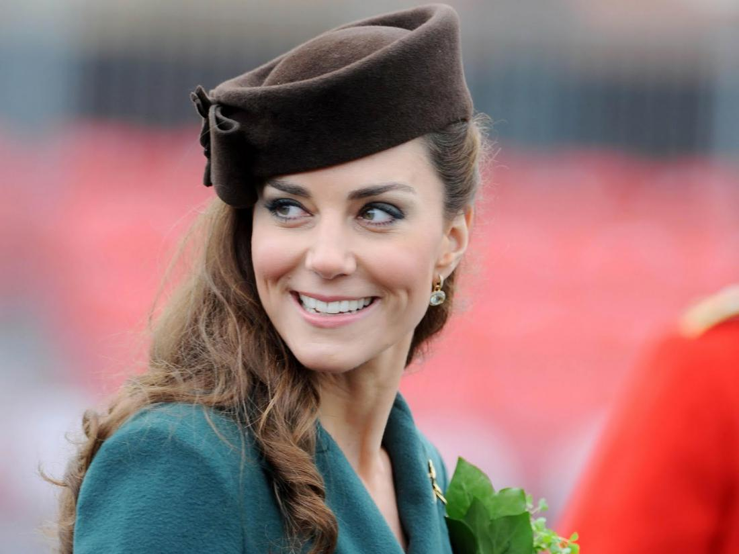

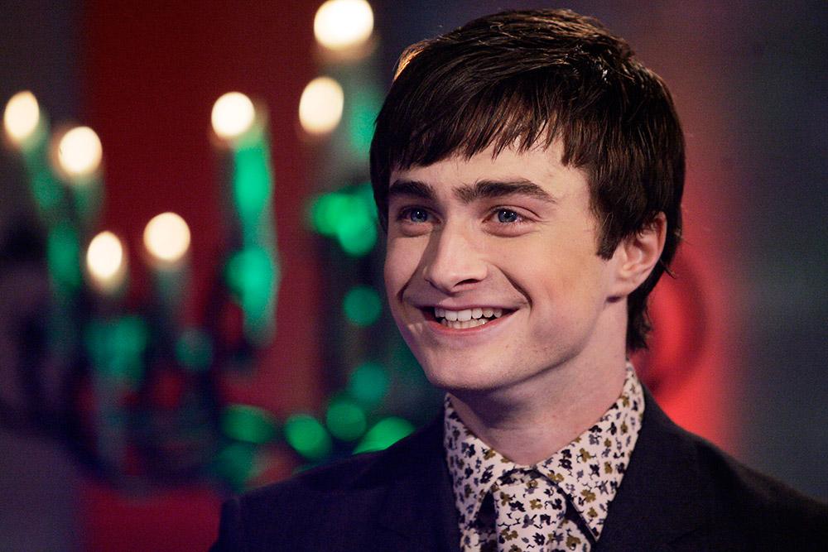
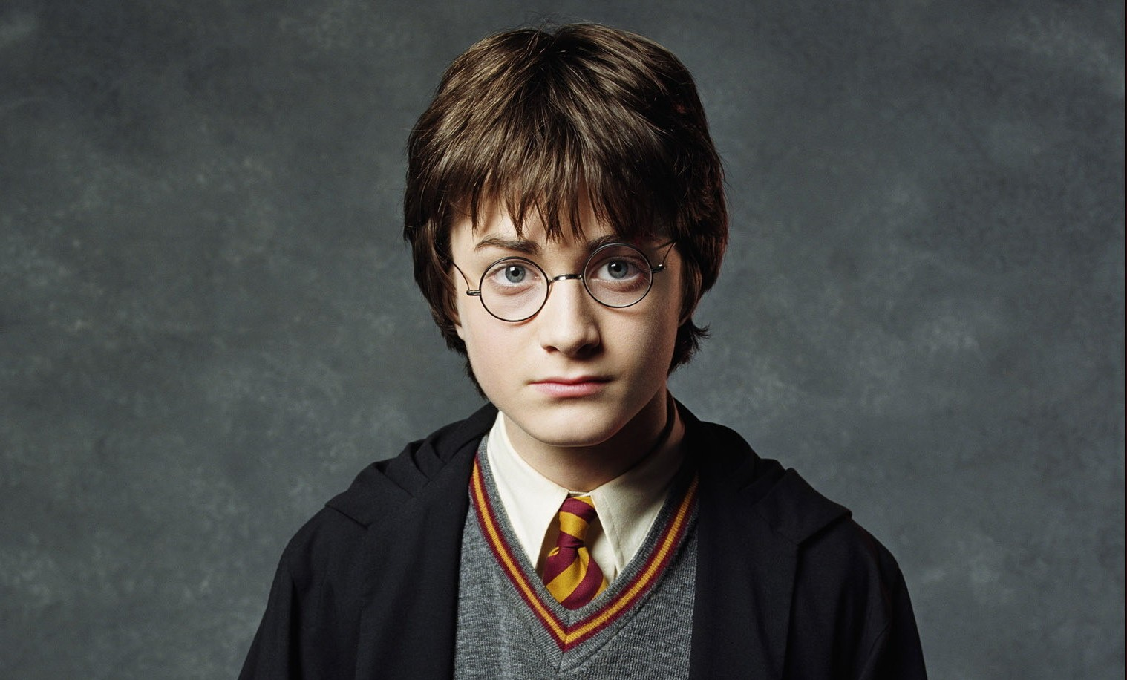

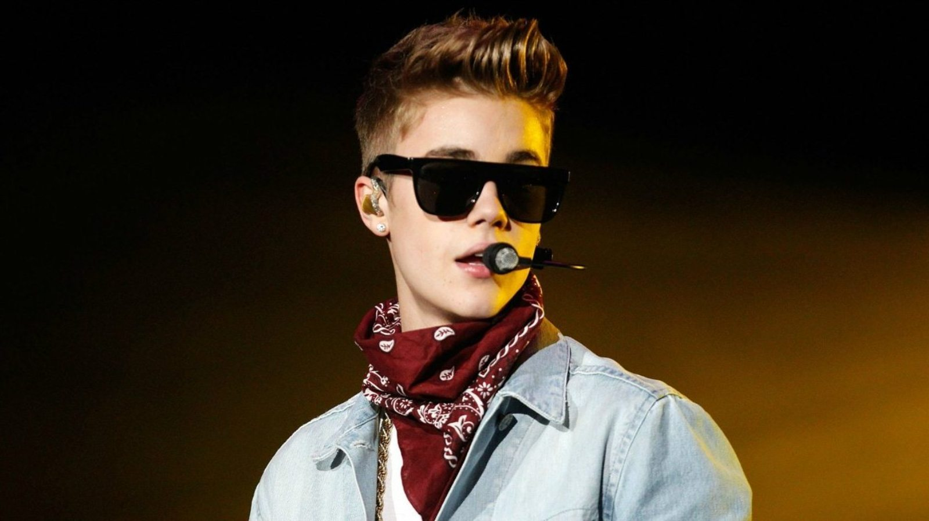

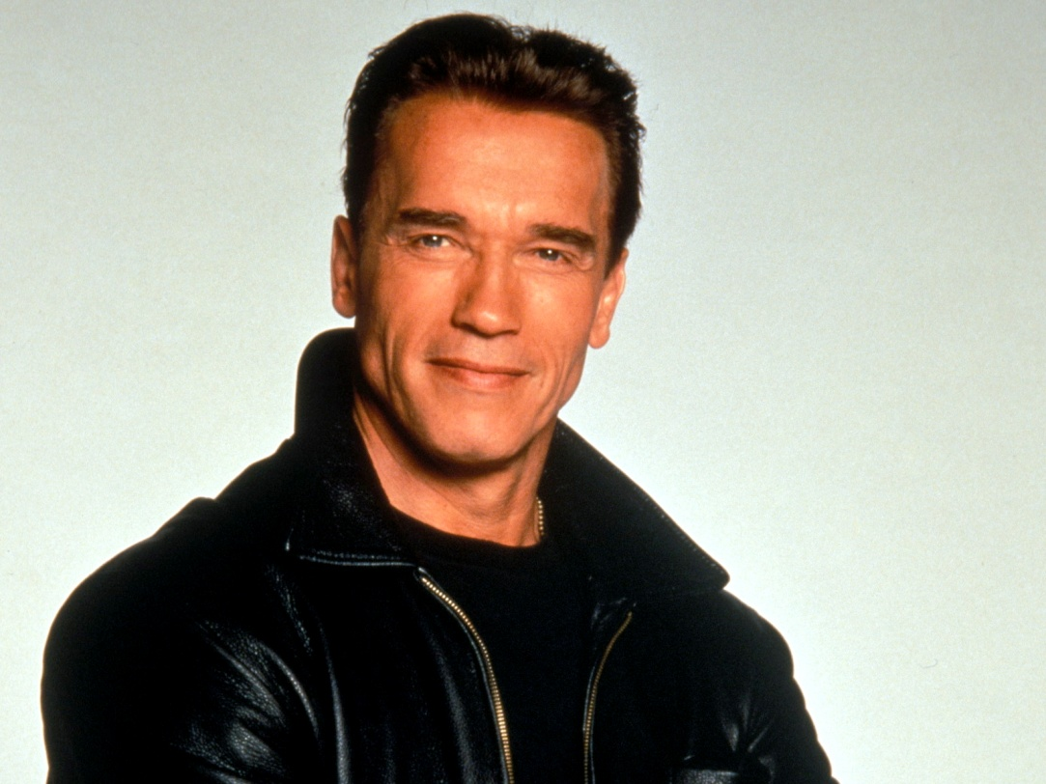

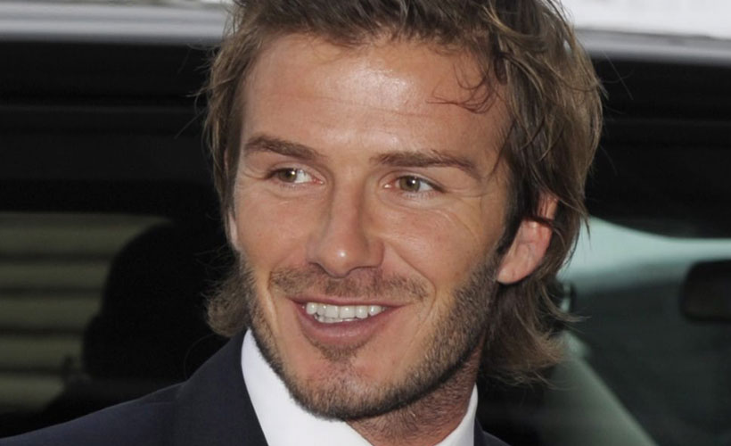

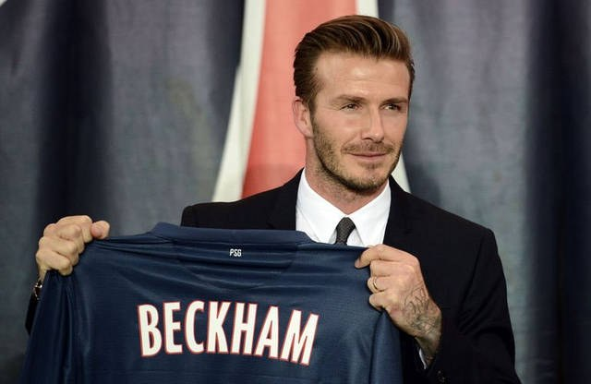

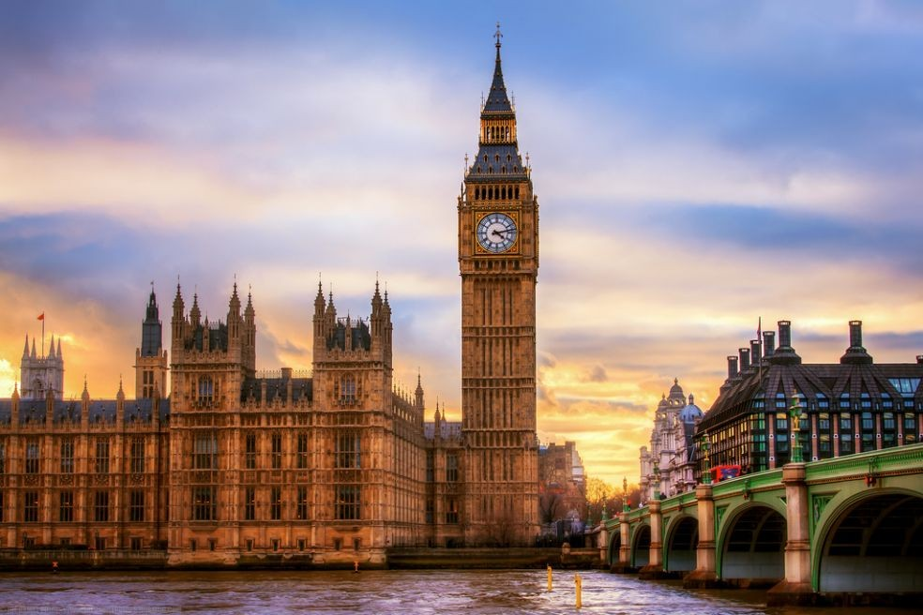

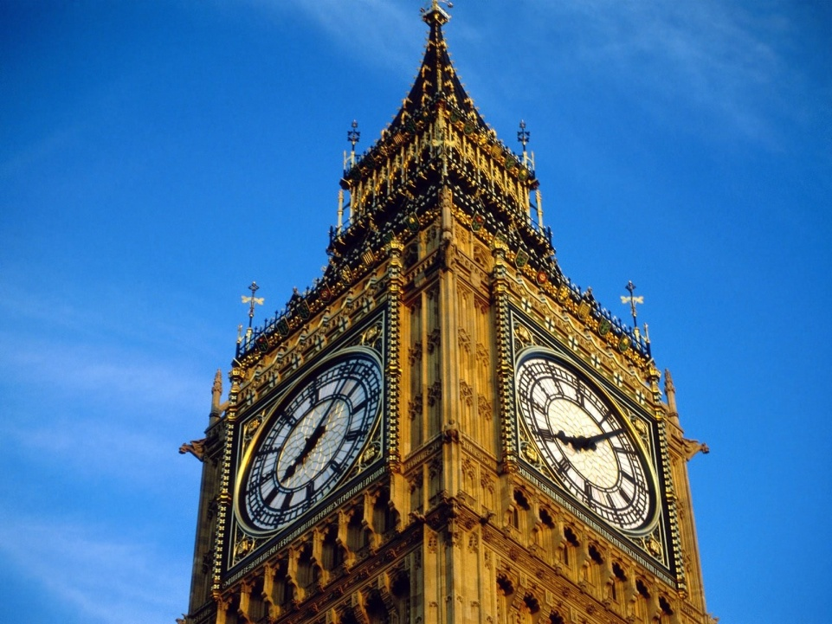

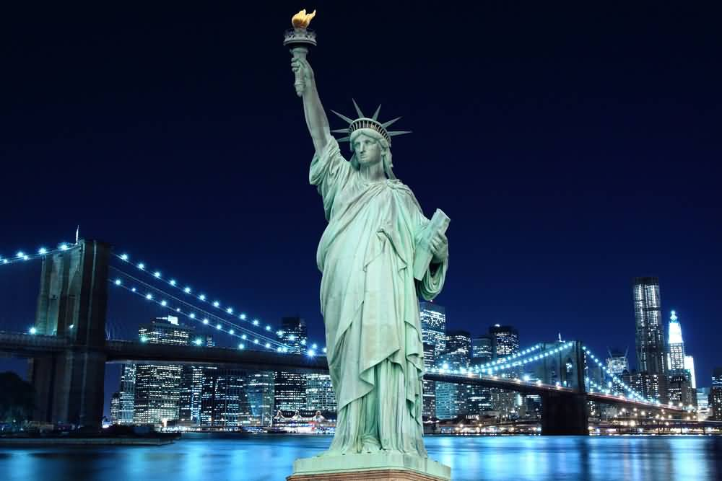

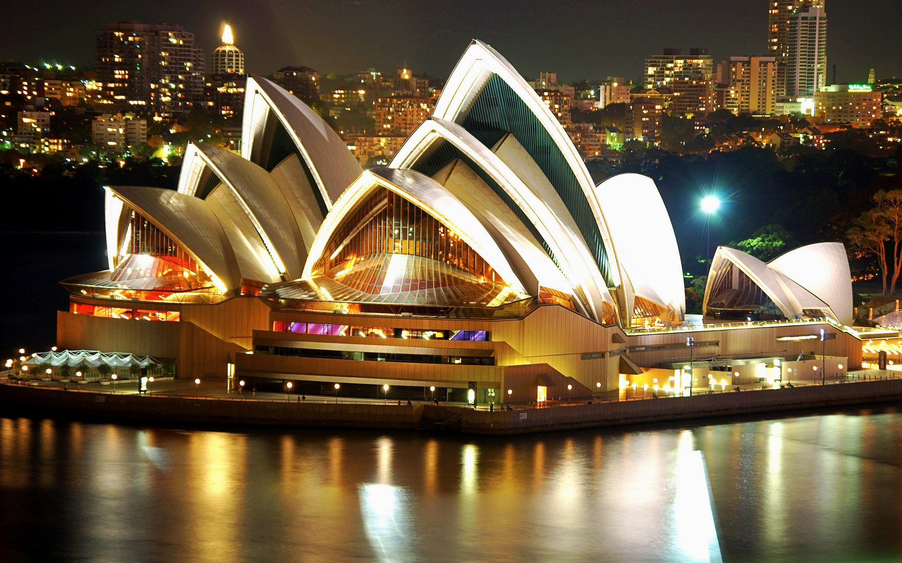

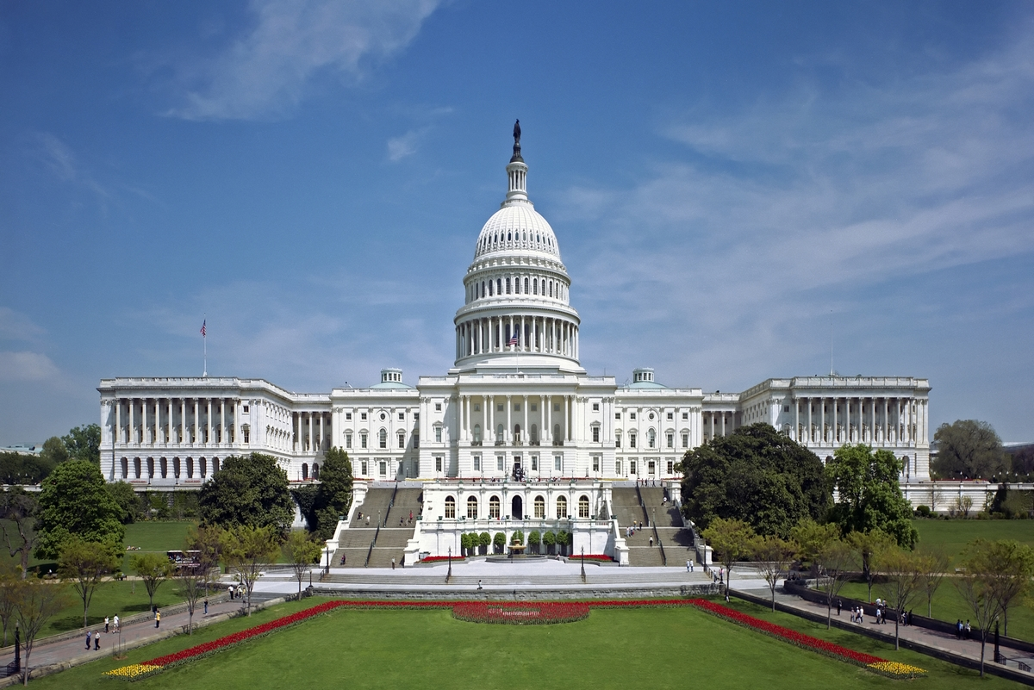

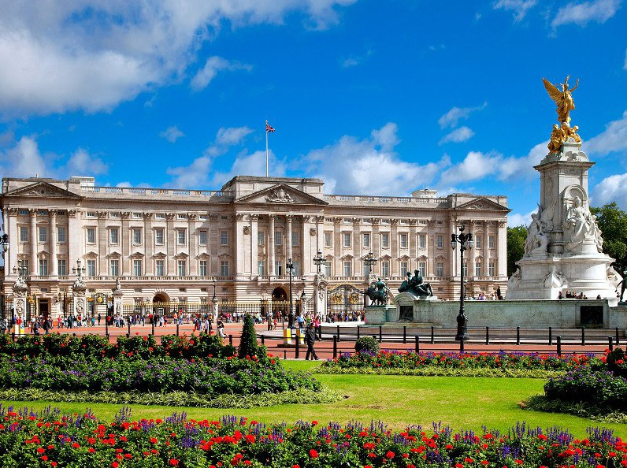

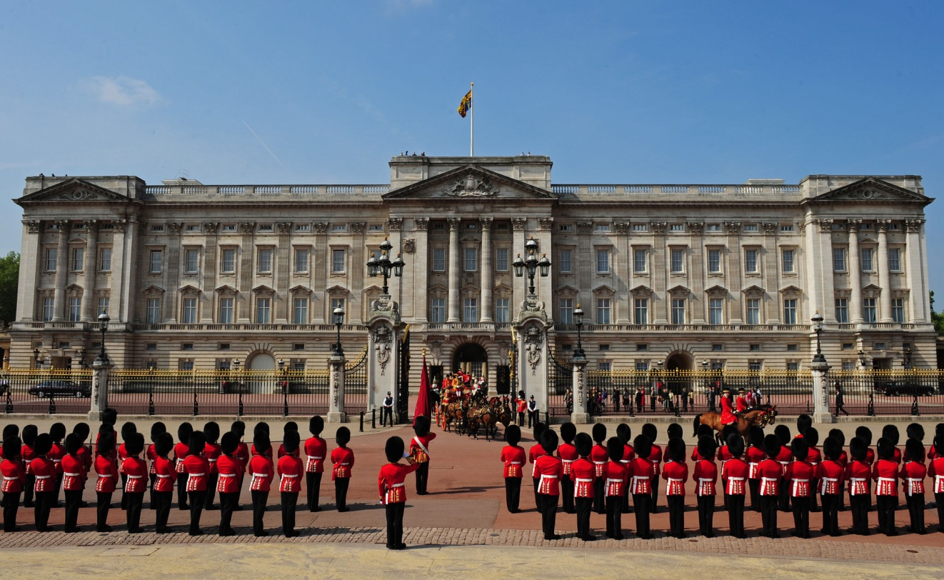

KEYS

1. The name of the queen Elizabeth’s son:
A. Tom B. Charles C. Michael

2. The name of the British flag:
A. Striped Thomas B. Golden Bird C. Union Jack

3. The game which was found by English nuns (монахини).
A. Polo B. football C. basketball

4. Who discovered America?
A. Columbus B. Ch. Dickens C. Миклухо-Маклай

5. The most popular English poet and dramatist.
A. Shakespeare B. Burns C. Chaplin

6. The most prestigious price in cinematography.
A. Oscar B. Teffi C. Nika

7. One of the most popular way of traveling in America.
A. by plane B. on foot C. Hitch-hiking

8. Where does singer Madonna live?
A. N. Y. B. London C. Washington

9.When was America discovered?
A. 1497 B. 2003 C. 1998

10.When Ch. Columbus discovered America, what ship did he sale? (name)
A. Mayflower B. Donald Trump C. Pocahontas

11. Кейт Миддлтон
Дэниэл Рэдклифф
Джастин Бибер
Арнольд Шварценеггер
Дэвид Бэкхэм
Биг Бен
Статуя свободы
Здание Сиднейской оперы (оперный театр в Сиднее)
Вашингтон, здание Капитолия
Букенгемский дворец

