ГОСУДАРСТВЕННОЕ АВТОНОМНОЕ ПРОФЕССИОНАЛЬНОЕ ОБРАЗОВАТЕЛЬНОЕ УЧРЕЖДЕНИЕ РЕСПУБЛИКИ БАШКОРТОСТАН
«САЛАВАТСКИЙ МЕДИЦИНСКИЙ КОЛЛЕДЖ»

ЗАДАНИЯ С ВИЗУАЛИЗАЦИЕЙ
по учебной дисциплине Иностранный язык
Специальности 31.02.01 Лечебное дело,
34.02.01 Сестринское дело,
31.02.02 Акушерское дело
Тема «Welcome to Britain»

Преподаватель: Л.В. Янгулова

2017 г.
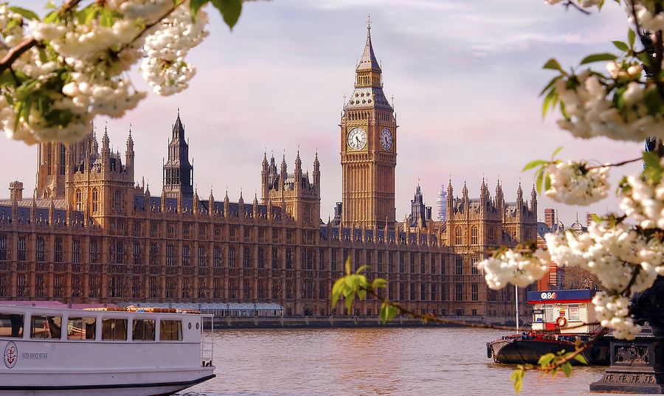
- ______is the great bell of the largest clock of England.

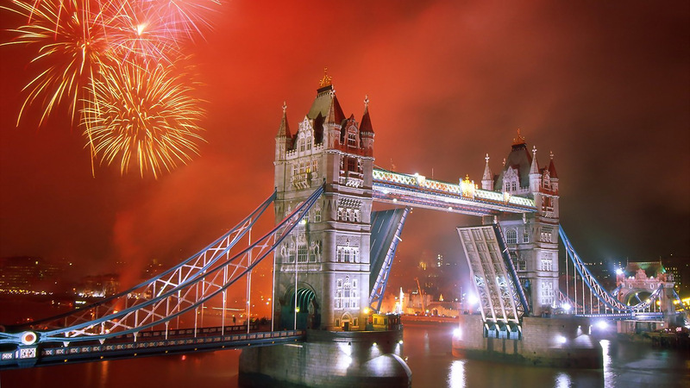
- What’s this?

- Who is this Lady?
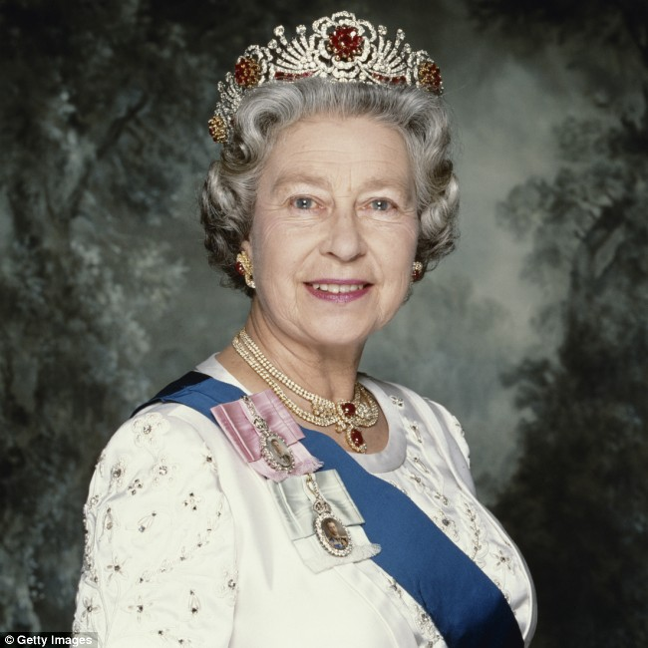

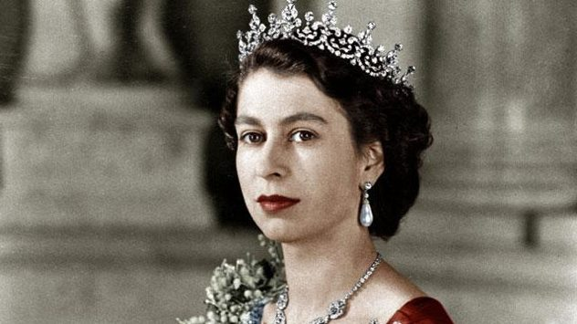

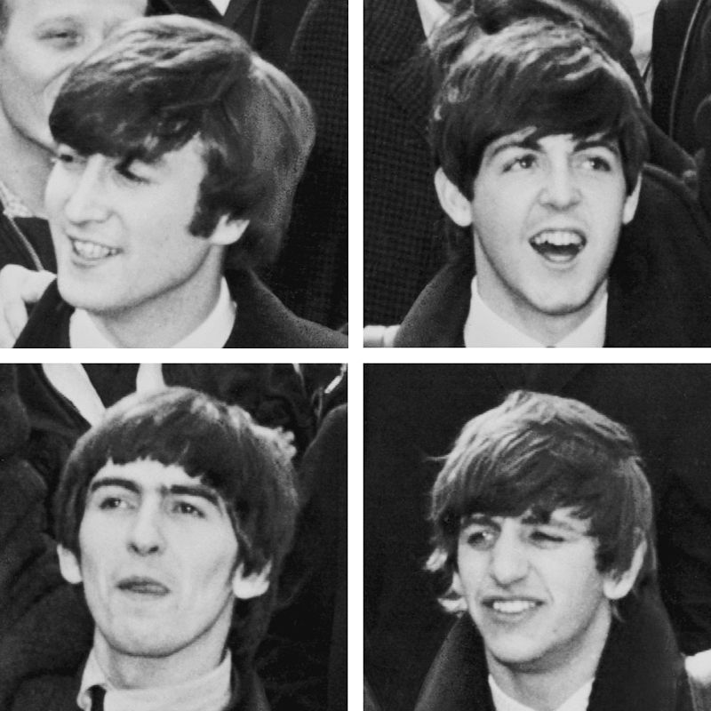
- They are
among
the most
popular
singers
in the
world.
Who are
they?

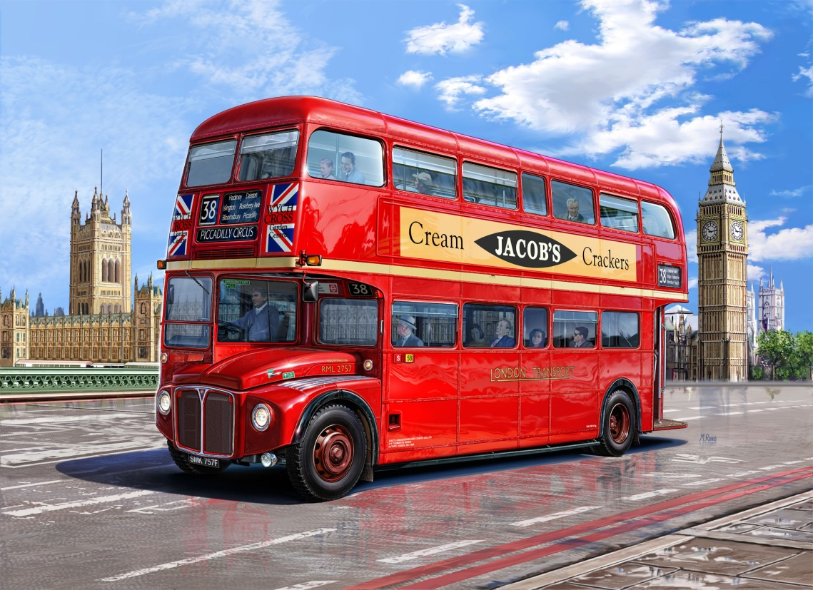
- What is it?

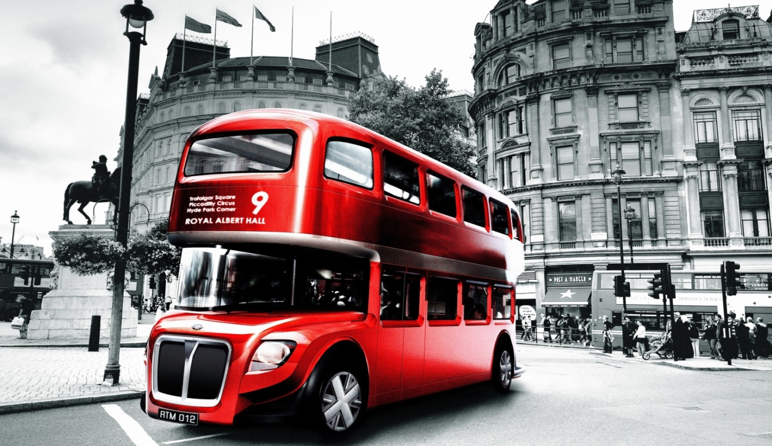

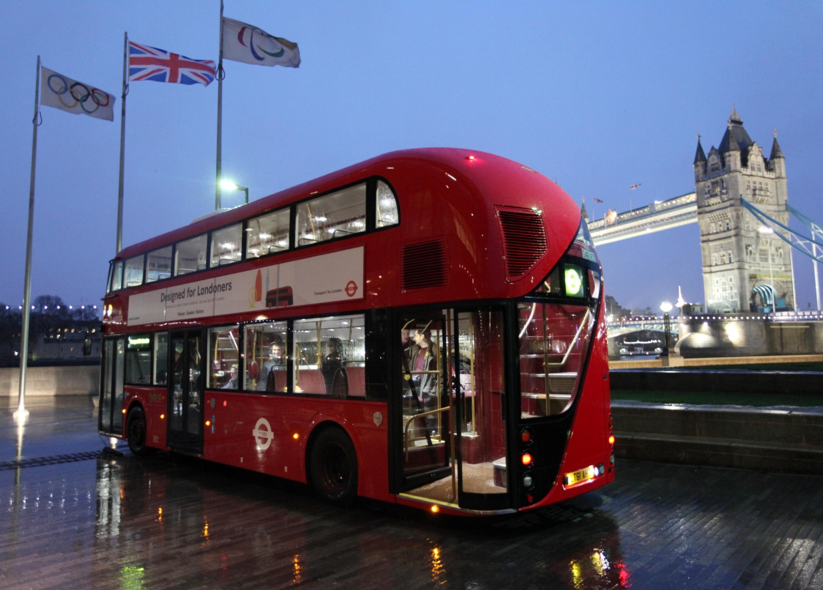

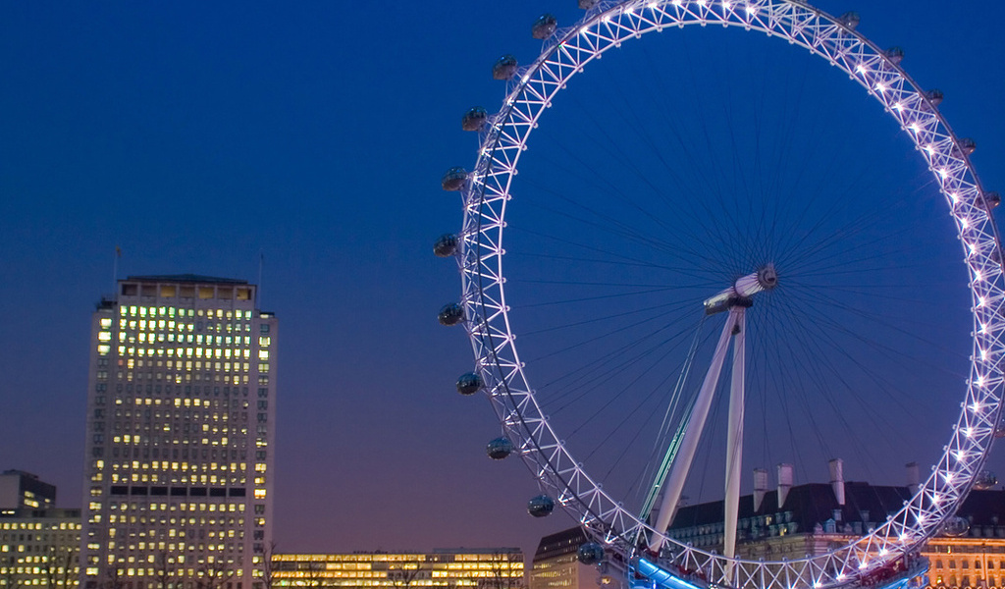
- The_________
is a 135-metre tall wheel on the banks of the River Thames in London.
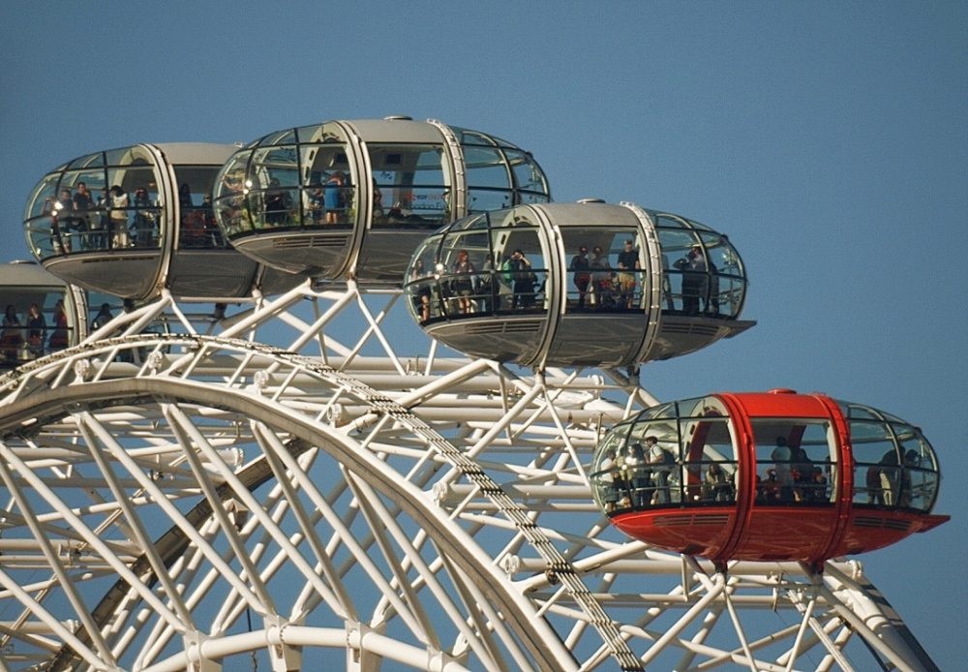

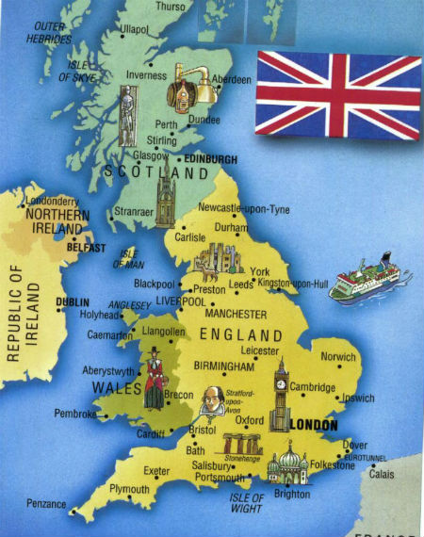

7. What parts does Great Britain consist of?

- What colours is the flag of the United Kingdom?
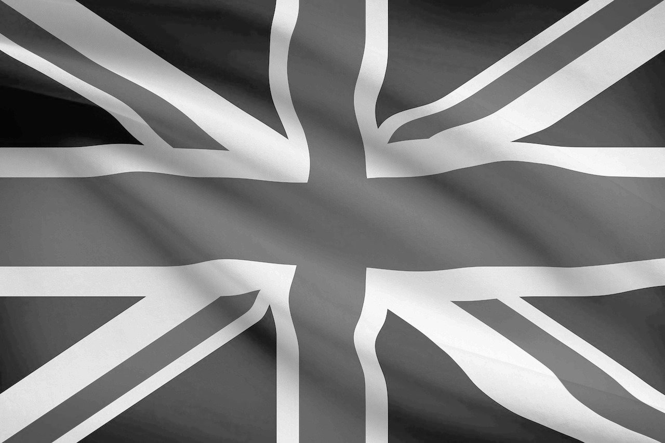

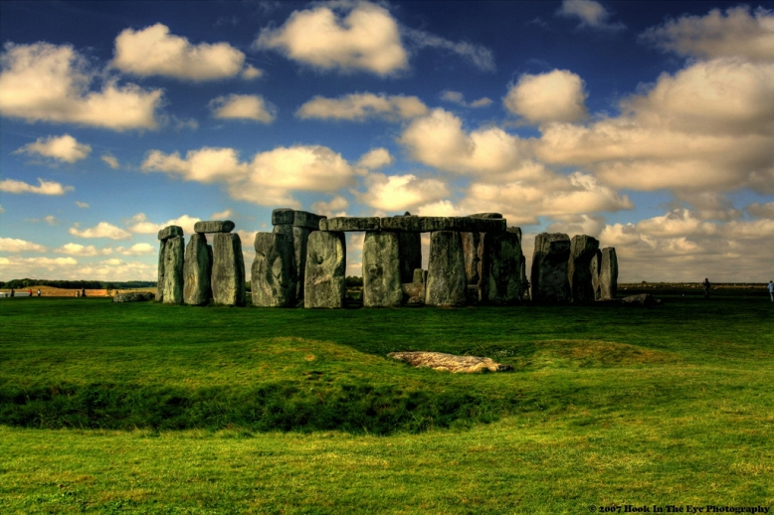
- What is it? Where is it situated?
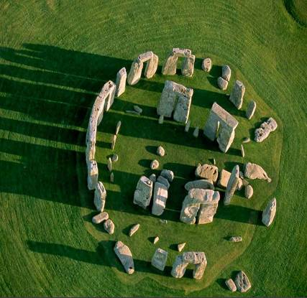

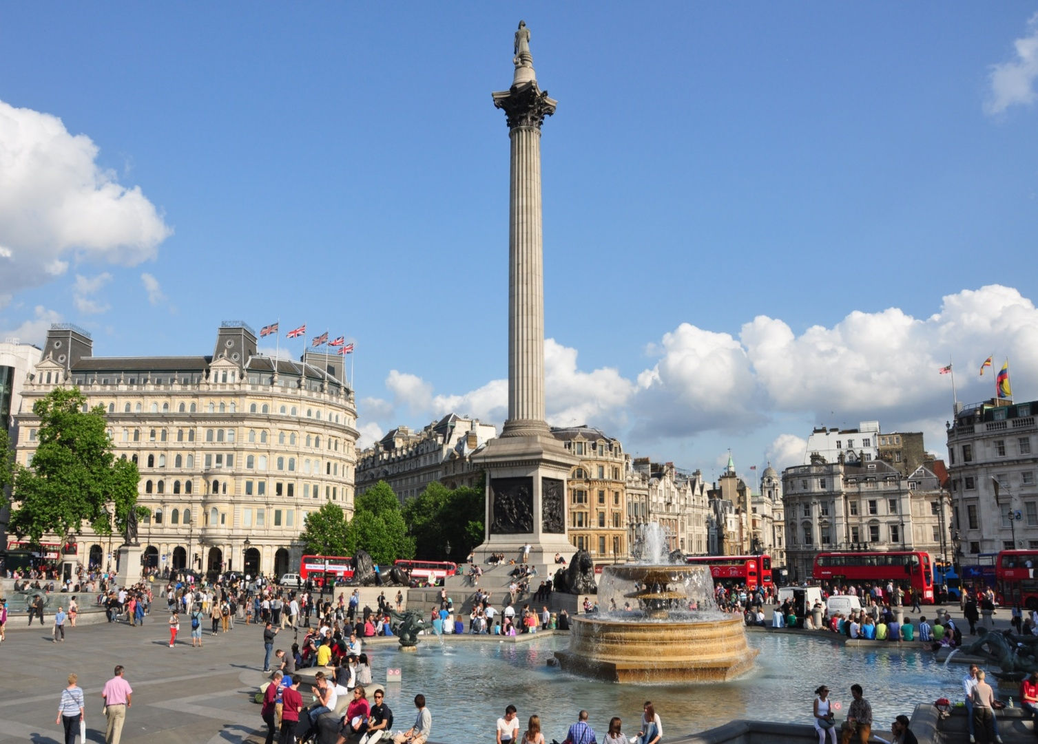
- What is the name of the column? of the square?

KEYS

- …is the great bell of the largest clock of England. (Big Ben)
- What’s this? (Tower Bridge)
- Who is this Lady? (The Queen Elizabeth II)
- They are among the most popular singers in the world. Who are they? (The Beatles)
- What is it? (London (English) bus - The Double-Dekker)
- The_________ is a 135-metre tall wheel on the banks of the River Thames in London. (London Eye)
- What parts does Great Britain consist of? ( England, Scotland, Wales and Northern Ireland)
- What colours is the flag of the United Kingdom? (red, blue and white)
- What is it? Where is it situated? (Stonehenge. England )
- What is the name of the column? of the square? (Nelson column, Trafalgar square).

