Государственное бюджетное профессиональное образовательное учреждение
«Курганский базовый медицинский колледж»

HUMAN ANATOMY

учебно-методическое пособие для студентов
2 курса специальностей
31.02.02 Акушерское дело
34.02.01 Сестринское дело
31.02.03 Лабораторная диагностика

Курган 2019

РАССМОТРЕНО  на заседании ЦМК ОГСЭ и ЕН  протокол №___  от « ___» _______2019 г.  председатель ________ И.Г. Пальчуковская | УТВЕРЖДАЮ  Зам. директора по ИМР  __________ Н.Е.Горшкова  «___» _________2019 г.

HUMAN ANATOMY: учебно-методическое пособие для студентов 2 курса специальностей 31.02.02 Акушерское дело, 34.02.01 Сестринское дело, 31.02.03 Лабораторная диагностика / авт.-сост.: В. В. Корепанова. – Курган, 2019. – 62 с.

Автор - составитель:

В.В. Корепанова, преподаватель иностранного языка высшей квалификационной категории ГБПОУ «Курганский базовый медицинский колледж»

Рецензенты:
Л.В. Иванова, преподаватель иностранного языка высшей квалификационной категории ГБПОУ «Курганский базовый медицинский колледж»
А.И. Бомштейн, преподаватель иностранного языка первой квалификационной категории ГБПОУ «Курганский базовый медицинский колледж»

Утверждено Методическим советом ГБПОУ «Курганский базовый медицинский колледж» протокол №___ от _________ г.

Данное учебно-методическое пособие разработано для студентов второго курса специальностей 31.02.02 Акушерское дело, 34.02.01 Сестринское дело, 31.02.03 Лабораторная диагностика, составлено в соответствии с рабочей программой «Иностранный язык» (английский) и соответствуют требованиям ФГОС. Пособие помогает расширить словарный запас, развивать речевые навыки и умения в основных видах речевой деятельности в пределах изучаемой тематики и на лексико-грамматическом материале типичном для медицинской литературы; формировать у студентов умения использовать английский язык как средство профессионального общения, получения информации и самообразования.

© Корепанова В.В., 2019
© ГБПОУ «Курганский базовый медицинский колледж», 2019
Содержание

Введение | 5
We study Anatomy | 7
The Human Skeleton | 11
Muscles | 17
Skin and its functions | 22
Blood Components | 26
Organ Systems | 29
The Cardiovascular System | 31
Heart diseases | 35
The Respiratory System | 40
The Digestive System | 44
Texts for additional reading | 49
Список используемых источников | 61

Введение

Учебно-методическое пособие «Human anatomy» предназначено для студентов очной формы обучения второго курса четвертого семестра, специальностей 31.02.02 Акушерское дело, 31.02.03 Лабораторная диагностика, 34.02.01 Сестринское дело и составлено в соответствии с рабочей программой учебной дисциплины «Иностранный язык» (английский) для организации работы практических занятий (36 часов) и самостоятельной подготовки (12 часов).
Основной целью учебного пособия является формирование иноязычной коммуникативной компетенции специалиста-медика, позволяющей использовать иностранный язык как средство профессионального и межличностного общения.
Структура и содержание пособия ориентированы на взаимосвязанное решение коммуникативных, познавательных, развивающих и воспитательных задач и формирование у студентов-медиков профессиональной иноязычной коммуникативной компетенции.
Учебно-методическое пособие включает следующие темы:
We study Anatomy
The Human Skeleton
Muscles
Skin and its functions
Blood Components
Organ Systems
The Cardiovascular System
Heart diseases
The Respiratory System
The Digestive System
Каждая тема содержит активный словарь; текст, который включает основную смысловую информацию и предназначен для развития навыков устной речи; комплекс пред- и послетекстовых упражнений, направленных на развитие навыков разговорной речи.
Раздел «Texts for additional reading» включает материалы для дополнительного чтения.
Настоящее учебно-методическое пособие предназначено для обучения английскому языку студентов медицинских колледжей, как под руководством преподавателя, так и для самостоятельной работы.
В ходе изучения раздела должны быть сформированы следующие компетенции:
ОК 4. Осуществлять поиск и использование информации, необходимой для эффективного выполнения профессиональных задач, профессионального и личностного развития.
ОК 6. Работать в коллективе и команде, эффективно общаться с коллегами, руководством, потребителями.
ОК 8. Самостоятельно определять задачи профессионального и личностного развития, заниматься самообразованием, осознанно планировать и осуществлять повышение квалификации.
ПК 1.1. Проводить мероприятия по сохранению и укреплению здоровья населения, пациента и его окружения.

We study Anatomy

1. Translate the words and learn them by heart:

Head  Hair  Face  Ears  Eyes  Eyelashes  Eyebrows  Forehead  Nose  Mouth  Lips  Tongue  Tooth-teeth  Chin  Cheeks  Neck | Trunk  Arm  Shoulder  Elbow  Forearm  Wrist  Hand  Finger  Leg  Hip  Thigh  Knee  Shin  Ankle  Calf  Foot-feet  Toe

2. Complete the sentences:
1. I can eat with my ….
2. I can smell with my….
3. I can hear with my ….
4. I can run with my ….
5. I can hug with my ….
6. I can speak with my ….
7. I have one …, …, …, …, …, ….
8. I have two …, …, …, …, ….
9. I have ten …, ….
10. I have thirty-two ….

3. Read and translate the text:

We study Anatomy
The study of anatomy is important for all health professionals to understand how the human body is structured.
The principle parts of the human body are the head, the trunk and the limbs (extremities). We speak of the upper extremities (arms) and the lower extremities (legs). The head consists of two parts: the skull which contains the brain, and the face which consists of the forehead, the eyes, the nose, the mouth, the cheeks, the ears and the chin. In the mouth there are gums with teeth, the tongue and the palate.
The head is connected with the trunk by the neck. The upper part of the trunk is the chest (thoracic cavity) and the lower one is the abdomen. The principle organs in the chest are the lungs, the heart and the esophagus. We breathe with the lungs. The heart contracts and makes 60-80 beats per minute. The esophagus passes food and liquids to the stomach.
The principle organs in the abdominal cavity are the stomach, the liver, the spleen, the intestine, the kidneys, the gall-bladder, the pancreas and the urinary bladder.
The skeletal system supports and protects the soft tissues of the body and helps the body to move. It consists of bones, which are bound together by ligaments and cartilages. The skeletal system attaches to muscles. The bones also help in blood formation.
The bones are covered with muscles. The muscular system works with the skeletal system in helping the body to move.
The upper extremity is connected with the chest by the shoulder. Each arm consists of the shoulder, forearm, elbow, wrist and hand. We have five fingers on each hand. The lower extremity (the leg) consists of the hip, the thigh, the knee, the calf, the ankle, the foot and five toes.

4. Translate from Russian into English:
- защищает мягкие ткани;
- верхняя часть туловища;
- верхние конечности – руки;
- нижние конечности – ноги;
- легкие, сердце, пищевод – основные органы в грудной клетки;
- печень, селезенка, желудок, почки, желчный пузырь, поджелудочная железа, кишечник, мочевой пузырь – основные органы в брюшной полости;
- голова состоит из двух частей – черепа, лица;
- головной мозг;
- лицо состоит изо лба, глаз, щек, ушей, носа, рта, подбородка;
- десны, зубы, язык, нёбо находятся во рту;
- сердце совершает 60-80 уд;
- помогает телу двигаться;
-помогает в формировании крови
- передает пищу и жидкости.

5. Use English equivalents
1. A man has four (конечности).
2. (Глаза) are under the (лоб).
3. (Язык) is the organ for speech.
4. The heart is in the (грудная клетка).
5. We breathe with the (легкие).
6. The skull contains (головной мозг).
7. (Шея) connects the head with the (туловище).
8. The spleen is in the (брюшная полость).
9. (Плечо) connects the upper extremity with the chest.
10. The leg consists of the hip, thigh, knee, (голень), ankle and the foot.

6. Answer the questions:
1. What is studied at anatomy classes?
2. What are the principal parts of the human body?
3. What is the organ of thinking called?
4. What is there in the mouth?
5. What is the head connected with the trunk by?
6. How many beats per minute does the heart make?
7. Which organs are located in the abdominal cavity?
8. What is the function of the skeleton?
9. What does the arm consist of?
10. What does the lower extremity consist of?

The Human Skeleton

Figure 1.The human skeleton

Figure 2. Anatomy of long bones
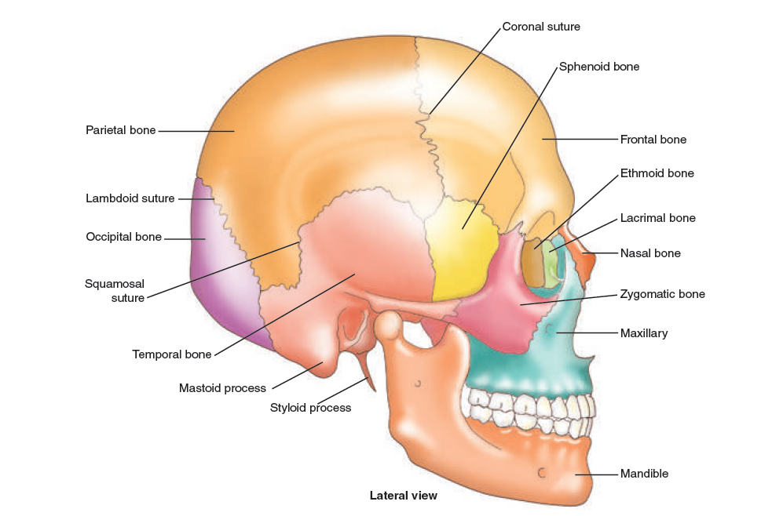
Figure 3. The skull

1. Learn the words:
Framework – основа
To sustain – удерживать
Backbone (spine, ) – позвоночник
To serve – служить
To support – поддерживать
Vertebra(e) – позвонок (и)
Hole – отверстие
To correspond – совпадать
Pipe – труба
To contain – содержать
Marrow - костный мозг
Fibro-cartilage – волокнисто хрящевой
To lend – придавать
Flexibility – гибкость
Vertebral column – позвоночный столб
Rib – ребро
To protect – защищать
Triangular – треугольный
Shoulder-blade (scapula) – лопатка
Collar-bone (clavicle) – ключица
Breastbone (sternum) – грудина
Shoulder girdle – пояс верхних конечностей
Humerus – плечевая кость
Radius – лучевая кость
Ulna – локтевая кость
Carpal – пястный
Metacarpal – запястный
Pelvic girdle – пояс нижних конечностей
Femur – бедренная кость
Patella – коленная чашечка
Tibia – большая берцовая кость
Fibula – малая берцовая кость
Tarsal – предплюсна
Metatarsal – плюсна
Skull (cranium) - череп
Frontal – лобный
Occipital – затылочный
Temporal – височный
Parietal – теменной
Sphenoid – клиновидный
Ethmoid – решётчатый

2. Read and translate the text

The structure of the Human Skeleton
The skeleton consists of bones and constitutes the framework, which sustains the softer parts of the human organism. The backbone or the spine serves as the support to the body. It consists of thirty-three or thirty-four vertebrae. There are seven cervical, twelve thoracic, five lumbar, five sacral and three or four coccygeal vertebrae. There is a hole in every vertebra. These holes correspond with each other through all the vertebrae forming a long bony pipe, or canal, which contains the marrow. A fibro-cartilage substance forms the intervertebral discs between the vertebrae uniting them and lending a certain degree of flexibility to the vertebral column.
The chest is composed of the thoracic cage, which includes 12 pairs of ribs connected to the thoracic vertebrae and the sternum. The first seven pairs are true ribs, the last five pairs are false ribs. The thoracic cage protects the heart, lungs and other internal organs.
On the upper part of the back there are two triangular bones, the shoulder-blades or scapulae. Each shoulder-blade is connected with the clavicle or collarbone, which is jointed at the other end to the breastbone or sternum. The shoulder-blades and the clavicles form the shoulder girdle, to which the upper limbs are attached. The arm has the humerus, the radius, the ulna. The hand is the part of the upper limb that consists of the wrist, palm, and fingers. They include carpal bones, metacarpal bones and phalanges (finger bones).
The pelvic girdle attaches the lower limbs to the skeleton. The leg consists of a femur (the longest bone in the body), a patella, a tibia, a fibula, tarsals, metatarsals and phalanges.
The skull, or the cranium, is a bony case that forms the framework of the head and encloses the brain. It consists of eight bones, namely, the frontal and occipital bones, the two temporal and parietal bones; the sphenoid bone of the base of the skull; and the ethmoid bone at the top of the root of the nose.

3. Complete the sentences:
1. The skeleton consists of bones and constitutes (основу) which sustains the (мягкие части) of the human body.
2. (Позвоночник) serves as support to the body.
3. There are seven (шейных) vertebrae, twelve (грудных позвонков), five (поясничных позвонков).
4. There is (отверстие) in every vertebra.
5. On the upper part of the back there are two flat (треугольные кости), the shoulder blade or (лопатки).
6. (Пояс нижних конечностей) attaches the lower limbs to the skeleton.
7. The skull or (череп) is (костный каркас) that forms the framework of the head and (включает) the brain.
8. It consists the (лобная) and (затылочная) bones, the two (височные) and (теменные) bones; the (клиновидная) bone of the base of the skull; and the (решётчатая) bone at the top of the root of the nose.

4. Use English equivalents
- позвоночник состоит из 33 или 34 позвонков;
- отверстия совпадают друг с другом;
- канал, который содержит спинной мозг;
- на верхней части спины имеются две треугольные кости;
- лопатки и ключицы образуют пояс верхних конечностей;
- плечевая кость, лучевая кость, локтевая кость;
- пястье, запястье и фаланги;
-бедренная кость, коленная чашечка, большая берцовая кость, малая берцовая кость;
- череп состоит из восьми костей;
- корень носа.

5. Answer the questions:
1. What does the skeleton consist of?
2. What is the function of the spine?
3. Does the vertebral column consist of a single elongated bone or a number of independent bones?
4. How many vertebrae are there in man?
5. What is the hole in every vertebra for?
6. What is located in the spinal canal?
7. How many pairs of ribs are there in the human skeleton?
8. What internal organs do the ribs afford protection to?
9. What bones form the shoulder girdle?
10. What are the bones of the upper limbs?
11. What girdle are the lower extremities attached to?
12. What are the bones of lower limbs?
13. What is the skeleton of the head termed?
14. Name the the bones composing the skull.

6. Review questions
1. Which of the following is a bone of the forearm?
A. Radius B. Femur C. Fibula D. Humerus
2. Which of the following bones is triangular in shape?
A. Sternum B. Scapula C. Clavicle D. Rib
3. The bones that form the wrist are the
A. metacarpals. B. metatarsals. C. tarsals. D. carpals.
4. Which of the following is the longest bone in the body?
A. Tibia B. Femur C. Fibula D. Humerus
5.There are … thoracic vertebrae?
A. 5 B. 7 C. 12 D. 26

Muscles

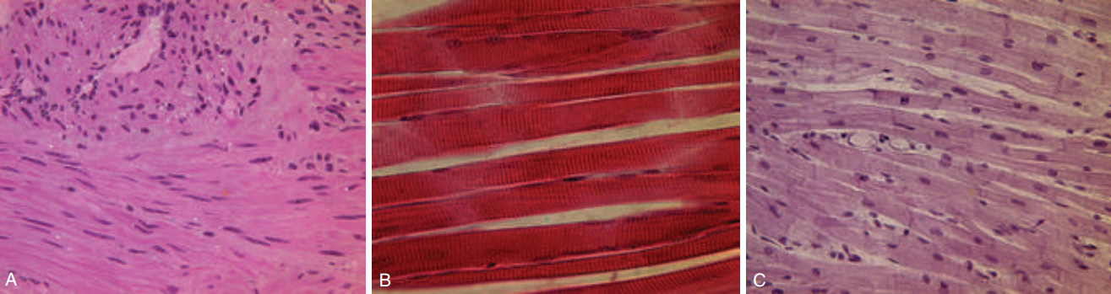

Figure 4. The three types of muscle fibers: (A) skeletal, (B) smooth, (C) cardiac

1. Learn the new words:
Muscle – мышца
Muscular – мышечный
Striated – поперечно-полосатая
Smooth – гладкая
Visceral – висцеральная (внутренних органов)
Cardiac – сердечная
Voluntary – произвольно сокращающаяся
Involuntary – непроизвольно сокращающаяся
Weight – вес
Cell – клетка
Fiber – волокно
Internal – внутренний
Bundle – пучок, связка
Skin – кожа
To contract – сокращаться
Tissue – ткань
To respond – отвечать, реагировать
Vessel – сосуд
Blood – кровь

2. Read and translate into Russian:
the contraction of muscles, the blood vessel wall, the body weight, connective tissue cells, to determine the blood group, a rapid change, to contract slowly, the direction of muscular fibers, to find out the universal method, to introduce into practice, direct connection, to respond to stimuli, wide bundles, excitability, contractility, extensibility, and elasticity.

3. Read and translate the text, find English equivalents of these word combinations:
Согласно одной теории, происходит от латинского слова, греческое выражение, двигательный аппарат, произвольные и непроизвольные, контролируются сознанием, устойчивое сокращение, действие температуры, поворот головы, изменения окружающей среды, характерная черта, не имеет ни начала, ни конца, огромная сеть.

The word “muscle”, according to one theory, comes from a Latin word that means “little mouse”: when a man’s muscles are contracting they look as if a little mouse runs about under the skin. According to another theory the word “muscle” comes from a Greek expression that means “to enclose”, that is layers of muscles enclose the body. We know that the muscles constitute about 50 per cent of the total body weight.
Muscles are needed for many body activities, including breathing, talking, walking, and even sneezing. Muscles are the active part of the motor apparatus.
Functionally all muscles are divided into two groups: voluntary and involuntary muscles.
Skeletal muscle attaches to bones and is the only type of muscle that is consciously controlled. It is, therefore, referred to as voluntary muscle. Skeletal muscle can, however, also be activated by reflexes. Smooth muscle tissue is similar, but not identical, to skeletal muscle. It is not under voluntary control and has slow, sustained contractions. Cardiac muscle tissue is found only in the heart. It is under involuntary control.
There are three main types of muscular tissue that we identify and classify on the basis of its structure:
1. smooth or visceral muscle;
2. striated or skeletal muscle;
3. cardiac muscle.
Muscle tissue has four unique characteristics, which include excitability, contractility, extensibility, and elasticity.
Smooth muscles can contract slowly. They make up the walls of the internal organs. Since we identify the internal organs as viscera, we sometimes call smooth muscles visceral muscles. The walls of the blood vessels are contracting when they respond to some chemicals in the blood or to the effect of temperature. For this reason we may call them involuntary muscles. Smooth muscle tissue consists of long cells. Smooth muscle fibers are bound into bundles by connective tissue which contains blood vessels and nerves.
Striated muscle tissue consists of large fibers in the form of bundles. These muscles are necessary for manipulation of the bones of the skeleton for walking, running, turning the head and so on. That’s why we sometimes call them skeletal muscles. This type of muscular tissue includes the large muscle masses of the body, the muscles of the arms, legs, back, etc. It includes all the muscles which must respond quickly to changes in the environment. For this reason we call striated muscles voluntary muscles. There are more than 400 skeletal muscles in the human body.
Cardiac muscle is made up of striated tissue. A characteristic feature of cardiac muscle is that fibers have neither a beginning nor an end. In other words the heart is a huge net of muscles in which all elements are continuous with each other. Cardiac muscles have the strength of contraction of the skeletal muscles.
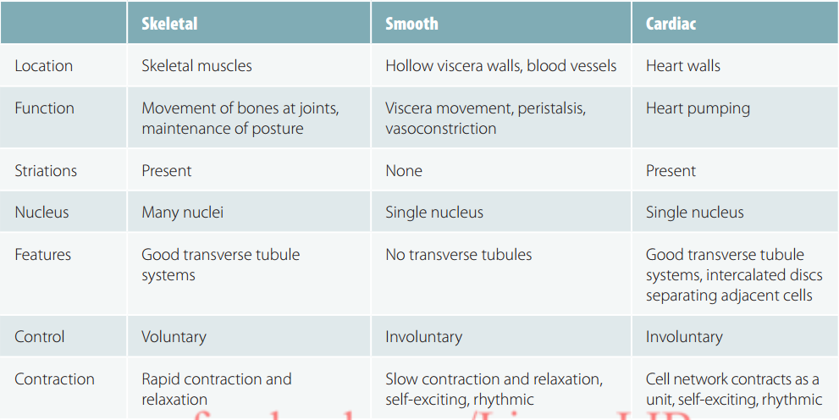
Figure 5. Skeletal, Smooth and Cardiac Muscle

4. Complete the following sentences:
1. Functionally all muscles can be divided into …
- three groups
- two groups
- numerous groups
2. Smooth muscles make up …
- free parts of the extremities
- the walls of the internal organs
- the main parts of the trunk
3. Striated muscles are necessary for …
- motion and contraction
- formation of fibrous bundles
- manipulation of the bones of the skeleton
4. Cardiac muscle is …
- under involuntary control
- under voluntary control

5. Express your agreement or disagreement with the following statements:
1. The word muscle is an English word.
2. Muscles constitute about 50 per cent of the total body weight.
3. Muscles are the active part of the nervous system.
4. There are five main types of muscular tissue on the basis of its structure and functions.
5. Smooth muscles make up the walls of the internal organs.
6. Striated muscles are called involuntary or visceral muscles.
7. Cardiac muscle tissue is found in the heart and in the stomach.

6. Answer the questions:
1. What is the origin of the word muscle?
2. What groups of muscles do you know?
3. What are the other names for smooth muscles?
4. Why can we call smooth muscles visceral muscles?
5. Why can we call them involuntary muscles?
6. What are the other names for striated muscles?
7. Why can we call them voluntary muscles?

7. Translate the sentences into English:
1. Мышцы необходимы для многих видов деятельности человека.
2. В теле человека примерно 400 скелетных мышц.
3. По функциям мышцы можно разделить на две основные группы.
4. Гладкие мышечные волокна связаны в пучки соединительной тканью, которая содержит кровеносные сосуды и нервы.
5. Поперечно-полосатые мышцы иначе можно назвать скелетными мышцами.
6. Волокна сердечной мышцы непрерывны.
7. Сердце – это огромная сеть мышц.

Skin and its functions
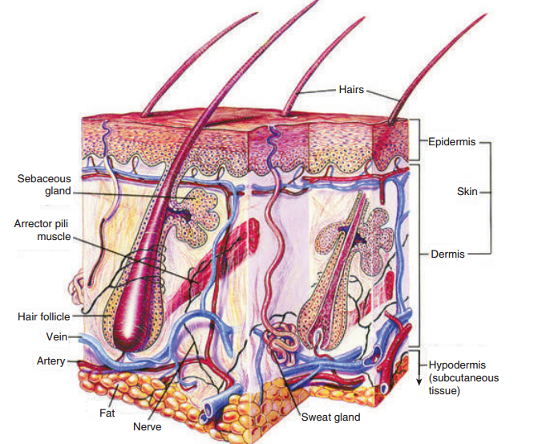
Figure 6. Anatomy of the skin
1. Read the text and fill in the table

The skin
The skin is the largest organ of the body. It is composed of two main layers: the dermis with a rich network of blood vessels and nerves and epidermis, a protective outer layer without blood vessels. The cells of the surface layer are non-living and require no supply of blood for nourishment. The cells at the base of the epidermis are alive and are constantly growing. The epidermis is thinner than the dermis and is made up of several layers of different kinds of cells. The number of cells varies in different parts of the body; the greatest number is in the palms of the hands and soles of the feet, where the skin is the thickest. An adult’s skin weighs about 6.6 pounds.
Skin colour is caused by the presence of melanin, a pigment that is produced by special cells in the epidermis. The amount of melanin determines the differences in skin colours among the different races. Melanin makes an Indian brownish-red, a Chinese yellow, and an African black. The skin of the white race contains the least melanin pigment.
Albinism is a genetic disorder in which there is a lack of melanin. Albinism affects the hair, skin, and eyes. The hair is usually white, the skin extremely pale, and the eyes may range in color from blue to reddish, violet, hazel, or brown. Patients must avoid skin damage from the sun.
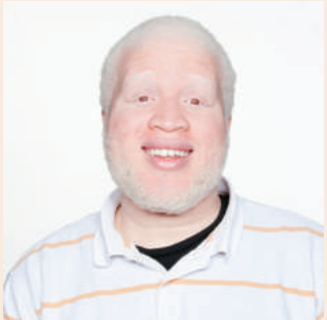
Figure 7. Albinism

Skin layer | Contains blood vessels and nerves | Contains melanin | Comparison in thickness
 | - | + | thinner
 | + | - | thicker

2. Answer the questions:
1. Which layer of the skin contains blood vessels?
2. Which layer is thicker?
3. What kinds of cells – living or non-living – are in the epidermis?
4. What amount of melanin – the least or the most – does the skin of the white race contain?
5. What is albinism?

3. Open the brackets and translate the sentences
1. The amount of melanin (to determine) the differences in skin colours.
2. The skin (to compose) of two layers.
3. The dermis (to make up) of several layers of cells.
4. The thickness of the outer layer (to vary).
5. The dermis (to contain) blood vessels and nerves.
6. The cells of the epidermis (to require) no supply of blood.
7. Melanin (to produce) by special cells-in the dermis.
8. The presence of melanin (to cause) skin colour.

4. Make up sentences
Подлежащее (термин) | Глагол- связка | Именная часть сказуемого  (с сопутствующими словами)
1. The epidermis | is/are | the organs that filter the blood.
2. A bone |  | the part of the body which has eyes, mouth, and brain in it.
3. A cell |  | the bony box that encloses the brain.
4. The eyes |  | the tiny unit of the living tissue.
5. The heart |  | the muscular organ that pumps the blood.
6. The kidneys |  | the organs of sight.
7. The skull |  | the outer layer of the skin.
8. The head |  | a piece of the skeleton.

5. Read the text and name the functions of skin
The skin performs many vital functions:
1. Protection of the underlying organs and tissues against injury and fluid loss.
2. The skin is a sensory organ with many cells that are sensitive to pain, pressure, temperature, and touch and relay of this information to the nervous system.
3. Maintenance of normal body temperature.
4. Melanin production, to protect underlying tissue from ultraviolet (UV) radiation.
5. Keratin production, to serve as water repellant and to protect against abrasion.
6. Vitamin D3 synthesis.
7. Helps to excrete body wastes in the form of perspiration.

6. Make up sentences
The function of | the skin | is | to protect the brain.
 | the skull |  | to pump blood through the body.
 | the bones |  | to provide anchorage for the muscles.
 | the heart |  | to maintain the temperature of the body.
 | the blood |  | to transport oxygen and nutrients to the organs.

Blood Components

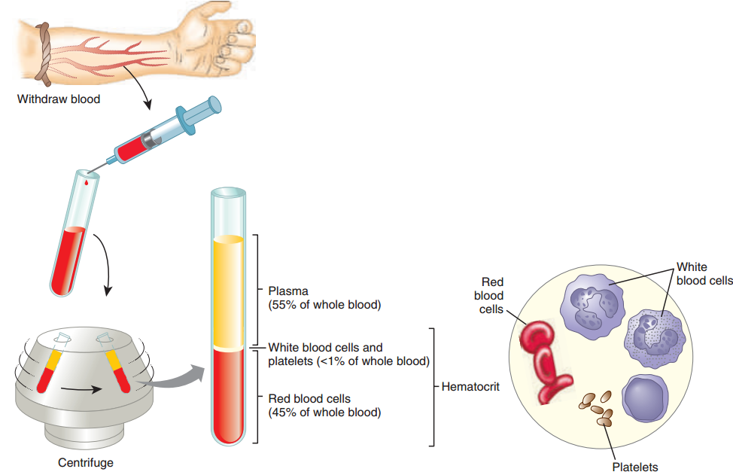

Figure 8. The composition of whole blood.

1. Read and translate the text:

Blood Components
Normally, 7-8% of human body weight is from blood. In adults, this amounts to 4.5-6 quarts of blood. This essential fluid carries out the functions of transporting oxygen and nutrients to our cells and getting rid of carbon dioxide, ammonia, and other waste products. In addition, it plays a vital role in our immune system and in maintaining a relatively constant body temperature. Blood is a highly specialized tissue composed of more than 4,000 different kinds of components. Four of the most important ones are red cells, white cells, platelets and plasma.

Red Cells
Red cells, or erythrocytes, are relatively large microscopic cells without nucleus. Red cells normally make up 40-50% of the total blood volume. They transport oxygen from the lungs to all of the living tissues of the body and carry away carbon dioxide. The red cells are produced continuously in our bone marrow. Hemoglobin is the gas transporting protein molecule that makes up 95% of a red cell. Each red cell has about 270,000,000 iron-rich hemoglobin molecules.
White Cells
White Cells protect the body against bacteria, viruses, parasites, cancer cells, and toxins. Leukocytes exist in variable numbers and make up a very small part of blood's volume – normally only about 1% in healthy people. Leukocytes are not limited to blood. They occur elsewhere in the body as well, most notably in the spleen, liver, and lymph glands. Most are produced in our red bone marrow.
Platelets
Platelets, or thrombocytes, are small cell fragments without nucleus. They live for about 10 days. Approximately one third of the body’s platelets are held in the spleen and other vascular organs instead of in the bloodstream. The function of platelets is primarily to block injuries to damaged blood vessels and to start forming blood clots. They accomplish this by sticking to the damaged site and forming a temporary plug to seal the broken area. Recent research has shown that platelets also help fight infections by releasing proteins that kill invading bacteria and some other microorganisms. In addition, platelets stimulate the immune system. Like the red and white blood cells, platelets are produced in bone marrow from stem cells.
Plasma
Plasma is the relatively clear, yellow liquid made up of 90% water. It also contains amino acids, carbohydrates, lipids, proteins, hormones, electrolytes, vitamins, and waste materials. As the heart pumps blood to cells throughout the body, plasma brings nourishment to them and removes the waste products of metabolism.

2. Use English equivalents
Необходимая жидкость, транспортировка кислорода и питательных веществ, выведение углекислого газа, играть жизненно важную роль, постоянная температура тела, различные виды компонентов, объем крови, костный мозг, газотранспортная белковая молекула, богатая железом, защищает тело, непостоянное количество, здоровый человек, лимфатические железы, находятся в селезенке, кровоток, блокировать повреждения, сгустки крови, стенки сосудов, прикрепляться к поврежденному месту, временная закупорка, бороться с инфекциями, убивать вторгающиеся бактерии, стимулировать иммунную систему, прозрачная желтая жидкость, удаляет продукты метаболизма.

3. Replace with synonyms the underlined words
1. The function of erythrocytes is to carry oxygen and carbon dioxide.
2. Thrombocytes are tiny particles of the blood.
3. Leuccocytes differ in size and shape.
4. White cells are situated not only in the bloodstream.
5. Plasma includes different components.
6. The function of platelets is first of all to block injuries to damaged blood vessels.

4. Answer the questions:
1. What is the normal amount of blood in adult?
2. What are the main functions of blood?
3. What does blood consist of?
4. What is the function of erythrocytes?
5. What is hemoglobin?
6. What is the function of leucocytes?
7. What is the normal volume of white cells in healthy people?
8. How long do the platelets live?
9. What is the function of thrombocytes?
10. What are the components of plasma?

Organ Systems

1. Look at the table and study it
The human body is made up of several organ systems that all work together (Tab.1). The organ systems play different roles in helping the body work.
Table1. Organ systems
System | Organs in the system | Functions of System
Cardiovascular | - - Heart  - - Blood vessels (arteries, capillaries, veins) | Pumps blood and circulates it throughout the body
Respiratory | - - Nose  - - Pharynx  - - Larynx  - - Trachea  - - Bronchi  - - Lungs | Adds oxygen to the blood and removes carbon dioxide from the blood
Nervous | - -Brain  - -Spinal cord  - -Nerves | Controls all other body systems and the communications between all body components
Digestive | - - Mouth  - - Esophagus  - - Stomach  - - Small intestine  - - Large intestine  - - Rectum  - - Anus  - - Liver  - - Gallbladder  - -Pancreas  - - Appendix | Digests and absorbs food and excretes waste products from the body
Endocrine | - - Thyroid gland  - - Parathyroid gland  - - Adrenal glands  - - Pituitary gland  - - Pancreas  - - Thymus  - - Hypothalamus  - - Pineal gland  - - Ovaries  - - Testes | Produces chemical messengers (hormones) carried in the blood, which direct the activities of different organ systems
Urinary | - - Kidneys  - - Ureters  - - Bladder  - - Urethra | Excretion of organic wastes from body fluids and their elimination
Musculoskeletal | - - Muscles  - - Tendons  - - Ligaments  - - Bones  - - Joints | Provides structure and allows motion of the body
Reproductive | Male:  - Penis  - Prostate gland  - Seminal vesicles  - Vasa deferentia  - Testes  Female:  - Ovaries  - Fallopian tubes  - Uterus  - Vagina  - Mammary glands | Production of new living organisms

2. Answer the questions
1. What are the major organ systems of the body?
2. Name the organs of each system.
3. What are the functions of the organ systems?
4. Which system controls breathing?
5. Which organ system is not vital?
6. Which system connects the brain to the rest of the body?
7. What system includes the liver and the pancreas?
8. What organ system differs women from men?

The Cardiovascular System

1. Choose the words to the topic
Ventricle, palm, dermis, capillary, skin, race, vein, atrium, finger, artery, foot, circulation, mouth, clavicle, aorta, skeleton, heart, blood vessels, bone, systemic circuit, face, pulmonary circuit.

2. Find the definition to the following terms
Heart | is a tiny vessel which connects the smallest arteries and veins.
Blood | is the biggest systemic artery in the body.
Artery | is a blood vessel carrying blood to the heart.
Vein | is a lower compartment of the heart.
Capillary | is the fluid circulating through the heart, arteries, capillaries and veins.
Atrium | is a blood vessel carrying blood away from the heart.
Ventricle | is a muscular organ lying slightly to the left of the middle of the chest between the two lungs.
Aorta | is an upper compartment of the heart.

3. Make up the sentences from the words:
1. is, of, in the body, a rich network, there, blood vessels
2. blood, kinds, are, three, vessels, capillaries, and, of, veins, there, arteries
3. no, between, is, the heart, there, connection, the two sides, of

4. Learn the new words
cardiovascular system – сердечнососудистая система
blood circulation – кровообращение
artery – артерия
vein – вена
capillary – капилляр
blood vessel – кровеносный сосуд
to pump blood – выталкивать кровь
oxygen-poor blood – кровь, бедная кислородом
oxygen-rich blood – кровь, обогащённая кислородом
chamber of the heart – камера сердца
atrium (atria) – предсердие
ventricle – желудочек
valve – клапан
cardiac cycle – сердечный цикл
vascular system – сосудистая система
pulmonary system – лёгочная система
to separate – разделять
portal system – портальная система

5. Read the text. Pay attention to the new words for better understanding

The Cardiovascular System
The cardiovascular system is the system of blood circulation. It includes the heart, the arteries, the veins and the capillaries.
The centre of the circulatory system is the heart. The heart is the size of about clenched (сжатый) fist. The average adult heart is about 14 cm long by 9 cm wide and weighs approximately 300 g. The normal weight of the heart is about half of one per cent of the total body weight. The human heart contracts from the first moment of life to the last one.
The contractions of the heart pump blood through the arteries to all parts of the body. Blood flows through your body using your blood vessels such as capillaries, veins and arteries. When the oxygen-poor blood goes to your lungs, the blood will be oxygen-rich and will give oxygen to your whole body and does this over and over again.
There are four chambers in the heart. There are two chambers on the top and two chambers on the bottom. The top two chambers are called the atria. There's a left atrium and a right atrium. They receive blood returning to the heart from the body and lungs. The bottom two chambers are the ventricles. There is also a right ventricle and a left ventricle. The ventricles give the blood to the body and lungs. The valves separate the atria from the ventricles. The valves are located at the entrance and exit of each ventricle.
Each beat of the heart is followed by a period of rest for the cardiac muscle. Each wave of contraction and period of rest of the heart compose a cardiac cycle.
The vascular system consists of three groups of vessels – arteries, veins and capillaries. The vessels carrying blood to and from the tissues of the body compose the general system. They are called the systemic vessels. The pulmonary system is formed by the vessels carrying blood to and from the lungs. The portal system is formed by the veins passing to the liver.
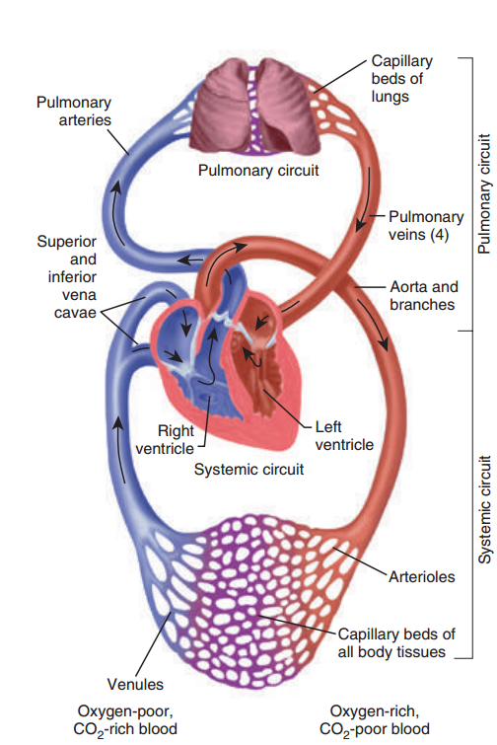
Figure 9. The blood pathway includes two circuits: systemic and pulmonary

6. Write down the physical features of the heart. Speak about the heart according to the plan
1. Size: …
2. Weight: …
3. Structure: …
4. Function: …
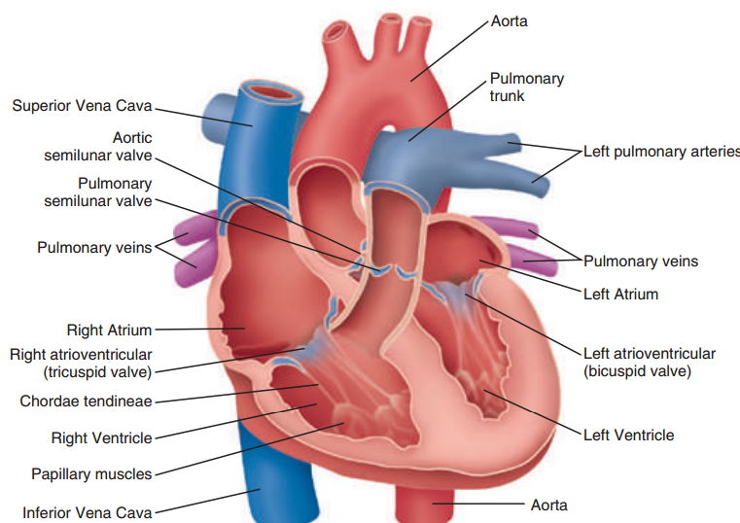
Figure 10. Anatomy of the heart

7. Complete the sentences using the text “The Cardiovascular System”.
1. The cardiovascular system is …
2. The centre of the cardiovascular system is …
3. The contractions of the heart …
4. Two chambers on the top are called …
5. Two chambers on the bottom are …
6. The valves separate …
8. Match two parts of the sentences together
 | Blood flows through the body  The oxygen-poor blood goes to the lungs  The atria receive the blood  The ventricles give the blood  Each beat of the heart is followed by  The heart consists of  The cardiovascular system includes | - from the body and lungs.  - the heart, arteries, veins and capillaries.  - using the blood vessels.  - a period of rest.  - four chambers.  - where it becomes oxygen-rich.  - to the body and lungs.

9. Put the steps of blood flow in the order from 1 to 7. The first step is labeled for you
___ Blood from the right ventricle is pushed through the semilunar valve into the pulmonary artery that carries it to the lungs.
___ The left ventricle sends blood through the aortic semilunar valve into the aorta.
1 Blood enters the right atrium from superior and inferior vena cava.
___ Blood picks up oxygen in the lungs.
___ Blood passes through the bicuspid valve into the left ventricle.
___ Blood returns to the left atrium via the pulmonary veins.
___ Blood passes through the tricuspid valve into the right ventricle.

10. Match the terms
Aorta, aortic semilunar valve, bicuspid valve, inferior vena cava, left ventricle, left atrium, pulmonary artery, pulmonary semilunar valve, pulmonary veins, right atrium, right ventricle, superior vena cava, tricuspid valve.
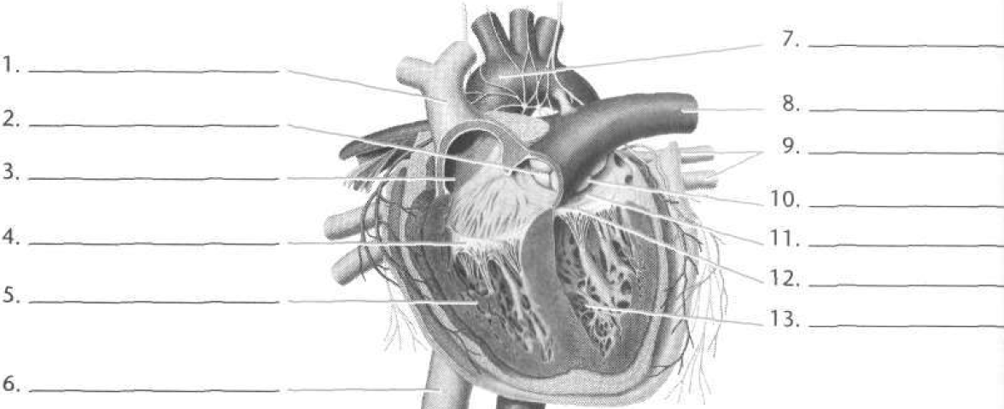

Heart diseases

1. Find the matches
heartache | немедленно
headache | состояние
immediately | боль в сердце
calm the patient | давление крови
condition | головная боль
prescribe drugs | успокоить пациента
the pressure of blood | выписать лекарство
complain of | жаловаться на
2. Write down the words; find their meaning in the dictionary
disorder to depend on
congenital to pick up
acquired puffiness
club-like breathlessness
pulmonary artery

3. Read and translate the text:
Heart diseases
Heart disorders fall into two broad groups: congenital and acquired. Congenital heart defects are caused by structural defects. Acquired heart disease is mainly due to rheumatic fever. Congenital defects may result in cyanosis if the defect is such that blood doesn’t pass through the lungs for oxygenation. The patient has blue lips and blue-finger and toe-nails. The ends of the fingers are rounded and club-like. Sometimes there is an opening between the left and right side of the heart, or even between the aorta and pulmonary artery.
Symptoms depend on the type of heart disease. Sometimes, the defect is picked up on a routine examination, at other times there may be breathlessness, difficulty in walking or running, swellings. Some these anomalies can be surgically corrected.

4. Use English equivalents
Врожденный, приобретенный, пороки сердца, структурные дефекты, врожденные пороки сердца, посиневшие губы, пальцы на руках и ногах закругленные, похожие на барабанные палочки, отверстие, легочная артерия, обнаруживать, плановый осмотр, одышка, отеки, хирургический путь.
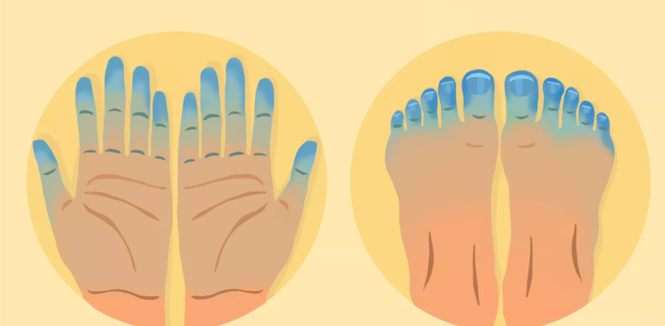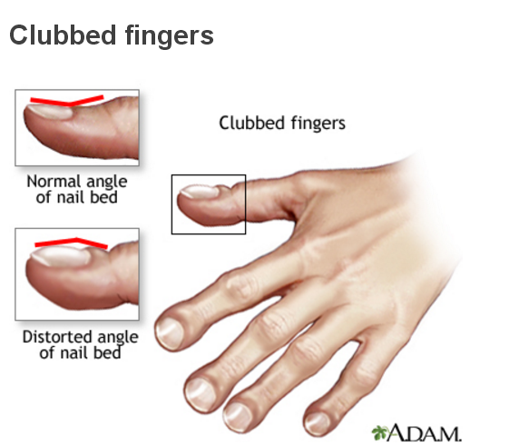
Figure 11. Cyanosis Figure 12. Club-like fingers

Hypertension
1. Read out
hypertension
hypertensive crisis
primary hypertension
essential hypertention
secondary hypertension
blood
blood pressure
measure blood pressure
high blood pressure
persistent high blood pressure
low blood pressure
to treat – treatment
to prevent – prevention
to measure – measurement
to cause – cause
to complain of – complaint
to elevate – elevation
to reduce – reduction

2. Warm-up discussion
What is hypertension?
Why do you think so many people in developed countries suffer from this disease?
What can we do to solve the problem?

3. Read the text and answer the questions

Hypertension
Hypertension is a persistent elevation of the systolic blood pressure above 140 mm Hg and the diastolic blood pressure above 80 mm Hg. It can be classified as primary (or essential) and secondary. Primary hypertension indicates that no specific medical cause can be found. Secondary hypertension indicates that the high blood pressure is the result of another condition, such as kidney disease or certain tumors.
High blood pressure is the major risk factor for coronary, cerebral, renal, and peripheral vascular disease. The disease is initially asymptomatic. But later the patient may complain of headache, visual disturbances, dizziness, chest pain, tinnitus, etc.
One of the serious complications of hypertension is hypertensive crisis. It refers to any clinical condition requiring immediate reduction in blood pressure. It is acute and life-threatening. The accelerated hypertension requires emergency treatment, since target organ damage (brain, heart, kidneys, retina of the eye) can occur quickly. Death can be caused by stroke, renal failure, or cardiac disease.
Diagnosis of hypertension is generally made on the basis of a persistent high blood pressure. It usually requires three separate measurements at least one week apart. If an elevation is extreme, or end- organ damage is present, the diagnosis may be applied immediately.
The treatment includes reduction of blood pressure and prevention or lessening of the extent of organ damage. Non pharmacological methods, such as lifestyle changes, may be initially prescribed. The patient may require pharmacological treatment: such medications as beta-blockers, ACE-inhibitors, diuretics and others.
It is evident that our health mostly depends on us. If you want to be healthy, people should keep to a diet, be active, even-tempered, and never smoke or use any substances, such as drugs or alcohol.

4. Answer the questions:
1. What is the systolic blood pressures in hypertension?
2. What is the diastolic blood pressure in hypertension?
3. List the risk factors for this disease.
4. What does the patient with hypertension complain of?
5. How can we make a diagnosis of hypertension?
6. What are the ways of treatment of hypertension?
7. What does non pharmacological method of treatment include?
8. What organs can be damaged in hypertensive crisis?

5. Are these statements true (T) or false (F)? If the statement is false, correct it.
1. Hypertension is a reduction of blood pressure.
2. Primary hypertension is caused by kidney disease.
3. Hypertensive crisis is a life-threatening condition.
4. The treatment of hypertension can be non pharmacological.
5. To make a diagnosis of hypertension BP measurement is not necessary.

The Respiratory System

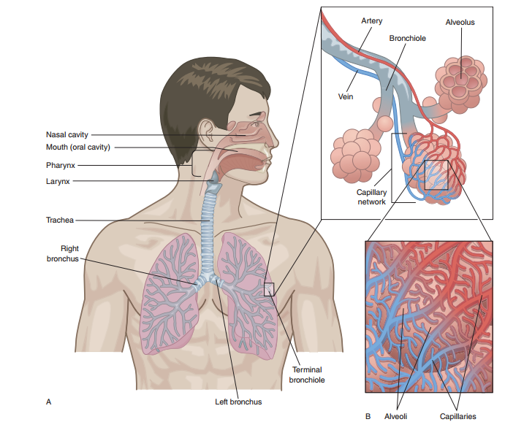
Figure 13. The structure of Respiratory System

1. Learn the following new words:
Airway – дыхательные пути
Alveolus – альвеола
Bronchus – бронх
Bronchiole – бронхиола
Breathe – дышать
Сarbon dioxide – углекислый газ
Diaphragm – диафрагма
Division – граница
Exhalation – выдох
Inhalation – вдох
Larynx – гортань
Lung – легкое
Muscles of respiration – дыхательные мышцы
Muscular tunnel – мышечная трубка
Pharynx – глотка
Pleura – плевра
Oxygen – кислород
Trachea – трахея

2. Read and translate the text:

Anatomy of Respiratory System
The cells of the human body require a constant stream of oxygen to stay alive. The respiratory system provides oxygen to the body’s cells by removing carbon dioxide.
There are 3 major parts of the respiratory system: the airway, the lungs, and the muscles of respiration.
The airway includes the nose, mouth, pharynx, larynx, trachea, bronchi, and bronchioles.
The nose and nasal cavity form the main external opening for the respiratory system through which air moves. The nasal cavity is a hollow space within the nose and skull that is lined with hairs and mucus membrane which warm, moisturize, and filter air.
The pharynx, also known as the throat, is a muscular tunnel. It extends from the nasal cavity to the larynx and esophagus.
The larynx, also known as the voice box, is a short section between the pharynx and trachea.
The trachea is a tube which extends from the base of the larynx to the lungs, where it divides into two bronchi.
The bronchi are two tubes which begin at the division of the trachea. The left bronchus is slightly longer than the right one as it passes around the heart to reach the left lung. Each bronchus leads into a lung. Inside the lungs, the bronchi divide, and subdivide, into smaller numerous bronchioles. The bronchioles end in very fine alveolar ducts leading to the alveoli.
The alveoli, or air sacs, are the ends of the air passages. Each alveolus is closely surrounded by blood capillaries. There are over 700,000,000 alveoli in the lungs. The total surface of the alveoli is about 90 sq.m (square meters).
The lungs are paired, spongy organs located in the chest. The lungs are divided into lobes – the right lung has three lobes and the smaller left lung has two lobes. Each lung is enclosed in a membranous sac, or pleura. The lungs have many capillaries with the total surface of about 80 sq.m.
It is considered that in the adult the vital capacity of the lungs is about 3-4 liters.

3. Find the equivalents:
a single bronchiole | полость в носу и черепе
nasal cavity | короткий участок дыхательных путей
a hollow space within the nose and skull | варьироваться от … до…
external opening | удалять углекислый газ
a short section of the airway | быть окруженным кровеносными капиллярами
to be lined with hairs and mucus membrane | носовая полость
to range from … to… | простираться от … до…
to extend from … to… | одна бронхиола
to remove carbon dioxide | внешнее отверстие
to be surrounded by blood capillaries | быть выстланным волосками и слизистой оболочкой

4. Answer the questions:
1. What is the respiratory system responsible for?
2. What are the main parts of the respiratory system?
3. What is the nose lined with?
4. What is the pharynx?
5. What is another term for larynx?
6. Which bronchus is larger and why?
7. How many alveoli are there in the lungs?
8. What are the lungs? What is their vital capacity?

5. Match the terms with their definitions:
 | trachea  larynx  bronchus  alveolus  lung  pleura  nasal cavity | - either of the two main branches of the trachea that lead to the lungs, where they divide into smaller branches;  - a membrane that encloses each lung and lines the chest cavity;  - either of the two saclike respiratory organs in the thorax of humans and the higher vertebrates;  - a tube that connects the pharynx and larynx to the lungs, allowing the passage of air;  - any of the tiny air-filled sacs arranged in clusters in the lungs, in which the exchange of oxygen and carbon dioxide takes place;  - a muscular and cartilaginous structure lined with mucous membrane at the upper part of the trachea in humans, in which the vocal cords are located;  - a hollow space located behind the nose.

6. Arrange sentences in the correct order to explain the term “lungs”:
The lungs are divided into lobes – the right lung has three lobes and the smaller left lung has two lobes.
The lungs are the main organs involved in the process of respiration.
The lungs are paired, spongy organs located in the chest.
Each lung is enclosed in a membranous sac, or pleura.
Respiration is a process which provides body with oxygen for growth and other metabolic activities and removes waste products in the form of carbon dioxide.

7. Write down organs in their appropriate position:
Bronchi, lungs, nasal cavity, oral cavity, trachea, pharynx.
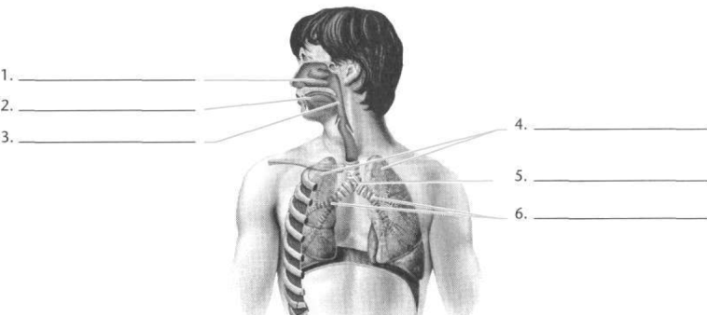
The Digestive System

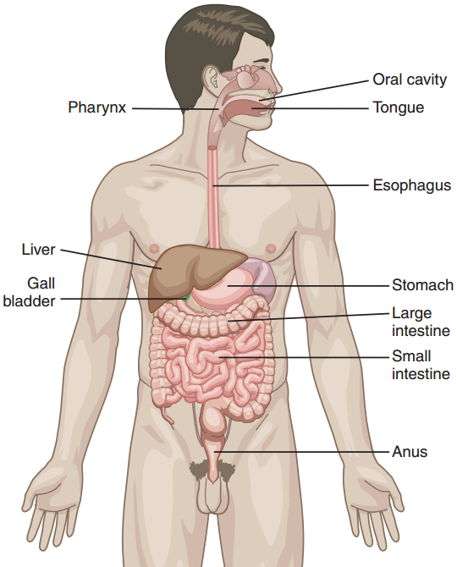

Figure 14. The digestive system

1. Learn the following new words:
Abdomen – брюшная полость
Alimentary tract – пищеварительный тракт
Anus – анальное отверстие
Caecum – слепая кишка
Colon – ободочная кишка
Digestive system – пищеварительная система
Duodenum – двенадцатиперстная кишка
Esophagus – пищевод
Ileum – подвздошная кишка
Jejunum – тощая кишка
Gallbladder – желчный пузырь
Gland – железа
Large intestine – толстый кишечник
Length – длина
Liver – печень
Musculomembraneous – мышечно-мембранный
Oral cavity – ротовая полость
Pancreas – поджелудочная железа
Palate – нёбо
Rectum – прямая кишка
Salivary glands – слюнные железы
Small intestine – тонкий кишечник
Stomach – желудок
Tube – трубка

2. Translate the following word combinations from English into Russian:
To extend from the oral cavity to the anus, the first division, to pass through the pharynx to the esophagus, the upper part of the abdomen, to be composed of, a thin-walled muscular tube, to absorb water, the largest gland in the human body, a major role in metabolism, a number of functions in the body, a hollow sac, a long thin gland.

3. Put words in the appropriate column:
Parts of the cardiovascular system | Parts of the digestive system
Ileum, heart, vessel, anus, jejunum, artery, duodenum, tongue, vein, pharynx, stomach, capillary, esophagus, intestine, aorta, atria, rectum, oral cavity, salivary glands, mouth, chamber, caecum, colon, teeth, ventricle.

4. Read and translate the text:

Anatomy of the Digestive System
The digestive system is a musculomembraneous canal about 8½ metres in length. It extends from the oral cavity to the anus. It consists of the mouth, pharynx, esophagus, stomach, small intestine, and large intestine. The liver with gallbladder and pancreas are the large glands of the alimentary tract.
The first division of the alimentary tract is formed by the mouth. Important structures of the mouth are the teeth and the tongue, which is the organ of taste. The soft and hard palates and the salivary glands are also in the oral cavity.
From the mouth food passes through the pharynx to the esophagus and then to the stomach.
The stomach is a muscular, hollow organ. It is in the upper part of the abdomen under the diaphragm. It measures about 21-25 cm in length, 8-9 cm in its largest diameter. It has a capacity of from 2.14 to 4.28 litres.
The small intestine is a thin-walled muscular tube about 6.5 metres long. It is located in the middle portion of the abdominal cavity. The small intestine is composed of the duodenum, jejunum and ileum.
The large intestine is the last part of the alimentary tract. Its function is to absorb water from the remaining indigestible food matter, and then to pass useless waste material from the body. It is about 1.5 metres long. It is divided into caecum, colon and rectum.
The liver is the largest gland in the human body. It is in the right upper part of the abdominal cavity under the diaphragm. The weight of the liver is 1,500 g. This organ plays a major role in metabolism and has a number of functions in the body.
The gallbladder is a hollow sac lying on the lower surface of the liver, where bile is stored, before it is released into the small intestine.
The pancreas is a long thin gland lying behind the stomach.

5. Answer the questions to the text:
1. What is the digestive system?
2. What does the alimentary tract consist of?
3. What is the 1st division of the alimentary tract formed by?
4. What is the stomach?
5. What is the small intestine?
6. What is the function of the large intestine?
7. What largest glands in the human body do you know?
8. What is the function of the gallbladder?

6. Write down organs in their appropriate position:
Stomach, large intestine, liver, esophagus, small intestine, mouth.
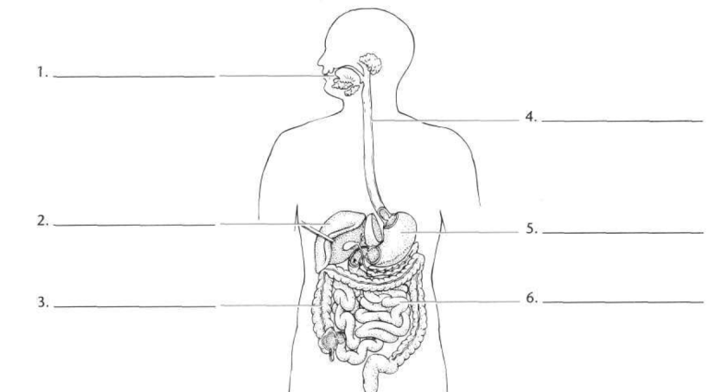

7. Match the terms with their definitions:
 | alimentary tract  stomach  pharynx  small intestine  large intestine  esophagus | - the passage between the pharynx and the stomach;  - the passage to the stomach and lungs; located in the front part of the neck below the chin and above the collarbone;  - beginning with the cecum and ending with the rectum; includes the caecum and the colon and the rectum; extracts moisture from food residues which are later excreted as feces;  - the tubular passage extending from the mouth to the anus, through which food is passed and digested;  - the longest part of the alimentary canal; where digestion is completed;  - an enlarged and muscular saclike organ of the alimentary canal; the principal organ of digestion.

8. Say what organ is spoken about:
1. This organ is the largest gland in the human body. It is in the upper part of the abdominal cavity under the diaphragm in the right side of the abdomen. This organ consists of small lobules connected together by connective tissue, different vessels and nerves.
2. This organ is pyriform (грушевидный) in shape. It is a dilated portion of the alimentary canal. It is in the upper part of the abdomen under the diaphragm. The liver is above this organ, and the colon is below it. The pancreas is behind this organ.
3. It is the beginning of the alimentary tract and the digestion starts here when taking the first bite of food. Chewing breaks the food into pieces that are more easily digested, while saliva mixes with food to begin the process of breaking it down into a form your body can absorb and use.
4. It is a tubular organ that lies behind the trachea and heart and in front of the spinal column; it passes through the diaphragm before entering the stomach.
5. This organ is a part of two different systems of the body, digestive system and respiratory system. It is a passageway leading from the mouth and nose to the esophagus and larynx.
6. This is a long, narrow gland that is located across the upper abdomen, behind the stomach and the spleen. It produces important digestive enzymes and hormone called insulin.
7. This is a hollow organ located beneath the right lobe of the liver and measures 8 centimeters in length. Its function is to store bile.
8. It is the last part of the digestive system. Water is absorbed here and the remaining waste material is stored before being removed by defecation.

Texts for additional reading

Text 1

Read and translate the text:

Anatomy and Physiology of the Nervous System
Nervous system is the vast network of cells specialized to carry information (in the form of nerve impulses) to and from all parts of the body in order to bring about bodily activity. The brain and spinal cord together form the central nervous system. The central nervous system controls the voluntary muscles of the head, trunk, and the limbs, and it is responsible for all movement in them and for all sensation in skin, muscles, bones and joints. The remaining nervous tissue is known as the peripheral nervous system and includes the autonomic nervous system which controls all involuntary muscles. It supplies all the internal organs, and is made up of nerve cells (neurons) supplying the glands and the muscular walls of the internal organs and the blood vessels. The autonomic nervous system is divided into the sympathetic and parasympathetic nervous systems.
Sympathetic nervous system has fibers that leave the central nervous system in the thoracic and lumbar regions. Sympathetic nerves are distributed to the blood vessels, heart, lungs, intestines and other abdominal organs, sweat glands and salivary glands.
Parasympathetic nervous system has fibers that leave the central nervous system from the brain and the lower portion of the spinal cord. The nerves are distributed to blood vessels, glands, and the majority of internal organs. The system works in balance with the sympathetic nervous system.
In human beings the nervous system has the ability to form cortical associations. All the human beings have this function which is formed upon signalization. It is a process in which the stimulus produces the same range of reactions as the stimulus with which it is associated. Such reflexes are called conditioned. And the stimuli producing reactions which don’t depend on surrounding conditions are called unconditioned.

1. Answer the following questions:
1. What is the main function of the nervous system?
2. What is the central nervous system formed by?
3. What does the central nervous system control?
4. What does the peripheral nervous system include?
5. How are nerve cells called?
6. Where are the nerves of sympathetic nervous system distributed?
7. What works in balance with sympathetic nervous system?
8. What is called conditional reflexes?

2. Complete the sentences:
1. … supplies all the internal organs, and is made up of nerve cells.
2. … form the central nervous system.
3. … includes the autonomic nervous system which controls all involuntary muscles.
4. … are distributed to blood vessels, glands, and the majority of internal organs.
5. The autonomic nervous system is divided into….
6. … are distributed to the blood vessels, heart, lungs, intestines and other abdominal organs, sweat glands and salivary glands.

Text 2

Read and translate the text:

The Brain
The brain (cerebrum) is the enlarged and highly developed mass of nervous tissue that forms the upper end of the central nervous system. The average adult human brain weighs about 1400 g and is continuous below with the spinal cord. The spinal cord is the portion of the central nervous system enclosed in the vertebral column, consisting of nerve cells and bundles of nerves connecting all parts of the body with the brain. It contains a core of grey matter and is enveloped in three layers of membrane (the meninges) and extends from the medulla oblongata in the skull to the level of the second lumbar vertebra.
The brain is a complicated organ which consists of grey matter or nerve cells on the surface, and white matter or nerve fibers in the center. It contains many important nerve centers which make it not only the largest but the most important part of the brain.
The functions of the brain. The role of nervous system in our body is often compared to that of a centralized computer which controls the functioning of an entire system. The nervous system plays an important role in the smooth functioning of the different parts of our body. It is basically a complex network of cells with specialized functions. These cells communicate with each other by means of electrochemical waves. The neurons are the important components of the nervous system.
Central nervous system is the seat of all sensation due to the bringing in of the stimuli from the tissues by afferent fibers to the sensory centers of the brain. These stimuli pass through three or more afferent neurons before they reach the sensory centers of the cerebrum. Central nervous system controls all movements of voluntary muscles – muscles of the head, limbs and trunk. Movement is due to nerve stimulus. Movement is classified as voluntary and reflex one. The brain is the special seat of all the special senses – sight, hearing, smell, touch, and taste. The brain is the seat of all the higher mental powers – reasoning, will power, consciousness, memory, emotions, etc. The brain also controls the vital functions of the respiration and circulation, the controlling centers being located in the medulla.

1. Answer the questions:
1. What is the brain?
2. What is the average weight of the human brain?
3. What is the spinal cord like?
4. Where does the spine extend?
5. What parts does the brain comprise?
6. What is the most important part of the brain?
7. What is the role of nervous system in the body?
8. What processes does CNS control?

9. What is movement due to?

2. Match terms with their definitions:
 | consciousness  spinal cord  sensitivity  stimulus  brain  memory  medulla | - It is the center of the nervous system in all vertebrate animals. It is located in the head, usually close to the primary sensory organs for such senses as vision, hearing, balance, taste, and smell;  - It is the ability to remember past experiences, and the power or process of recalling to mind previously learned facts, experiences, impressions, skills and habits;  - In physiology it is a detectable change in the internal or external environment;  - The ability of an organism or organ to respond to external stimuli;  - It is the quality or state of being aware of an external object or something within oneself;  - It is the part of the brainstem that is situated between the pons and the spinal cord;  - It is a long, thin, tubular bundle of nervous tissue and support cells that extends from the medulla oblongata in the brainstem to the lumbar region of the vertebral column.

Text 3

Read and translate the text:

The Urinary System
The urinary system is a group of organs in the body concerned with filtering out excess of fluid and wastes from the bloodstream. Wastes in the blood come from the normal breakdown of active tissues and from food. The body uses food for energy and self-repairs. After the body has taken what it needs from food, wastes are sent to the blood.
The urinary system keeps the chemicals and water in your body balanced. A type of waste called urea is removed from the blood by the urinary system. Urea is produced when foods containing protein, such as meat, are broken down in the body. Urea is carried in the bloodstream to the kidneys.
The urinary system consists of two kidneys, which secrete the urine, the ureters, or ducts, which convey urine to the urinary bladder, where it is stored for some time; and the urethra, through which it is discharged from the body.
The kidneys are paired bean-shaped organs with two surfaces, two borders, and an upper and lower extremity. There are three major regions of the kidney: the renal cortex, the renal medulla and the renal pelvis. The kidneys are situated in the posterior part of the abdomen, behind the peritoneum. They are covered by the renal capsule. The left kidney is longer and narrower, than the right one.
There are more than 1000000 nephrons in each kidney. The nephron carries out nearly all of the kidney's functions. Its chief function is to regulate the concentration of water and soluble substances like sodium salts by filtering the blood, reabsorbing what is needed and excreting the rest as urine. The nephron eliminates waste substances from the body, regulates blood volume and blood pressure, controls levels of electrolytes and metabolites, and regulates blood pH. The inflammation of nephrons in the kidneys is called nephritis.
The ureters are two tubes which measure from 25 to 30 cm in length. They convey the urine from the kidneys to the urinary bladder. Muscles in the ureter walls continually tighten and relax forcing urine away from the kidneys. If urine backs up or stands still, a kidney infection can develop.
The urinary bladder is a triangle-shaped, hollow musculomembranous organ. It is located in the lower part of the abdomen and is held in place by ligaments that are attached to other organs and the pelvic bones. The urinary bladder is a temporary storage for the urine. The bladder's walls relax and expand to store urine, and contract to empty it. Nerves in the bladder alert a person when it is time to urinate.
The urethra is a tube that connects the urinary bladder with the outside of the body. Male and female urethra differs in shape and length. Male urethra length varies from 17.5 to 20 cm; and it is divided into three portions, the prostatic, membranous, and cavernous. The female urethra is a narrow membranous canal, about 4 cm. long. The brain signals the bladder muscles to tighten, which squeezes urine out of the bladder. At the same time, the brain signals the sphincter muscles to relax to let urine exit the bladder through the urethra. When all the signals occur in the correct order, normal urination occurs. Normal urine is sterile fluid. It contains fluids, salts and waste products, but it is free of bacteria, viruses and fungi.

1. Answer the questions:
1. What does the urinary system consist of?
2. What is urine?
3. Where are the kidneys situated?
4. What is the function of nephrons?
5. What is the function of the ureters?
6. Where is the urine stored before it is discharged from the body?
7. What is urethra?
8. What is the function of the urethra?
9. What conveys urine from the kidneys?
10. What is the function of the urinary bladder?

2. Fill in the gaps with words from the box:
nephrons | urine | bladder | kidneys | wastes | urea | ureters | nerves

1. … in the blood come from the normal breakdown of active tissues.
2. Normal … contains fluids, salts and waste products.
3. … usually holds 300-350 ml of urine.
4. … carry urine from the kidneys to the bladder.
5. All the blood in our bodies passes through … several times a day.
6. Urine is formed by … together with water and other waste substances.
7. A person gets an alarm from the … in the bladder when it is time to urinate.
8. In humans, a normal kidney contains 800,000 to 1.5 million ….

3. Agree or disagree with the following statements:
1. Urine is stored in the urethra before discharging from the body.
2. A nephron regulates the concentration of water and soluble substances.
3. The urinary bladder is a hollow bean-shaped organ, which discharges urine from the body.
4. The ureters convey the urine from the kidneys to the urinary bladder.
5. Kidney is a muscular sac which stores the urine before eliminating it from the body.
6. The urine is discharged from the body through the ureters.
7. Urethra is a tube that connects the kidney and the urinary bladder.
8. The main function of the ureters is to regulate the concentration of water and soluble substances.

Text 4
Read and translate the text:

Anatomy and Physiology of the Reproductive System
The reproductive system is a collection of organs that work together for the purpose of producing a new life. The major organs of the reproductive system include the external genitalia and internal organs. The anatomy of male and female reproductive system is different. The male reproductive system includes the scrotum, testicles, spermatic ducts, sex glands and penis. The female reproductive anatomy includes vagina, uterus, ovaries, and fallopian tubes.
Reproductive physical maturity and the capacity for human reproduction begin during puberty. During puberty, the hypothalamus produces hormones, which stimulate the gonads to produce testosterone (males) and estrogen and progesterone (females).
Male puberty generally occurs between the ages of 13-15 and is characterized by the secretion of the male hormone testosterone, which stimulates spermatogenesis, and the development of secondary sexual characteristics (increased height and weight, broadening shoulders, voice deepening, and muscle development).
Female puberty generally occurs between the ages of 9-13, and results in ovulation and menstruation, which involve cyclic hormonal changes in estrogen and progesterone. Secondary sexual characteristics (breast enlargement, widening hips, increased height, weight and fat distribution) also occur as part of the female pubertal process.
Function of the reproductive system is reproduction. Fertilization is the first step in pregnancy. During coitus (sexual intercourse) between a male and a female, semen is released into the vagina and transported through the uterus into the fallopian tube. Fertilization can only occur if intercourse takes place before the time of ovulation that usually occurs “mid-cycle”, or about 14 days before the woman's next menstrual period. At the time of ovulation, the ovum is released from the ovary and transported in the fallopian tube where it remains for about 24-48 hours. Pregnancy is most likely to occur if fresh semen is present when ovulation occurs.
Sperm cells remain viable within the female reproductive tract for about 72 hours. During fertilization, the sperm enters the cell membrane of the ovum so the nuclei of the sperm and egg cells combine to form a zygote. The zygote will remain in the fallopian tube for approximately three days before it travels to the uterus where it will remain for approximately four to five days before implantation into the uterine lining.

1. Answer the questions:
1. What is the reproductive system?
2. What does the word puberty mean?
3. What does the hypothalamus regulate?
4. When does male puberty occur?
5. When does female puberty occur?
6. When can fertilization occur?
7. How long do sperm cells remain viable in the reproductive tract?
8. What is zygote?

2. Match the terms with the definitions:
- puberty  - testosterone  - estrogen  - progesterone  - fertilization  7. gonads | - A white crystalline steroid hormone produced primarily in the testes and responsible for the development and maintenance of male secondary sex characteristics.  - A steroid hormone, secreted by the corpus luteum of the ovary and by the placenta, that acts to prepare the uterus for implantation of the fertilized ovum, to maintain pregnancy, and to promote development of the mammary glands.  - The act or process of initiating biological reproduction by insemination or pollination.  - The stage of adolescence in which an individual becomes physiologically capable of sexual reproduction.  - Any of several steroid hormones produced chiefly by the ovaries and responsible for promoting estrus and the development and maintenance of female secondary sex characteristics.  - Any organ or gland in which gametes are produced; an ovary or testis.

Text 5

Read and translate the text:

The Endocrine Glands
All glands in the human body can be divided into glands with ducts and ductless. Ductless glands have no duct but they make a secretion which they pour into the blood stream. These secretions are called internal secretions or hormones, and glands which produce them are also called endocrine glands.
The chief ductless glands are: the thyroid gland, the adrenal glands and the pituitary gland.
There are also other important glands which produce internal secretions as well as other substances, e.g. the pancreas, the liver and the reproductive glands.
The thyroid gland lies in the front of the neck. It consists of two lobes lying on either side, joined by a narrow band which crosses the trachea immediately below the larynx. The gland is well supplied with blood vessels and consists essentially of secreting cells. The cells secrete thyroxin, which passes into the circulation. Thyroxin controls the general metabolism or activity of the body tissues.
The adrenal glands are two small triangular glands lying one over each kidney. They consist of two parts, cortex and medulla. The outer part produces a secretion which affects sex. Oversecretion produces masculinity in the female and in the male it produces too early development of the male reproductive organs.
The medulla produces a very important secretion called adrenalin, It secreted amount increases in excitement and strong emotions such as fear or anger. The adrenals are therefore sometimes called the glands of “flight and fight”.
The pituitary gland (hypophysis) is a small gland about the size of a pea and yet is of great importance. It lies in the pituitary fossa in the base of the skull. It consists of an anterior and a posterior lobe.
The anterior lobe is the larger and produces a number of important hormones affecting growth and sexual development and the functioning of the ductless glands, particularly the thyroid and the adrenal glands. Undersecretion of this lobe in childhood causes dwarfing. Oversecretion causes overgrowth or gigantism. In the adult this oversecretion causes overgrowth of the head, hands, and feet, particularly affecting the lower jaw. This condition is known as acromegaly.
The posterior lobe produces the secretion known as pituitrin. This stimulates involuntary muscle and therefore contracts the blood vessels and raises blood pressure, stimulates peristalsis, contracts the uterus; it affects the use of water by the body.

1. Answer the questions:
1. How are glands in the human body classified?
2. What is hormone?
3. What are the main ductless glands?
4. What is the structure of the thyroid gland?
5. What does thyroxin control?
6. What is the structure of the adrenal glands?
7. When is adrenalin secreted?
8. What is the structure of the pituitary gland?
9. What does the pituitary gland affect?

2. Open the brackets using the correct form of the verb. Translate the sentences:
1. Thyroxin (to control) the general metabolism or activity of the body tissues.
2. The anterior lobe of the hypothesis (to produce) a number of important hormones.
3. The thyroid gland (to supply) well with blood vessels.
4. The hormones (to deliver) to various organs.
5. The chemical composition of some hormones (to be) well-known.
6. Each gland (to consist) of glandular epithelial tissue.
7. The outer part of the adrenal glands (to produce) a secretion which affects sex.
8. The hormones (to affect) the functions of the different parts of the nervous system.

Список используемых источников

1. Jahangir, M. Anatomy and Physiology for Health Professionals./M.Jahangir –Burlington, MA : Jones & Bartlett Learning, 2018. – 840 с.
2. English for medical students. Пособие по английскому языку для студентов 1 курса медицинского факультета. – Одесса: Одесский государственный медицинский университет, 2015. – 299 с.
3. Human Anatomy. Учебное пособие/ С.А. Крайникова, В.В. Охотская. – Волгоград: Изд-во ВолГМУ ,2016. – 107 с.
4. Козырева, Л.Г. Английский язык для медицинских колледжей./Л.Г Козырева, Шадская Т.В. – Ростов-на-Дону: «Феникс», 2018. – 329 с.

Автор составитель:
Корепанова В.В.

HUMAN ANATOMY

учебно-методическое пособие для студентов
2 курса специальностей
31.02.02 Акушерское дело
34.02.01 Сестринское дело
31.02.03 Лабораторная диагностика

Усл. печ. листов 3

