ШАДРИНСКИЙ ФИЛИАЛ
ГБПОУ «Курганский базовый медицинский колледж»

СБОРНИК ТЕКСТОВ И УПРАЖНЕНИЙ ПО ТЕМЕ
«ЗДОРОВЫЙ ОБРАЗ ЖИЗНИ И ВРЕДНЫЕ ПРИВЫЧКИ»

“Healthy Way of Life and Bad Habits”

Составитель:
Вениаминова Ирина Павловна – преподаватель учебной дисциплины «Английский язык»

Шадринск 2017

Healthy Way of Life and Bad Habits

1. Bad Habits
- Here are some bad habits. Which of them do you have? Which of them do you hate? Which of them are dangerous to your health?
Biting nails, lips | Кусать ногти, губы
Procrastination | Оставлять всё на последний день
Gambling | Играть в азартные игры
Picking your nose | Ковырять в носу
Spitting in public | Сплёвывать в общественных местах
Smoking | Курить
Alcohol abusing | Злоупотреблять алкоголем
Cracking knuckles, neck | Хрустеть костяшками пальцев, шеей
Mumbling | Невнятно разговаривать
Cursing | Ругаться
Talking with your mouth full | Говорить с полным ртом
Slouching | Сутулиться
Picking a wedgie | Поправлять нижнее бельё под одеждой
Twirling hair | Накручивать волосы на пальцы
Always being late | Всегда опаздывать
Talking on the phone in public places | Разговаривать по телефону в общественных местах
Clicking a pen | Щелкать ручкой
Snapping a gum | Громко жевать жвачку

- Read the text with correct pronunciation:

What's your bad habit?
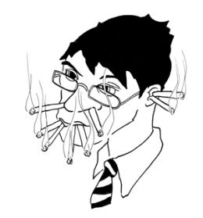
Everybody has a bad habit. Some habits aren't life-threatening or particularly dangerous to our health. Abandoning your socks under the kitchen table might get you into trouble with your housemates, but it will not result in any injuries. (This really may depend on what kind of forgiving people you live with.) If you have the habit of repeating yourself, you might find yourself short of conversation partners but that's about the extent of the negative reaction that you'll get to this annoying habit.
Then again, there are bad habits which really do harm to our health and put us at risk of becoming ill, developing diseases, or detract from our quality of life. At first you may start out drinking a glass of wine with your dinner at night, but soon find yourself adding a beer to breakfast, vodka to lunch, and need some rum or brandy to help you sleep at night. What was once a conscious choice now turns into an addictive repetitive action that is very difficult to put an end to. Smoking is also highly addictive and, depending on the stress level, those cigarettes really tend to multiply during the day. Gambling is high on the list of addictive bad habits that does have the potential to damage your physical health as well as your mental health.

How to break a bad habit
Knowing that you have a bad habit doesn't necessary make it easy to break. There are a number of reasons for why you seem unable to pull away from the vicious cycle that you've gotten yourself into. In some cases, it's because you are being innately defiant of the rules imposed by society, or maybe you don't really understand how harmful your bad habit is to your health. There are also those people who rationalize their habits and make excuses for them. In perhaps a worst case, you may have a genetic disposition to addiction, which makes it seem impossible to conquer.
How you tackle your bad habit is dependent on your ability to identify that you do indeed have a problem, and your willingness to confront and overcome it. Some helpful things that you can do to break your bad habit are at first identifying it and being conscious of when and why it occurs. Keep a log so that you'll be able to track your progress as your bad habit lessens and eventually disappears or you are able to get it under control. Set goals for yourself so that you know what it is that you'd like to accomplish in both the short-term and long-term. Make sure that your goals are realistic and gradual so that the sudden loss of one bad habit doesn't inspire a new one. If you recognize that your bad habit is highly addictive and/or harmful for your health, it might be a good idea to seek out a counselor, self-help group, or the support of your family and friends.

- Translate the words and word combinations:

- bad habit
- life-threatening
- trouble
- injury
- forgive
- extent
- to annoy
- annoying
- harm
- detract
- quality of life
- a conscious choice
- addictive
- to multiply
- gambling
- physical health
- mental health
- to break
- reason
- vicious cycle
- to impose
- innate
- defiant
- to make excuses
- perhaps
- genetic disposition to
- impossible
- to conquer
- ability
- to identify
- to confront
- to overcome
- eventually
- to disappear
- counselor
- to recognize

- Find the pairs of antonyms:
Good, short, appear, physical, loss, start, positive, bad, possible, difficult, lose, harm, disease, dangerous, safety, long, find, negative, benefit, health, mental, finish, easy, impossible, disappear, finding.

- Answer the questions:
- Are bad habits life-threatening?
- What bad habits do you have?
- Is it really dangerous to drink some rum or brandy to help you sleep at night?
- Can you identify which bad habit is dangerous for you and which of them can you excuse?
- How to break a bad habit?
- Who can be a counselor to help you to overcome your bad habit?

- Wright Past Indefinite from the following verbs:
Forgive, depend, extent, multiply, break, impose, make, conquer, confront, overcome, disappear, recognize, keep, be, inspire, may, occur.

2. The Problem of Smoking
- Read the text with correct pronunciation:
Smoking is the best way to bad health. Today half the men and a quarter of the women in the world smoke on the average. Some people think that there is not much damage from smoking, because the inhabitants of many cities and even villages breathe air contaminated with industrial and automobile wastes. They are very wrong. Vehicle exhaust gases are harmful in themselves, but a smoking driver is more dangerous.
Take another example: according to WHO (World Health Organization) figures, the sick rate is higher among smoking workers. The harm of tobacco smoke on women should be especially emphasized. In particular, smoking may affect the course of pregnancy. Smoking women may bring into the world crippled or abnormal children.
The evidence that the smoking is dangerous for smoker’s health is now incontrovertible. The smoker is a serious health risk to non-smokers, increasing their chance of contracting lung cancer and heart disease. Particularly there is a high risk among workers in the hospitality industries (bar staff, casino workers and other workplaces where smoking is routine).
In the past few years some measures have been taken to reduce smoking. The people throughout the world understand the dangers of smoking now. The anti-smoking campaigns in many countries have brought about extensive public censure of this harmful habit and a decrease in the number of smokers among some groups of the population.
In our country the campaign to beat the cigarette habit has acquired a purposeful nature. Special legislative, medical and educational measures are being worked out. Lessons about the harm of smoking have been included in courses of the anatomy, physiology and hygiene. The information against the harm of smoking are printed on packets of cigarette brands. The ministries of railways, civil aviation, merchant marine and culture have worked out and now implement measures for regulating, limiting and restricting smoking in long-distance and suburban trains, planes, on sea vessels, in theatres, clubs, etc.
The problem of smoking is much under discussion. Some people smoke, some don't. Most of those smokers wish to give it up, and heavy smokers often make several attempts before they give up... either smoking or the attempts. It requires not a little will power and determination. And only few succeed. And then those few say that they have felt so much better than before.

- Translate this words and learn them:

smoking
quarter
damage
inhabitant
to contaminate
waste
vehicle
exhaust gases
dangerous
according to
to emphasize
to affect
pregnancy
crippled
evidence
incontrovertible
to increase
lung cancer
hospitality industry
workplace
routine
to reduce
censure
to include
railways
to give up
attempt
to require
determination
will power

- Find in the text the words and combinations:
Течение беременности, выхлопные газы автомобилей, загрязненный воздух, в среднем, курение, опасный, повреждать, промышленные отходы, четверть, в соответствии с…, общепринятый, рабочее место, железная дорога, гражданская авиация, включать с состав, неопровержимое доказательство, сфера обслуживания, рак легких, общественное порицание, неполноценные дети, инвалид, сокращать, делать попытки, подземный транспорт, болезни сердца, дети-инвалиды и неполноценные дети, среди некоторых слоев населения, законодательные и воспитательные меры, торговый флот, это требует немалой силы воли и решительности.

- Find in the text the antonyms for following words:
Health, many, city, wrong, harmful, dangerous, sick, normal, smoker, increase, past, bad, little, better.

- Answer the questions:
- What is the best way to bad health?
- How many smokers are there in the world?
- What is harmful for the human body?
- Why is smoking more dangerous for women?
- Where is the risk for non-smokers very high?
- What anti-smoking measures are being worked out in our country?

- Put the right words:
- The best way to bad health is … .
- It is dangerous to breath … air.
- The sick rate is higher among … workers.
- If the woman smokes her children may be … or … .
- … … gases are harmful.
- Smoking increases the rate of … cancer and … disease.
- There are some measures in our country that must … smoking.
- Most of the smokers wish to … .

- Interview your friends. Here is the chart to help you:
you reduce smoking crippled children?
your friend smoke health of non-smokers?
Do your friends sometimes bring into the world the chance of
Does smoking often increase contracting lung cancer
a smoking woman always look and heart disease?
anti-smoking measures nowadays damage ugly and unpleasant?
non-smokers risk their health in public places?
the ministries
the smoker

3. Alcohol
- Read the text with correct pronunciation:
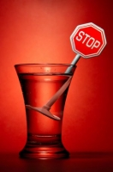
Health is the main value in every person’s life. It is important to take good care of it and to avoid bad habits, such as alcohol misuse, drug abuse, smoking, etc. One of the most harmful effects on our body is caused by drinking alcohol. For many people, the facts about alcoholism are not clear. What is alcoholism exactly?
Some people think that it is just a pleasant pastime. The truth is that alcohol influences most important parts of our organism including the heart, liver, stomach and other vital organs. Another problem, which is brought by alcohol, is the loss of common sense. Lots of crimes are committed under the influence of alcohol. It’s not so dangerous when taken in moderate amounts but drinking lots of alcohol damages the brain. As a result, people stop thinking clearly and start doing uncontrollable things. It includes suicides, homicides, recreational accidents, car crashes.
They say that moderate alcohol use for most adults is not harmful. Sometimes having one or two glasses of red wine per day can be even useful and healing. Moreover, vodka and spirit are used in medical purposes. However when people start drinking more alcohol they become gradually addicted to it. As a result, they turn into alcoholics. A large number of people in our country and in the world are seriously dependent on alcohol. This dependence leads to many unwanted effects and serious illnesses. Heavy drinking increases the risk of certain types of cancers, liver cirrhosis, immune system problems. I really think that people should lead healthier lifestyles.

- Translate this words and learn them:

- value
- to avoid
- alcohol misuse
- drug abuse
- pleasant pastime
- to influence
- common sense
- crime
- brain
- uncontrollable
- recreational accident
- moderate
- useful
- purpose
- gradually
- to addict
- to turn
- to turn into
- dependence
- to lead
- certain
- certainly
- cancer
- lifestyle

- Find in the text the words and combinations:
Приятное времяпрепровождение, потеря здравого смысла, главная ценность, здоровый образ жизни, влияет на самые важные части тела, под влиянием алкоголя, умеренное употребление алкоголя, неконтролируемые вещи, используется в медицинских целях, постепенно становиться зависимым, большое количество людей, приводить к серьезным заболеваниям, повышать риск, превращаться в алкоголиков, проблемы с иммунной системой, злоупотребление наркотиками.

- Find in the text the antonyms for following words:
Independence, health, controllable, bad, independent, useful, unpleasant, to stop, to exclude, child, less, wanted, to reduce.

- Find in the text irregular verbs. Write them in Present Indefinite and Past Indefinite.

- Answer the questions:
- What bad habits do you know?
- What does alcohol influence?
- Is it dangerous to take alcohol in moderate amounts?
- What uncontrollable things do occur as result of alcohol drinking?
- Is alcohol used in medical purposes?
- When do people become addicted to alcohol?

- Translate into English:
- Алкоголь влияет на самые важные части тела, включая сердце, печень, желудок и другие, жизненно важные органы.
- Важно избегать таких вредных привычек как курение, злоупотребление алкоголем и наркотиками.
- Большое количество алкоголя повреждает мозговую деятельность.
- Здоровье является главной ценностью в жизни каждого человека.
- Многие преступления совершается под влиянием алкоголя.
- Водка и спирт используются в медицинских целях.
- Большое количество людей серьезно зависят от алкоголя.
- Пьянство повышает риск развития некоторых видов рака, цирроза печени, проблем с иммунной системой.
- Людям нужно вести более здоровый образ жизни.

4. Drugs
- Read the text with correct pronunciation:
More people are abusing drugs today than in any other time in history of mankind, and many of those people are young. Drugs are a psychoactive substance. A psychoactive substance is something that people take to change the way they feel, think or behave. Some of these substances are called drugs and others, like alcohol and tobacco, are considered dangerous, but are not called drugs. The term drug also covers a number of substances that must be used under medical supervision to treat illnesses.
There are man-made drugs or naturally occurring substances used without medical supervision, basically to change the way a person feels, thinks or behaves. In the past, most drugs were made from plants. That is, plants were grown and then converted into drugs such as coca paste, opium and marijuana. Over the years, these crude products were further processed to drugs like cocaine and heroin and finally, in the 20th century, people found out how to make drugs from chemicals.
These are called man-made or synthetic drugs and include ecstasy, LSD, etc. These were initially manufactured for largely experimental reasons and only later were used for recreational purposes. Now, however, with the increased size and scope of the drug trade, people set out to invent drugs especially for human consumption.
For the first time in human history, a whole industrial complex creates and produces drugs that are meant to be used for the sole purpose of «having fun». People use drugs just to escape the reality, to have fun. The majority of them are young, even very young, who do not understand what might happen to them because of drugs.

- Translate this words and learn them:

- drug
- to abuse
- mankind
- psychoactive
- to behave
- to consider
- under medical supervision
- to occur
- to convert
- plant
- crude product
- purpose
- recreational
- scope
- to increase
- consumption
- to have fun
- to escape the reality
- what may happen to smb

- Answer the questions:
- Are people who abuses the drugs young or old?
- What is a psychoactive substance?
- What are drugs?
- What do the young people do to escape the reality?
- Why do the young people abuse the drugs?
- Why were made synthetic drugs at first?
- Do the young people understand what might happen to them because of drugs?
- What can you advise the young people?

- Find the pairs of antonyms:
Today, young, yesterday, late, illness, work, old, synthetic, many, few, early, dangerous, crude, harmless, health, naturally, manmade, recreation, refined.

- Find in the text the words and combinations:
История человечества, синтетические наркотики, искусственно созданные наркотики, для экспериментальных нужд, злоупотреблять, психотропное вещество, с увеличением объема торговли, без врачебного предписания, что с ними может случиться, под наблюдением врачей, для лечения болезней, впервые, использоваться для единственной цели, встречающиеся в природе вещества.

- Translate into English:
- Многие наркотики изготавливают из растений.
- Наркотики – это психотропное вещество.
- Он принимает лекарства без врачебного предписания.
- Вода не встречается в природе в чистом виде.
- Вчера мы хорошо повеселились.
- Он злоупотребляет наркотиками, чтобы уйти от реальности.
- Ты должен понимать, что может произойти с тобой из-за употребления наркотиков.

- Do the crossword:
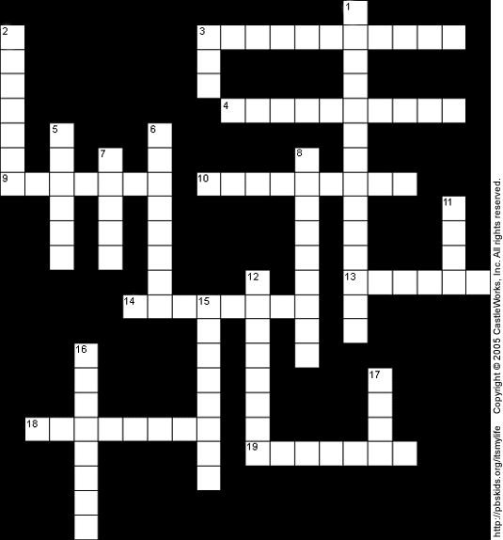

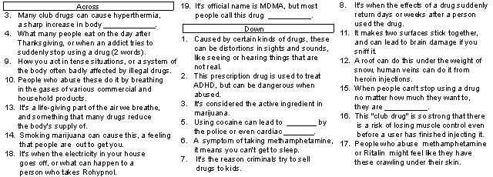

5. Healthy Way of Life
- Read the text with correct pronunciation:
People nowadays are more health-conscious than they used to be. They understand that good health is above wealth.
To be healthy we should avoid different bad habits that can affect our health. In my opinion, smoking and drinking too much alcohol, are the worst ones. It's common knowledge that smoking and drinking can shorten our lives dramatically. Smoking, for example, causes a number of heart and lung diseases, such as pneumonia, emphysema and cancer. Besides, it makes your teeth yellow and skin unhealthy. Fortunately, in recent years smoking has received a lot of bad publicity, and fewer people smoke nowadays. Some companies don't employ people who are smokers. Smoking has been banned in most public places because everyone agrees it does harm to our health. I don't smoke, because I don't want to have unhealthy skin and teeth and die young.
Smoking and drinking are joined by less dangerous habits, such as skipping meals, eating unhealthy food, or even overeating. Of course, they are not quite as deadly as smoking or drinking alcohol, but they also affect our health.
If we eat too much, we'll become obese, and obesity leads to serious health problems. A lot of people like drinking coca cola and coffee, and enjoy pizzas and hamburgers. But what is tasty is not always healthy. Fast food makes you fat, that's why Americans are the fattest people in the world.
In recent years eating habits have undergone a change. People are encouraged to eat less fat and more fiber. Fat is believed to be one of the major causes of obesity and heart disease. High fiber and low fat foods can now be found in all shops and supermarkets. Salads, beans, and fruit have taken the place of steak and ice cream. The fashion for health food is growing all the time.
Many people feel they are too fat, even if their doctors disagree. And a lot of people try to improve their fitness. There are a lot of ways to lose weight and avoid gaining it. Perhaps the most popular of them is following a diet. If you want to lose weight, you should cut out snacks and desserts, and cut down on fat. People have also become more aware of calories, the energy value of food. Some people count the number of calories they eat every day; so that they can try to take in fewer calories and lose weight. This is called a calorie-controlled diet. Manufacturers are increasingly producing special foods with fewer calories for slimmers.
But excessive dieting may be dangerous, too. Some people refuse to eat meat as they consider it harmful. They say a vegetarian diet reduces the risk of cancer and vegetarians live longer than others. I can't agree with them, because meat is an excellent source of good nutrition. In my opinion, it's wrong to put down a food simply because excessive amounts can cause health problems. Consumed in moderate amounts, meat is perfectly good for our health.
To my mind, the only way to stay healthy and to keep fit is by going in for sports. Among the benefits of regular exercise are a healthier heart, stronger bones, quicker reaction times and more resistance to various illnesses. Besides, you can eat and drink as much as you want because you are burning it all off.
To be healthy, it is also very important to spend a lot of time in the open air. It is useful to go for a walk before going to bed, or to air the room.
I think it is very important to be fit and healthy, and it is necessary to take care of your health. Being fat, in fact, can cause real problems. It is harder for fat people to get a good job, or even to make friends. If you want to do well, you must be thin. That's why I go in for sports on a regular basis. I have been doing aerobics for three years and I feel great. I am not enthusiastic about strict dieting, but I try to eat only low-fat food, and fruit and vegetables which are rich in vitamins.
Personally I believe that regularity in life promotes our health. Sleeping eight or nine hours, getting up early, regular meals, a healthy diet and going in for sports is really a good way to live.

- Learn this words:

health-conscious - заботящийся о своем здоровье
health - здоровье
healthy - здоровый
wealth - богатство
to avoid - избегать
to affect - влиять
it‘s common knowledge - общеизвестно
to shorten - сокращать, укорачивать
dramatically – резко
to cause - вызывать, быть причиной
heart disease - болезнь сердца
lung disease - болезнь легких
pneumonia - пневмония, воспаление легких
cough - кашель
cancer - рак
teeth - зубы
skin - кожа
fortunately - к счастью
publicity - реклама
to employ - нанимать на работу
to ban - запрещать
to do harm - причинять вред
to skip meals - пропускать прием пищи
overeating - переедание
obese - тучный, полный
obesity - тучность, полнота, ожирение
to lead - вести, приводить
tasty - вкусный
fast food - еда быстрого приготовления
fat - тучный, полный, жир
to undergo – подвергаться, претерпевать
to encourage – поощрять
fibre – клетчатка
to believe – считать, полагать
cause – причина
steak – бифштекс
fashion – мода
to improve – улучшать
fitness – спортивная форма
to lose weight – терять вес, худеть
to gain weight – набирать вес
to cut out – исключать
to cut down – снижать потребление
aware – осведомленный
energy value – энергетическая ценность
to count – считать
manufacturer – производитель
increasingly – все более, все в большей степени
to produce – производить
slimmer – худеющий (человек)
excessive – чрезмерный
dangerous – опасный
to refuse – отказываться
to consider – считать
to reduce – уменьшать
nutrition – питание
to put down – сокращать (потребление)
amount – количество
to consume – потреблять, съедать
moderate – умеренный
benefit – выгода, польза
bone – кость
susceptibility – восприимчивость
various – различный
to take care of – заботиться
thin – худой, стройный
strict – строгий
to promote – поддерживать, укреплять

- Answer the questions:
1. What good and bad health habits can people have?
2. In what way do bad habits affect people?
3. Are there any changes in health habits?
4. What is a healthy way of life?
5. What should you do to keep fit?
6. How does sport help you to stay healthy?
7. What are the most popular ways to avoid gaining weight?
8. What is a calorie-controlled diet?
9. What are your health habits?
10. What is your personal attitude towards health?
11. Do you have any health problems? Why do you think you have/don’t have them?

- Say what is healthy way of life:

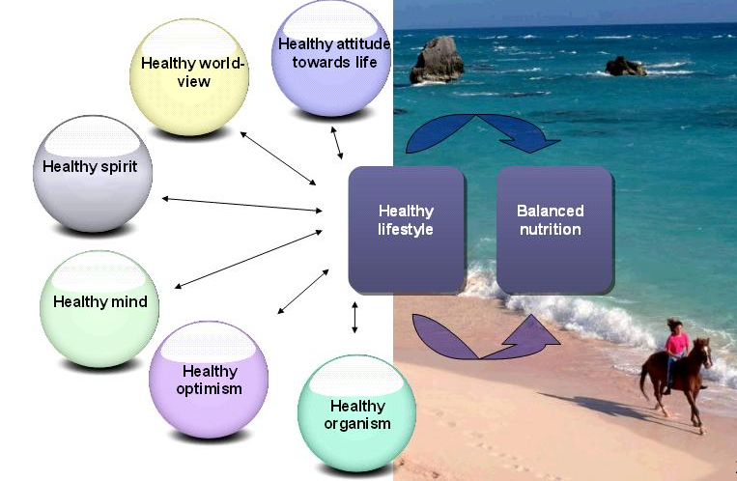

- Do the crossword:
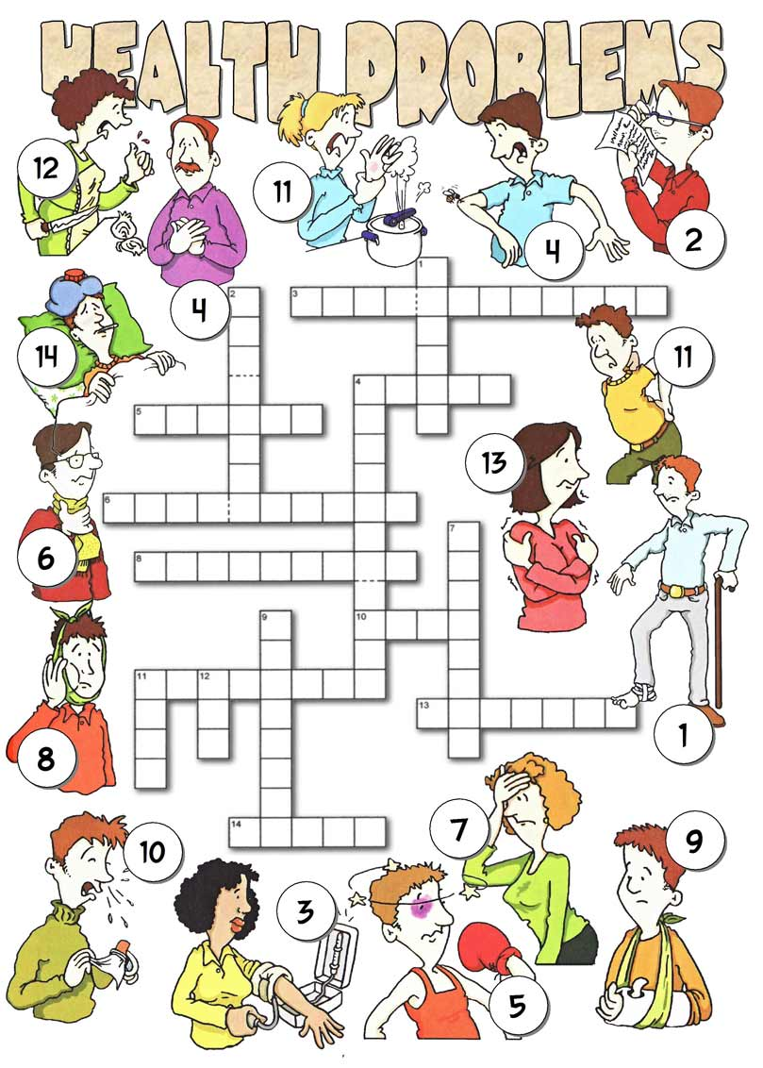

Список используемой литературы

- Аванесьянц, Э.М. Английский язык для старших курсов медицинских училищ и колледжей./ Э.М. Аванесьянц, Н.В. Кахацкая, Т.М. Мифтахова. – М.: «АНМИ», 2006. – 229 с.
- Баранова, Л.Г. Английский язык для медицинских училищ и колледжей. – Л.Г. Баранова, Т.В. Шадская - Изд. дом Дашков и К, 2007. – 336 с.
- Кисунько, Е.И. Английский язык. Все устные темы для подготовки к выпускному экзамену и ЕГЭ. 11 класс/ Е.И. Кисунько, Е.С. Музланова - Издательство: АСТ, 2014
- Тылкина, С. А. Пособие по английскому языку для медицинских училищ/ С. А. Тылкина, Н. А. Темчина - Издательство: «Альянс», 2012

ИНТЕРНЕТ-РЕСУРСЫ
- http://www.study.ru/
- http://abc-english-grammar.com/

СЛОВАРИ
- Большой словарь иностранных слов. - М.: ЛадКом, 2008. – 704 с.
- Новый большой англо-русский словарь: в 3-х т. / Ю.Д. Апресян, Э.М. Медников, А.В. Петрова. – М.: Рус. яз., 1993. – 1994 с.
- Macmillan English Dictionary for Advanced Learners. – Macmillan Publishers Limited, 2007. – 1749 c.

