министерство образования и науки Российской Федерации
Старооскольский технологический институт им. А.А. УГАРОВА
(филиал) федерального государственного автономного образовательного учреждения
высшего профессионального образования
«Национальный исследовательский технологический университет «МИСиС»
ОСКОЛЬСКИЙ ПОЛИТЕХНИЧЕСКИЙ КОЛЛЕДЖ

МЕТОДИЧЕСКАЯ РАЗРАБОТКА
Внеклассное мероприятие культурологической направленности на тему
«WHAT DO YOU KNOW ABOUT ENGLAND? »

Старый Оскол 2016

СЦЕНАРИЙ
ВНЕКЛАССНОГО МЕРОПРИЯТИЯ КУЛЬТУРОЛОГИЧЕСКОЙ НАПРАВЛЕННОСТИ НА ТЕМУ:
«WHAT DO YOU KNOW ABOUT ENGLAND? »

Мероприятие предназначено для студентов первого курса.
Цель: систематизировать знания учащихся по теме «Англия» в области устной и письменной речи.
Задачи:
Образовательные:
  - актуализация знаний, умений, навыков, приобретенных ранее, формирование и развитие речевых компетенций;
  - способствовать формированию навыков монологической и диалогической речи по теме внеклассного мероприятия;
  - отработка фонетических навыков.
Развивающие:
  - развивать внимание, память, логическое мышление, языковую догадку;
  - развитие коммуникативной компетенции учащихся.
Воспитательные:
  - воспитывать умение работать в парах и самостоятельно;
  - воспитывать уважительное отношение к культуре другой страны.
Оснащение: проектор, компьютер, тематические карточки с заданиями по английскому языку из серии «England», иллюстративная наглядность.

№  задания | название и суть задания | время выполнения | макс. кол-во баллов
I задание | приветствие: придумать название и девиз команды | 5 мин | max. = 5
II задание | разминка: А что вы знаете об Англии? | 5 мин | max. = 5
III задание | обучение устной речи: Вопросно-ответные упражнения на повторение и закрепление пройденного материала по данной теме | 12 мин | max. = 5
IV задание | нарисовать символ Англии. | 8 мин | max. = 5
V задание | решение кроссворда | 14 мин | max. = 5
VI задание | соотнесение картинки с изображенной достопримечательностью и слова | 10 мин | max. = 5
VII задание | найти слова, относящиеся к Англии в таблице из букв | 10 мин | max. = 5
VIII задание | прочитать о празднике в Англии и выбрать соответствующую открытку | 10 мин | max. = 5
IX задание | составление диалогов (как добраться до пункта назначения) | 11 мин | max. = 5
X задание | подведение итогов | 5 мин

Good morning, dear students and guests! I'm glad to see you. I hope, you're very well today.
The subjects of discussion are Great Britain and its biggest country - England. You already know a lot about Britain and its countries, its people, its customs and traditions. But some things are easily forgotten. Let's brush up our knowledge. We'll revise the material, we've done this term.

II задание. Разминка: What do you know about England? You should choose correct answer.
1.What country is it about?
The Loch Ness is in:
а) Wales;
b) Scotland;
с) England.
- Thе capital of England is: а)Cardiff;
b)London;
c)Edinburgh.
3. Thе symbol of England is:
а) the thistle;
b) the daffodil
с) the shamrock;
d) the red rose:
4. What countries does the Great Britain consists of:
- America;
- Australia;
- England;
- Scotland;
- Wales;
- Canada;
- North Ireland.
5. The word “ loch” means:
- The sea;
- The lake;
- The river.
6. Taxis in London are usually:
- green;
- yellow;
с) black.

III задание.

1.What are the colours of the British flag:
- Black;
- White;
- Blue;
- Red;
- Yellow.

2.Which of these cities are in England:
- New York;
- London;
- Oxford;
- Toronto;
- Sydney.

3.Which holiday is on 25th December:
- St. Valentine’s Day;
- Easter;
- Christmas.

4. Taxis in London are usually:
- Green;
- Black;
- Yellow.

5.What’s the name of the big river in London:
- The Don;
- The Thames;
- The Danube.
6.Тhе national dress of Scotland is:
а) shirt
b) skirt
с) kilt

V задание.
Do the crossword:

По горизонтали
2. On what holiday English children eats chocolate eggs
5. Who was lord protector of England
10. It is a highly populated region of England
12. The opening of the tennis tournament is celebrated on 1st June
15. It is 12th century university
18. The name of the parton of lovers
19. What is the birthplace of shakespeare?
22. It is one of the remarkable places in the UK, stone construction
24. The name of the queen whose birthday is celebrating the whole country

По вертикали
1. It is a place where dairy products are produced
3. Symbol of the holiday of St. Patrick
4. One of the region in the UK
6. The opening of the tennis tournament is celebrated on 1st June
7. In what area was Cromwell born?
8. It is a seat where monarchs sit
9. This is one of the famous historical cities of the UK
11. What time of year is celebrated day flowers
13. This building has 600 rooms
14. In what month Halloween celebrated?
16. This place is about 33 km west of central London
17. On what holiday people sings a carols
20. The annual London marathon
21. This city is well-known because of football club
23. Tourists
25. On what square put a Christmas Tree?

VI задание. Try to guess what refers to England?

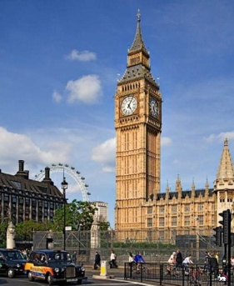 Big Ben 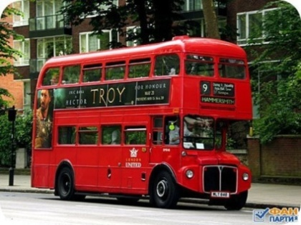 London Bus
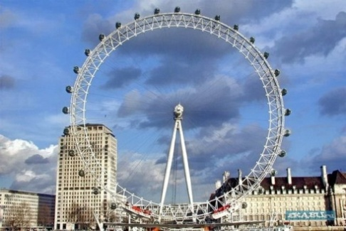 London Eye 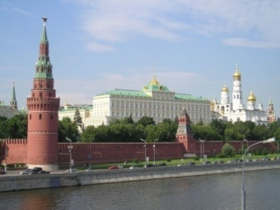 Kremlin
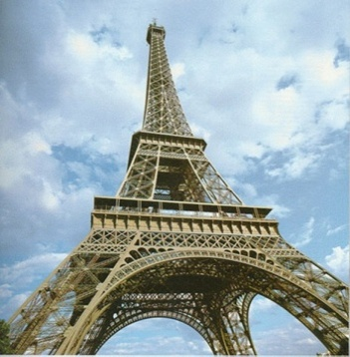 The Eiffel Tower 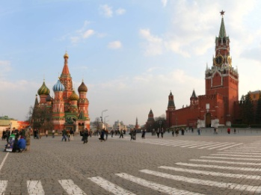 The Red Square

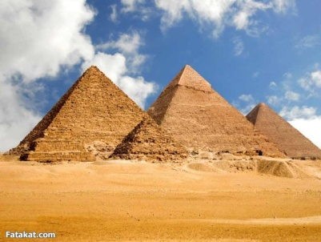
Egyptian Pyramid Tudor Rose
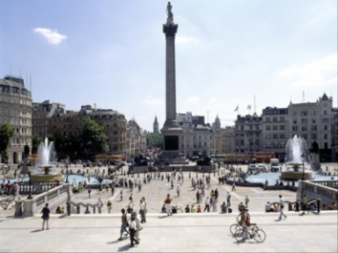 Trafalgar Square 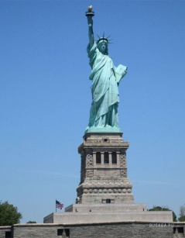 The Statue of Liberty

VII задание. Try to find all words.

N | B | U | S | P | D | K | F
D | I | A | R | M | J | M | L
J | G | S | B | C | L | S | A
M | B | D | D | X | L | A | G
L | E | H | S | S | O | N | Z
E | N | G | L | A | N | D | M
P | K | H | O | J | D | W | T
R | J | I | N | Q | O | I | U
J | D | Q | D | M | N | C | O
Y | S | P | O | X | W | H | L
W | A | I | N | M | E | S | K
R | O | S | E | V | T | K | D
H | O | H | Y | F | I | S | H
J | P | G | E | I | O | W | J

Big Ben; England; London; London Eye; Rose; Flag; Fish; Sandwich; Bus.

VIII задание.
Christmas in England.

All English people celebrate Christmas or Xmas on the 25th of December. It’s the greatest holiday of all in England. They give each other presents and send Christmas cards. Children find Xmas presents in their stockings. The traditional English dinner on Christmas is turkey and pudding.
On that day in Trafalgar Square there is a Christmas tree, which is over fifty feet high. It is a present from the people of Oslo. They send it to Londoners every year. There are big bright stars, shining balls of different colors all over the tree. Children and grown-ups like to stand and look at the Christmas tree because the tree is so very big and beautiful!

New Year in England.

Not all English people celebrate the New Year. Those who do, celebrate it on the 31st of December in one way or another.
Some have a New Year party. The party usually begins at about eight o’clock in the evening. At twelve o’clock they have a toast to New Year. Then the party goes on till early morning.
A lot of people go to Trafalgar Square to see the Christmas tree.
Another way of celebrating the New Year is to go to a New Year’s dance.
Some people stay at home and watch the celebration of the New Year on television.
There is another interesting New Year tradition in the North of England and Scotland. It’s an old custom of First-Footing. In Great Britain the fist visitor who comes into a house on New Year’s morning is called the First Foot.
This visitor is very, very important. The English people believe that the First Foot brings luck to the family for the following twelve months.
The First Foot comes very early, and the sooner he comes, the better. He brings some simbolic presents of food (usually a piece of bread), a piece of coal, a coin. That means that the family will have good luck, will be happy and rich in the coming year. The fist foot also brings an evergreen branch as a promise of continuing life.

Pancake day.

Pancake Day is a funny and tasty holiday with the English. It is usually in March. People eat pancakes! They have pancakes not only at home, but at school as well.
But they not only eat pancakes, they …run with them! In some villages and towns in England pancake races take place every year. These races are run by housewives must wear aprons, they must put on hats on their heads. They must run about 415 yards (410 miters). A bell rings twice before the race. With the first bell the women must make their pancakes. With the second bell they start running with a pancake in the frying pan. They must toss the pancake three times and catch it back on the frying pan. If the pancake falls down, the runner may pick it up and toss it again. The other members of the families watch the runners and cheer: “ Run, mum, run, run quickly!”

IX задание. The last round is «London’s streets». Do you know that there is more than 1,000 streets in London and taxi drivers must know all the streets by heart? Let's take a walk along the streets of London. Tourist can not orient well in city, so he should know how to ask for help. Imagine that you are a tourist in London and find out how to get to a particular place in the city (each team gets a map of London and a few key words to produce a dialogue.) Make up the dialogues and act them in the class.
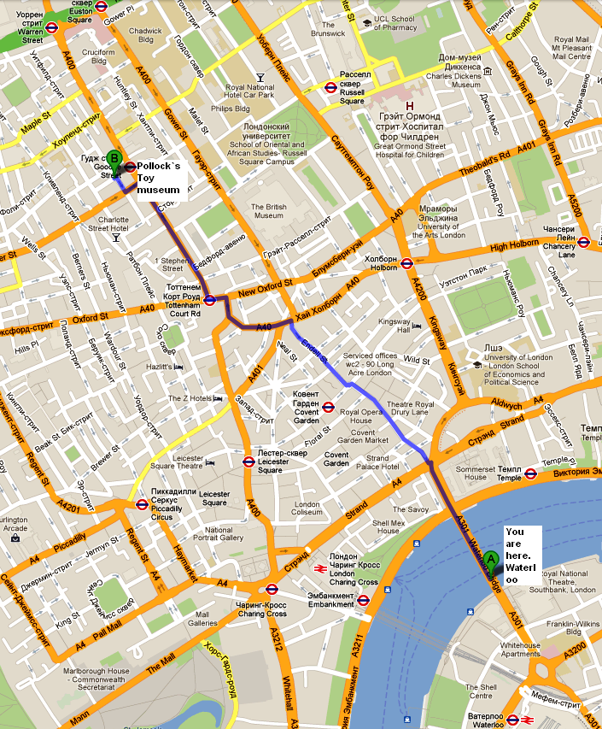
Excuse me…..
Could you tell me how to get to…..
Turn left \ turn right….
Go down there
Take the first on the left….

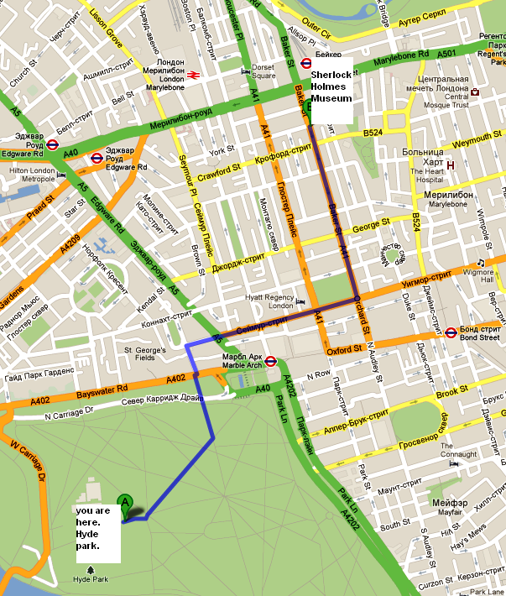
Excuse me…..
could you tell me how to get to…..
Turn left \ turn right….
Go down there
Take the first on the left….

X задание. Our game is over. Our jury will add up the score of the game.
Jury: Thank you for your work. It was good. We have two nominations «attentive and resourceful» and «fast and cheerful». The winner in the first nomination is «………» team. The winner in the second nomination is «………» team.

Teacher: Thank you for your work, too. It was a great pleasure for me to play with you today. Have you enjoyed our lesson? I think «Yes». And now let’s have tea with sweets and biscuits.

turkey - индейка
Trafalgar Square – Трафальгарская площадь
Oslo – столица Норвегии.
Scotland – Шотландия.
coal - уголь

