ДЕПАРТАМЕНТ ОБРАЗОВАНИЯ И НАУКИ КЕМЕРОВСКОЙ ОБЛАСТИ
ГОСУДАРСТВЕННОЕ ОБРАЗОВАТЕЛЬНОЕ УЧРЕЖДЕНИЕ СРЕДНЕГО ПРОФЕССИОНАЛЬНОГО ОБРАЗОВАНИЯ
«НОВОКУЗНЕЦКИЙ СТРОИТЕЛЬНЫЙ ТЕХНИКУМ»

О. А. Паршукова

Учебное пособие по развитию навыков чтения

Для студентов первого курса средних профессиональных учебных заведений и старшеклассников общеобразовательных школ.

Новокузнецк 2014

O. A. PARSHUKOVA

ENGLISH READER
WELCOME TO KUSBASS

Novokusnetsk 2014

Предисловие.
Предлагаемое учебное пособие по развитию навыков чтения «English reader. Welcome to Kusbass» может служить дополнительным пособием для учащихся школ 10 – 11-х классов, а также для студентов средних профессиональных учебных заведений (первый и второй курс). Тексты учебного пособия могут быть полезны преподавателям и учителям при работе над темой «Экология. Природа Кузбасса» на английском языке. Материалы текстов могут быть также использованы для проектной деятельности по краеведению. Пособие может быть использовано как для внеаудиторного чтения, так и для работы в аудитории под руководством преподавателя. Для этого автором пособия были разработаны предтекстовые и послетекстовые упражнения. При желании преподаватели могут использовать другие виды активизации языкового материала по теме.
Тексты сборника объединены в тематические главы. По мнению автора, такое расположение материала способствует большей цельности книги и облегчает пользование ею.

This beautiful and fragile world.
Part I
Water is a wonderful gift (I)
Exercises
- Read and translate the words. Make up your own sentences.
(Picturesque river, water stocks, sandbanks, nature monument, raffling, rock banks, non- examined)
- Comment on the following quotations from the text. Give the reason for your opinion.
- “SAVE WATER! There is no life, happiness, and wealth. There is nothing without water!”- academician A. Fersman said, we have nothing to add…
- How can we clean the Tom? The river can be cleaned only by itself. It is not idle conjecture it’s a Law of Nature.
- Read and translate the text.
Save water
Kemerovskaja region is rich not only in coal but also in fresh water. It is our treasure.
The average length of all rivers (short, long, deep, shallow) flowing along this territory is 32109 km.; common length is about 245152 km.
The biggest river, the Tom is over 600 km. long only in the Kemerovskaja region is also a home for 509 rivers. Each one carries its water for 10 km to discharge itself into the main waterway.

The main river uses are: to quench thirst of cities, towns, small villages, and great works and factories, it is irreplaceable for agricultural development and for transportation. There are some places of rest. We use its banks for gardens, cottages, households, and tour camps.
There are 850 big and small lakes in Kusbass, and 65 of them are high in the mountains with crystal clear water.
The region has considerable underground water stocks. Novokusneck uses 33% amount underground water stocks a day, but the rest water is taken from the Tom consumes about 450 thousand m3 of water.
A person needs 300 thousand m³ of water to grow one ton of wheat, 5- 10 thousand m³ for artificial irrigation of agricultural field.
One cow drinks 60 liters a day, but a sheep or a goat needs 10 liters.
“SAVE WATER! There is no life, happiness, and wealth. There is nothing without water!”- academician A. Fersman said and we have nothing to add…
Traveling down the river.
You may have a wonderful journey along the main river, the Tom and its tributaries, the Belsu, the Mrassu, the Usa, the Condoma, the High, the Middle, the Low Ters and the Taidon.

The picturesque river Kija, flowing in the territory of Mariinsk and Tisul regions, attracts attention by the unique “nature monument”. Reach large fanciful rocks rising out of the water up to a hundred meters high, caverns, grottos and waterfalls. This place is called “White Stone”
The Kija is famous for its beauty on the one hand and danger on the other.
Sandbanks, holes, rocks attend you! Among them are Serditij (Angry, Sour), Kiputsij (Boiled), Lohmatij (Tousled), Banditskij (Band). Sandbanks Barhatnij (Velvet), Mramornij (Marble), Zolotoj (Gold) fascinate you with wildlife.
The river Kija has three wonderful tributaries. The rivers banks are covered with thick forests. The most famous ones guard the current of the Mrassu, one of the picturesque rivers in Mountainous (Hilly) Shoria. If you walk in the heart of the wood, you can meet an elk, a deer (a maral), a bear. In the river water live otter, muskrat, also there are valuable kinds of fish, such as kharius, taimen and lenok as well.
While floating or rafting down the river you can visit one of the well known Mrassu’s caverns, existing practically on the whole territory of Mountainous (Hilly) Shoria.
The “nature monument” The Mednaja (the Copper) mountain is a fine place for fishing and swimming. Traveling farther down the current, you are taking delight from major lands and picturesque rock banks.
You can also visit the largest lake of Kusbass, situated in Tisul region in an ecologically fine zone. Big Bertshikul with its mud- treatment opportunities is also a rare place where marketable fishing prospers.
Belsu is the only part of our region that has simple hunting craft industry and nothing more. The picturesque landscapes, hills overgrown with Siberian plants, are famous by conifer, 40% of old cedar belong to them.
Fauna contains about 120 species of nesting birds; some of them are very rare and non-examined well enough until today: king chiff- chaff, nightingale- whistler, blue- nightingale, needle- tail martlet, and ets.
Hunters track down sables and kolinskies. Belsu is the only way of marals (dears) and roes’ migration from Khakasija.
There are no towns, no villages on the river’s banks, which means no pollution at all! The water is crystal pure! A man can drink it without danger! The lovers of fishing dream to visit these unforgettable places, spawning fish, to take wonderful photos of catching kharius or tajmen.
If you have a look at the map of the Tom’s flowing, you’ll see its meandering. It makes deep holes on the bottom, the plate places on the left turn out into fields and meadows. On the right bank river stretches Kusnetskij Alatau and the Saltimakovskij range. Small streams and rivers, short brooks and subterranean springs fall into the “main water” from the valley and from foothills…
How can we clean the Tom?
The river can be cleaned only by itself. It is not idle conjecture it’s a Law of Nature.
The Tom “knows” what to do: it mixes water on the sandbanks, filters it through pebble spits, freshens with cold springs, and settles in deep quiet and wide rocks.
Don’t prevent it!
There are dozens of big and small islands in the middle of the Tom’s flow. A part of the ground is overgrown with trees, bushes and grass. The river becomes shallow now and big ships don’t go along this “Siberian Beauty”.
- Fill in the gaps with the words in brackets.
(Territory, the thirst, water stocks, academician, tributaries, rocks)
1. The average length of all rivers flowing along this …. is 32109 km .
2. Rivers quench …. of cities, towns, small villages, and great works.
3. There is nothing without water! - …. A. Fersman said , we have nothing to add.
4. Sandbanks, holes and … attend you.
5. The region has considerable underground … …
6. The Tom has five beautiful …
- Answer the questions.
1.What is the average length of all rivers in Kusbass ?
2. What are the rivers used for?
3. How many lakes are there in our region?
4. What is the main river of Kusbass?
5. Were does the river Kija flow?
6. What «nature monuments» do you know?
7. How many tributaries does the Kiia have ?
8. What lake has mud-treatment opportunities?
9. What plants are the most famous in Siberia?
10. How many species of nesting birds are there in Belsu region?

VI. Do you agree or not? Choose the right answer. True or Falls?
- The average length of all rivers flowing along this territory is 30102 km – F
- The river doesn’t give us its banks for gardens, cottages, household, and tour camps. –F
- In the mountains there are rivers with crystal clear water. – T
- One cow drinks 10 liter a day. – F
- The Kija is a dangerous river. – T

- The Fauna contains about 120 species of nesting birds. – T

- The water in the Kija is not very pure. – F

- Big Bertshikul is a marketable place for fishing. – T

- Belsu is the only part of our region that has hunting craft among other industry. - F
- The Tom was shallow and big ships didn’t go along it. – F

- Write the composition on the topic “My favourite river“.Use extra material.
Part II
In the forest (I)
Exercises
- Read and translate the words. Make up your own sentences.
(Bio-diversity, species, vertebrate animals, forest trip, trunk, similar, to be tolerant)
- Comment on the following quotations from the text. Give the reason for your opinion.
- Kemerovskaja region is included into Altaj – Sajansk eco – system. We have many objects to be proud of and to save for future generations.
- Welcome to Kusbass! Take it at the first sight!

- Read and translate the text.

Bio-difference
Ants and elephants, alga and mushrooms, all creations comprise the biosphere of the planet. It preserves common surrounding finally used by humanity. We’ll become extinct like dinosaurs without natural world. Therefore, the progressive countries signed in 1992 in Rio – de – Janeiro the Convention about conservation of biology and the difference it can make.
The specialists of international organizations allocated more than 200 territories on the Earth with increased bio – diversity.
Kemerovskaja region is included into Altaj – Sajansk eco – system. We have many objects to be proud of and to save for future generations.
The modern fauna of vertebrate animals includes about 450 species: 68 mammalians, 325 species of birds, 6 reptiles, 5 amphibians, 42 species of fish and cytoplasms.
92 species of animals are either rare, endangered or already extinct.
Flora of our region is also very rich and includes 1585 sorts of plants, 400 sorts of moss and the same quantity of lichen.
Among them, there are several varieties unique sorts: oats, buttercups, serpentine. The Siberian globe – flower is a beautiful wide – spread plant loved by all the citizens. It’s not only pretty to look at, but medicinal as well; you can use its extract with oats.
Enjoy your forest trip
Nature has many mysteries exciting and intriguing. You have a chance to be surprised. Thousands of people consider the trip to be the greatest adventure of their lives. Why relax in warm Mediterranean, when you can get pleasure at home, when you live in great Kusbass, wonderful and unique.
Are you an adventurer? Would you like wandering in the forest?
Welcome to Kusbass! Take it at the first sight!
Don’t forget to pass through the Siberian Pine or Cedar forest.
The Siberian Pine (Pinus siberica; family Pinaceae) is a species of pine tree that occurs in Siberia. In the north of its range, it grows at low altitudes, typically 100-200 m, whereas further south, it is a mountain tree, growing at 1,000-2,400 m altitude. It often reaches the alpine tree line in this area. The mature size is up to 30-40 m height, and 1.5 m trunk diameter. Its maximum lifetime is 800-850 years.
Siberian Pinecones are 5-9 cm long. The 9-12 mm long seeds have only a vestigial wing and are dispersed by Spotted Nutcrackers.
Siberian Pine is treated as a variety or subspecies of the very similar Swiss Pine (Pinus cembra) by some botanists. It differs in having slightly larger cones, and needles with three resin canals instead of two in Swiss Pine.
Siberian Pine is a popular ornamental tree in parks and large gardens where the climate is cold, such as central Canada, exhibiting steady though not fast growth on a wide range of sites. It is very tolerant of severe winter cold and hardy down to at least –60°C, and very tolerant of wind exposure. The seeds are also harvested and sold as pine nuts.
The Russian name Сибирский кедр (tr. Sibirsky Kedr) is often miss-translated in English as "Siberian Cedar"; references to "cedar" in texts translated from Russian usually refer to this tree or related pines, not to cedars. However, in our book we call it by its double name: pine- cedar.
- Fill in the gaps with the words in brackets.
(Creations, future generations, moss, adventure, occurs, ornamental).

- Ants and elephants, alga and mushrooms, all … comprise the biosphere of the planet.
- We have many objects to be proud of and to save for … …. .
- Flora of our region is also very rich and includes 1585 sorts of plants, 400 sorts of … and the same quantity of lichen.
- Are you an … ?
- The Siberian Pine is a species of pine tree that … in Siberia.
- Siberian Pine is a popular … tree in parks and large gardens where the climate is cold, such as central Canada, exhibiting steady though not fast growth on a wide range of sites.
- Answer the questions.
- What year did the Convention in Rio-de-Janeiro take place?
- How many territories on the Earth have bio-diversity?
- What eco-system is Kemerovskaja region included into?
- How many sorts of plants does the flora of our region have?
- How many sorts of moss and Lichen are there in Kemerovskaja region?
- How can we call a cedar? Why?
- What is a cedar’s height?
- What is a cedar’s life time?
- What t° is it tolerant of?
- Do you agree or not? Choose the right answer. True or Falls?
- The progressive countries signed in 1929 in Rio – de – Janeiro the Convention about conversation of biology. - F
- Kemerovskaja region has many objects to be proud of and to save for future generation. – T
- The Flora of the region is very rich and includes 1585 sorts of moss and the same quantity of lichen, 400 sorts of plants. – F
- Siberian pinecones are 5 – 9 cm long. – T
- The natural cedars sizes are up to 30 – 40 m height, 1.5 m trunk diameter. - T
- Write the letter to your pen friend on the topic “ Welcome to Kusbass “ .Use extra material.

In the forest (II)
Exercises
- Read and translate the words. Make up your own sentences.
(Climate, was found, treatment, resin and balm, scientist, vitamins, thick forest)

- Comment on the following quotations from the text. Give the reason for your opinion.
- Could you believe the Pine was 200 years elder than Heops pyramids!
- Siberian cedar surpasses all other kind of pines; it is a real treasure of our region.

- Read and translate the text.

Conifers
As well as flower plants, conifers are reckoned as the most necessary and important ones whether in nature or in human’s life. Conifers play the great role for profiting in the wild world.
In conifer forests, the great muss of organic substance are kept, existing like the most valuable source of wood and other important goods. Conifer forests (trees) belong to the highest plants of evolutionary level.
Geological history of conifer plants began with carbon more than 370 ml. years ago. The rates of their evolution are very low. The record of the longest life belongs to one North-American pine (Pinus longaever). It was found in Earth Nevada, the age of the tree is determined as about 5 000 years. Could you believe the Pine was 200 years elder than Heops pyramids!
In modern conifer trees there are much pitch passages long and narrow, full of essential oil, resin and balm. Dead cellules, surrounded with 1-2 rows of alive cells, full of thick cytoplasm with nuclear and some other nutriments: drops of oil and grains of starch.
In these trunks conifer trees display bright rings of wood accretion coursed by the kombi season period activity, which connected with year changing. Each ring shows one season’s stout. Conclusions about climate in the past can be made using the tree rings and it’s wood accretion. These facts are used in the dendrochronology (a branch of science).
Cedar (Siberian pine) is a wonderful tree, Pride of Siberian taiga. It’s long, mild, threeside needles at 5 in one fascicle “live” on the branches from 3 to 7 years. It’s flowers, pollinated with wind are violet- red colored. Seeds- nuts covered with hard shell are dark- brown. A tree begins harvesting in 15-25 years in an open place and in 50-60 years when it grows in the thick forest.

Medicinal effect
The most valuable are pine –cedar nuts with their shell, needles, branches, pine pitch. Nuts are very tasty with high percent of essential oil (60-70 %), the best for the human body. They are perfectly assimilated by human used by treatment for making medicine. This type of oil contains about 20% of fiber, 12% of starch, 2% of pentazan, 4% of cellulose, 2% of ash that has some microelements, vitamins B, D.
If we have an opportunity to give only a handful of nuts for adults and children a day, they can nicely improve their health, strength immunity and increase longevity.
In 1792 Russian scientist, P.S.Pallas wrote that Siberian pine- cedar nuts restore men’s forth and return youth.
In folk medicine nuts’ milk, used against tuberculosis, for treatment of kidneys and bladder problems. Shell extract is used against piles. Young conifer tops, buds, soft needles contain ascorbic acid, essential oil and microelements suitable for treating scurvy. Nowadays it is broadly used in toothpaste production to fortify gums.
To make a vitamin drink take cedar needles and branches soak them with hot boiled water for 2-3 hours. Then it is ready to drink it.

The second way of making infusion maintains more vitamins. Take equal parts of cut needles and cold water with citric acid. Put the extract in warm place for 2 or 3 days, than have it.
The cedar pitch flowing out of the trunk notch possesses unique specific antibacterial properties. It often used for curing wounds, chronic ulcer, and furuncles.
In chemical factories, cedar pitch is used as raw material in synthetic camphor production for external remedies.
Cedar needles and pitch distinguish much phyto substance, which act as destructive influence on harmful microbes.
Siberian cedar surpasses all other kind of pines; it is a real treasure of our region.
- Fill in the gaps with the words in brackets.
(The great, harvesting, substance, record, Heops pyramids, wonderful)
- Conifers play … role for profiting the wild world.
- In conifer forests the great moss of organic … are kept, existing like the most valuable source of world and other important goods.
- … of the longest life belongs to one North-American pine.
- Could you believe the Pine was 200 years elder than … !
- Cedar is … tree, pride of Siberian taiga.
- A tree begins … in 15-25 years in open place and on 50-60 years when it grows in the thick forest.

- Answer the questions
- What role do Conifers play in the wild world?
- When did the geological history of conifer plants begin?
- How many years was the Pine in Earth Nevada elder than Heops pyramids?
- What are the most valuable parts of pines?
- What substances do nuts contain?
- What did Russian scientist P.S. Pallas write about cedar nuts?
- What diseases can be treated with a help of nuts milk?
- How can a person make vitamin drinks?
- What properties have the cedar pitch?
- Why the Siberian cedar is a real treasure of our region?
VI. Do you agree or not? Choose the right answer. True or Falls.
- The most valuable are pine nuts with their shell, branches and pine pitch. – T
- This type of nut oil contains fiber, starch, pentazan, cellulose, ash and vitamins A, B. – F
- In folk medicine nuts’ milk is used against tuberculosis and for treatment other lung diseases. – F
- In 1791 Russian scientist wrote that Siberian pine – cedar nuts restore men’s forth and return youth. F
- Nuts oil is used for treatment of kidneys and bladder, but shell extract is used against piles. T
- In folk medicine young conifer tops were used for treating scurvy, but nowadays they broadly used in toothpaste production to whiten teeth. F
- Cedar forests are useful for a person and they act as destructive influence on harmful microbes. T
VII . Write the composition on the topic “Conifer”. Use extra material.

In the forest (III)
Exercises
- Read and translate the words. Make up your own sentences.
(marals, elks, tsar’s, hunting, iron – ore production, on the 17- th century)
- Comment on the following quotations from the text. Give the reason for your opinion.
- . Cedars forests play the great role in presenting the animals and birds who aborigines have been historically hunting.
- At the beginning of the 17-th century, only 250 of beavers’ pelts were received by region authorities.
- Read and translate the text
Bio- difference in pine- cedar forest.
Forests with cedar trees keep more than 2/3 of fauna mammalians. Cedars forests play the great role in presenting the animals and birds who aborigines have been historically hunting. Animals, such as sables, dears (marals), elks, brown bears, white hares, beavers, and squirrels.
In tsar’s Russia, the main barter taxing between state treasury and the native people consisted of hunting and iron-ore production. At the beginning of the 17-th century, only 250 of beavers’ pelts were received by region authorities.
Later, in the 20-th century, during the Soviet period, the demand for furs changed several times. In addition, even small value furs were stored up. For example: chipmunk, polecat, American mink and white hare.
But only in cedar forests can live and breed the most valuable and famous specie. I mean sable whose fur is always in vogue at any time, at any century.
In the Soviet period, some attempts were made to put sables into other forests such as Salair Ridge, but all those attempts failed. Sables prefer only cedar forests.
Nowadays, sables number about 5800 individuals, are found in Mezhdurechensk, Tashtagol, Tisul region, in hunts of Shoria National Park far from civilizations.
Pine- cedars stretches on 4, 5% of all the forests in Kemerovskaja region and have from 62 until 83% of beasts and fish. But not only that. There is some wild growing in cedar taiga: colba (cheremsha, allium victorialis is the Latin name), red and black currant, raspberry, bilberry, snowdrops, maral root, gold root, cedar nuts, est. These plants are so useful!
- Fill in the gaps with the words in brackets.
(Forests, taxing, prefer, soviet, sable)
- Cedar …play the great role in aborigines life because of their hunting.
- In tsar’s Russia, the main barter… between state treasury and the native people consisted of hunting and iron – ore production.
- Later in the 20 – th century during the … period, the demand for furs changed several times.
- It is … whose fur is always in vogue at any time, at any century.
- Sables … only cedar forests.
- Answer the questions
- What animals live in Siberian forests?
- What were the main barters between state treasury and native people in tsar’s Russia?
- What fur animals were popular during the Soviet period?
- What is the sables’ number in our region nowadays?
- Where is Shoria National Park situated ?
- How many per sent (%) of all the forests in Kemerovskaja region do pine – cedar compose?
- What plants growing in cedar taiga do you know?
- Do you agree or not? Choose the right answer. True or Falls?
- Forests with cedar trees keep more than 1/3 of Fauna mammalians. – F
- Sables, dear, white bears and hairs, beavers and squirrels live in cedar forests. – F
- At the beginning of the 17- th century only 100 of beavers pelts were received by region authorities. F
- Nowadays, sables number about 5800 individuals are found in Shoria National Park not far from civilizations. F
- Pine cedars have from 62 until 83% beasts and fish of our region. T

- Write the composition on the topic “In the Siberian taiga” “.Use extra material.

Part III
On holidays (I)
Exercises

- Read and translate the words. Make up your own sentences.
(Layman, to sell, to pick, risk, to cross, to shell)
- Comment on the following quotations from the text. Give the reason for your opinion.
- If you want to get cedar cones, wait until autumn, don’t be in a hurry!
- Citizens began to attack, by great surprise, at poor cedars even in July.

- Read and translate the texts.
Getting cones.
If you want to get cedar cones, wait until autumn, don’t be in a hurry! Our wonderful country people are obsessed by the idea of getting more, much more, paying less and selling expensive. Having such “beautiful” thoughts, citizens began to attack, by great surprise, at poor cedars even in July.
If you are a layman, not a professional, you’ll take a great sack or two and that’ll do for you. If you try to sell nuts, take several sacks and a horse. You’re lucky to get to the one- line cedar taiga. It is unforgettable adventure.
Take a big wooden beetle with you. You see a cedar and determine it as a young tree. Than put the wood beetle at the trunk, have fitting and beat several times. Act very carefully! I know that your friends are staying with wildly opened mouths and watching you, holding their breath. They get many blows on their heads with cedar cones that begin to fall.
However, if the cedar is gigantic, old, greatly thick, your beetle is useless. Then make like this: the youngest and the most quick- moving fellow climes the tree and shakes separate branches. You are leading him covering your forehead: “Right, left!” If your friend is lucky, you’ll catch him.
What ways do you elect? Certainly, none of them. It’s a joke. Do you know what to do? Wait until September and you’ll pick the cones up from the earth without any risk.
Early, unripe cones are tarred with resin. For example, you want to crack nuts tasting them. You can take one cone in hand trying to tear high husks together with resin or you can boil it. Take any kettle or bucket, put cones, pour water, plug some grass and cover the cones in the bucket. Its content begins gurgling rather quickly on the open fire. Resin comes to the surface and is soaked up by the grass. In 5 min., cones are ready. You can have nuts after cooling.
Thus another period comes: cones hulling or shelling. You need two wooden boards or rollers with deep notches for braking or squashing cones. The seeds drop on any litter together with shells, to strip seeds from shells one uses two sieves with holes of different diameters. Finally, you get pure cedar nuts.
A funny story.
Three “Siberian men” went to taiga to get nuts and to have a good time. They were told, “to cross seven streams and rivers in fords” from the place Gelsan. Men’s hike was long and exhausting. At last, they saw cedars and stopped. Immediately they started eating and drinking. One fellow clamed a cedar and shook its branches, cones felt on their heads, making lumps on their foreheads. After that wonderful “Siberian men” continued their meal, enjoying themselves and felt asleep near the fire without even any tents. One of them awoke during the night and heard strange noise and rustling. Next day they got up jaunty, without any headache at all. No wonder! If they slept inside the tent, their bodies would be poisoned with bad fumes, but resinous smell, rare essential oil, pure medicinal air made its affair. In the morning, they wanted to pick cones up, do you think they could? No, the answer is wrong, they couldn’t. The cones were empty: squirrels, chipmunks, nutcrackers, mice “worked” for the whole night, shelling cones, regaled themselves and thanked “Siberian men”.
Max, 30
- Fill in the gaps with the words in brackets.
(To be in a hurry, citizens, a good time, cones, September, hulling)
1. If you want to get cedar cones, wait until autumn, don’t .. …
2. Having such thoughts, … began to attack the poor cedars even in July.
3. They get many blows on their heads with cedar … that begin to fall.
4. Wait until September and you’ll pick the cones up from the earth without any risk.
5. Thus another period comes: cones … or shelling.
6. Three men went to taiga to get nuts and to have … …
V. Answer the questions.
- In what time must people get cones?
- What do you need if you want to get cones
- Why do you need a big wooden beetle?
- How can you pick cones in September?
- Why is it difficult to taste unripe cones?
- Why must a person boil cones? How?
- What do you need if you want to hull or to shell cones?
- What kind of air is there in cedar forests?
- What useful substances does it contain?
- Why did three men go to taiga?

- Do you agree or not? Choose the right answer. True or Falls?
1. If you want to get cedar cones, wait until winter, don’t be in a hurry. F
2. Getting cones is unforgettable adventure. T
3. Wait until May and you’ll pick the cones up from the earth without any risk. F
4. You cannot taste nuts in unripe cones. T
5. Boil unripe cones for 15 minutes. F
6. You’re unlucky to get to the one – line cedar forest. F
7. Men’s hike was long and exhausting. T
8. A girl clamed a cedar and shook its branches. F
9. Next day they got up jaunty. T
10. Their cones were full. F
VI. Write the composition on the topic “Cedar cones” .Use extra material.

On holidays (II)
Exercises
- Read and translate the words. Make up your own sentences.
(To beat, to miss, to give up, a squirrel, a lecture, offence)
- Comment on the following quotations from the text. Give the reason for your opinion.
- Kostenkovo is a popular place you know.
- My friend in the camp allured one squirrel, it clamed his jeans, T- short and took biscuits from his mouth.
- Read and translate the text
In the camp.
Once, my friend and I went to the camp. The camp was in the cedar forest and I visited it every summer. Kostenkovo is a popular place you know.
In the morning, as usually, everybody makes the beds, washes faces, than goes to do the exercises; we call it “Cheerful”. Oh, they invited us to breakfast, standard and untesty: serial, bread and cacao. Than in our time- table, there was “a break, “a window” that lasted for two hours. I decided walking through taiga alone.
Suddenly a big cone felt on my head and beat me badly. I looked round, saw nobody and went further. Again, something felt on my forehead, I surveyed- nobody. Then I lifted my eyes and saw a sour squirrel. It was cracking a nut, then jumped and turned, waging with its tail. I picked up a small cone and threw it up. Of course, I missed and hardly even troubled the sour squirrel. I run back to my group, called my friends and we went to the same place. Dead silence met us there and it lasted for some minutes, then husks and cones flew to our heads. We took a great offence, picked up cones from the earth and threw them in the cedar. Suddenly I saw that it was two squirrels. Oh, it was a real battle, and we honestly lost, didn’t ever hit them once, but our “symbolic adversary” shot like expert shooters!
Boys got away but didn’t give in. That day in the camp we had dinner, “cool” games, disco, but I was inexorable. I gathered the whole team; we went to the same place in anticipation of adventures and the end of the “great war”. Nobody was there, the squirrels run away, the “enemy retreated”. Ha-ha-ha.
That evening, our Leader gave us a lecture about squirrels. It turns out; they are best of prey and time to time ruin nests of singing birds, that’s why there are no birds’ songs when squirrels “boss the show”. These small animals fret and fume when people encroach upon their territory. But on the other hand, they take treatment with great pleasure. Therefore, we rested a small hill of nuts, biscuits, wafels, under the tree. In a day, the small hill disappeared. Thus, we made up. My friend in the camp allured one squirrel, it clamed his jeans, T- short and took biscuits from his mouth with its forepaws.
Next summer I’ll try to do the same.
Vova, 12

- Fill in the gaps with the words in brackets
(The camp, treatment, time – table, squirrel, beat, run away)
- … was in the cedar forest and I visited it every summer.
- Then in our … there was a break, “ a window” that lasted for two hours.
- Suddenly a big cone felt on my head and … me badly.
- Then I lifted my eyes and saw a sour … .
- Nobody was there, the squirrels … … and we were sad.
- But on the other hand, they take … with great pleasure.

- Answer the questions
- Where was the camp situated?
- How did the boy call the morning exercises?
- How long did “a window” last?
- Where did the boy notice a squirrel?
- Why did the boys return to the forest?
- What did the Leader tell about squirrels?
- What did these animals feel when people encroach upon their territory?
- Who took “a small hill” of treatment in the forest?
- Who allured one squirrel after the “great war”?
- What did the boy want to do next summer?
- Do you agree or not? Choose the right answer. True or Falls?
- The camp was near the birch groove and the boy visited it every summer. F
- The breakfast was standard and tasty: serial, bread and cacao. F
- The boy decided walking through taiga alone. T
- Then he lifted his eyes and saw a nice pretty squirrel. F
- It was a “real battle” but the boys had lost. T
- A squirrel never leaves the forest because of a person. F
- The boy wanted to replay his adventure. T
- Write the composition on the topic “ In the camp” .Use extra material.
On holidays (III)
Exercises
- Read and translate the words. Make up your own sentences.
(To catch kharius, modest, puddle, cozy, to swamp, arrogant, to thump)

- Comment on the following quotations from the text. Give the reason for your opinion.
- I thought it would be better to sell the Kija water instead of cola in the town.
- A man threw spinning. A fish thumped but didn’t give in.

- Read and translate the text.

Fishing
My friends are serious people; they live in high industrial towns, have a good education, are hard workers; they are wise husbands and strict fathers. However, once a year they are transformed into adventures. This wonderful change takes place in August when they become simple fishmen for the holidays. We are in a habit of going to Kija to catch kharius.
Last year we found Happy islands. First the men’s company swam by boat 150 km to the upper Kija. When we had landed on the bank we saw thousands of forest peonies. In this place, we all fell on knees and began to pray lamenting laud: “Oh, Mother Kija! Be kind to us! Don’t drown us! Take us with peace and love! Feed and drink true slaves of Thee! Amen!”
The river was crystal pure, the entire stones- white, blue, green, red and flagged bottom were seen from one bank to another, it looked like puddle. I made a step, trod and sank through waist-deep into the water. What an optical illusion! I thought it would be better to sell the Kija water instead of cola in the town. We skied glide along clear glass surface in the boats but I dreamt as if tobogganed. We moved further turned and got into the tale in Fair land where castles in fantastic towns astonished imagination but they were just picturesque rocks. We passed about 10 km down the river with white marble bottom, landed and strode on snow- white stone suitable for palaces or sculptors.
Our small team went to the Kija first for enjoying, and secondary for fishing. It was hunting for fish kharius, there were three of them: white (200 gr), blue (400 gr) and black (1 kg).
That time I was lucky twice. The river lifted my boat, turned it several times then threw down and icy water swamped my small ship. I was wet through, hurried to the bank to wring my clothes out. Suddenly I saw a good place and decide to cast a line just under the rapids at the plumb rock of the opposite bank. The float moved quickly not far from the bank sinking in eddy. At last, it stayed and skimmed into the depths against the current. I hooked automatically and felt heavy load and alive fish. Oh, let me hold! The fish didn’t stir from its place but drew to the bottom. I was sure to see the “king” of the pool- tajmen but I was mistaken. The great gold-brown fish was already near the bank turning in the water, lenok about 3 kg called Siberian trout. Suddenly the fish broke and loose the hook. Without a moment hesitation I felt from above upon it to catch it finally. Our fishing team envied me the caption said: “I haven’t been getting such beauty for 15 years already”. I was satisfied.
However, our meeting took place for all that. Fishman Fortune is changeable. Next day on the plump in 3-4 meters from the bank, my float went down sharply. When I had a look at a big (about a meter) red- cooper fish calmly stood at the bottom. I waited a minute and started roughly. Tajmen was arrogant and proud. It turned with great dignity, waged its red tail and swam to the middle of the river. My line snapped, the scarlet float followed the fish and danced among the waves for a long time.
By the end of our modest trip, I could catch khariuses in different places changing baits. In one place it took worms we had kept in moss for a week, in other place it used only insects that stayed overnight under the big leaves of burdock, in the third- kharius took only gadflies. Therefore, I grasped ingenuity of fishing.
Our captain cooked wonderful fish- soup and offered it to us. We ate with great pleasure and listened to the story. Aleksey was the last to come to the cozy tent, sleeping bags were ready, gnats didn’t trouble but he lingered. Aleksey went to the river, he was listening, catching distinctive sounds. He understood tajmen was in the middle. He run back took his tool said: “ I’ll fish “on mouse”, and resistance began. A man threw spinning. A fish thumped but didn’t give in. I felt asleep and the outcome was unknown for me until morning, until fish- soup. Aleksey neglectly called his gain one tajmen of 4 kg a “trifle” and explained last time he caught carcass of 20 kg “on mouse”.
I made the river map of my own and outlined islands we had great fishing and named them Happy islands.
Nikolay, 40
- Fill in the gaps with the words in brackets.
(Illusion, eddy, happy, peace, to pray, through, captain)
- Last year the fishmen company found … islands.
- In this place we all fell on knees and began …
- “Oh, Mother – river! Don’t drown us! Take us with … and love!”
- What an optical … !
- I was wet … hurried to the bank to wring my clothes out.
- The float moved quickly not far from the bank sinking in …
- Our … cooked wonderful fish – soup and offered it to us.
- Answer the questions
- Why does the wonderful change take place every year?
- Where did the fishing usually begin?
- Why did the adventures pray to Kija?
- What did the optical illusion mean?
- How did they find a lucky place?
- Whom did Nikolay see one day?
- Did he catch this tajmen?
- What did Aleksey do one night?
- How did he call his gain?
- What did the friends find one morning?

- Do you agree or not? Choose the right answer. True or Falls?

- This serious people transformed into adventures once a year because of fishing. T
- It was impossible to see the stones through the water of the Kija. F
- The fishmen decided to sell the Kija water instead of cola in the town. F
- The marble bottom of the river was suitable for palaces or sculptors. T
- The fishman saw a “king of pool”, a big, red – cooper fish stood at the bottom. T
- Nikolay didn’t catch any fish. F
- The travelers refused from fish – soup. F
- Aleksey caught tajmen of four kg “on mouse” T
- Write the composition on the topic “Fishing”. Use extra material.

On holidays (IV)
Exercises
- Read and translate the words. Make up your own sentences.
(Cheerful, non – deep, strawberries, landscapes, harvest, high hills)
- Comment on the following quotations from the text. Give the reason for your opinion.
- Imagine emerald and sapphire together with clear moonstone and you find the colours of Telbes.
- Tired but happy and satisfied we return to N. to tell our friends about this place.

- Read and translate the text.
Romantic trip.
You won’t find this lake on the map of the region. The mountain river and the village have the same name but the lake is not so famous.
There are three suspension bridges across the purest river. They are stretched and count our steps. We passed by one of them and went along the bank. Juicy grass swaying but one still can see wild strawberries allure with ripe harvest. We helped ourselves enjoying picturesque landscapes. Cold and non- deep river makes a bend in this place submitting hills whim. Sides are covered with conifer and they seem gloomy but as soon as sunlight, they become more friendly and grateful. We pick up berries but keep in mind the aim of the trip is the lake. We have passed by some small houses and suddenly see IT. I have never met such water as if you are at the Indian Ocean coast. Imagine emerald and sapphire together with clear moonstone and you find the colours of Telbes.
Narrow stone isthmus grows apart the lake and the river. Rocks hover above its pure water and image as if in the mirror. My friend and I together synchronously sink, drive out and swim on the surface in cool cheerful water. The water was so cleaned that I could see the bottom, vow! However, it was optic illusion the depth of the lake reaches 30 meters.
Tired from swimming we begin to examine grottos in rocks above the water. We see two holes just above our heads. My friend begins to clime here is the sacred entrance but she was disappointed: the grottos are small and not deep. We go on clime higher walking with short steps. My friend Masha and I are care- laden of our way. Reaching the safe ledge, we turn and see unforgettable view: blue- sparkling lake, next Mountain River carries its water, next there is “green sea of the forest” high hills are overgrown with trees. Caves meet us with darkness and cold our blow turns out in vapor. We move inside. The mountain ice drops fall from above the daylight rest behind suddenly we see sleepers and rails. Oh, the cave is handmade! Some years ago, people cut this tunnel in iron- ore production.
Tired but happy and satisfied we return to N. to tell our friends about this place.
Lisa, 20
- Fill in the gaps with the words in brackets.
(Sunlight, passed by, village, picturesque, grottos, vapor)
- The mountain river and the … have the same name but the lake is not so famous.
- We … by one of them and went along the bank.
- We helped ourselves enjoying … landscapes.
- Sides seem gloomy but as soon as … , they become more friendly and grateful.
- Tired from swimming we begin to examine … in rocks above the water.
- Caves meet us with darkness and cold our blow turns out in … .
- Answer the questions.
- What name do the mountain river and the village have?
- What kind of water was in the river?
- What berries grew on the banks of the river?
- What were the sides of the river covered with?
- How did the banks of the river look like?
- Was the water in the lake warm or cool?
- What was the depth of the lake?
- What did the girls find above the lake?
- What did they see in the caves?
- Were the caves natural or handmade?
- Do you agree or not? Choose the right answer. True or Falls?
- You can find this place on any map. F
- The aim of the travel was picking berries. F
- The colours of Telbes looked like sapphire together with clear moonstones. T
- The depth of the lake is about 30 meters. T
- The grottos in rocks were small and not deep. T
- The girls have seen usual view. F
- Lisa was satisfied by her trip. T
- Write the composition on the topic “My romantic trip“ .Use extra material.

Part III
Wild pets (I)
Bella.
Exercises
- Read and translate the words. Make up your own sentences.
(Squirrel, temper, nest, human, to stretch, woodpecker, snowstorm, paws)

- Comment on the following quotations from the text. Give the reason for your opinion.
- Do you know that practically each squirrel could break her bones several times? Squirrels have enemies: a marten and a man. The last one is the most dangerous and the most terrible.
- In human families sometimes parents don’t believe in their children:”You won’t make anything good- says Mother to her Son- you can only play football with your foolish friends in the yard.” “You won’t make anything good- says Father to his Daughter- you can only overdress and twist round the mirror”. They both are mistaken.

- Read and translate the text.
1. Bella.
I called her Bella and we became friends since I came and began to live in her forest near the rest home for some years.
First, she met me unfriendly: swore hard, frightened me, and stole my products…
Some time later, she humbled herself, in other words we “ate a humble pie”. Really, it was not “a pie” there were ring- shaped (crackers). Bella felt in love with my rings- shaped and my cedar nuts. Soon we became friends.
Bella stole rings- shaped from my table, hung them on the twigs of the nearest tree, put them under the mat and under the pillow in my bed. It was winter reservation of food.
2. A boy- friend.
My squirrel had a very ordinary and even niceless appearance but her “boy- friend” was a good- looking guy, such a “play-boy”, and a “lady- killer”. He was young, keen, big, in smart dark- brown fur. Such a “macho”.
But Bella didn’t pay attention to his beauty, she was proud and unapproachable. She behaved herself as she did with me: swore, it looked like she called names to him, terrorized and sometimes beat him. “The boy- friend” knew “the women’s hearts were not like pieces of ice” they would smell one day, he stood and wait, I believed he was right.
Eventually the “Lovers” came to my place together side by side:”Come in, dear guests, - I greeted them a smile, - Help yourselves!” I gave good refreshment. Bella took cedar nuts and began to crack, but her “boy- friend” proudly turned from “the table”, a real man could get food by himself!
But that nice romantic period of tender courting did not last that long. Soon their interests went by separate ways. He wanted to have a good time: to jump from branch to branch, to play with Bella, to bask in the sun and to have no problems.
Handsome boy-friends have analogous thoughts. Are you going to become a mother? It’ your own business! Don’t worry, be happy, good- bye! That is the naked truth, the home truth. Oh, what am I grumbling about?
Bella urgently began to build a nest for her expected undergrowths. First, she tried to occupy empty coop and provoke great brawl with starlings. They gathered in a big flick and drove away one squirrel. It looked like fair public organized a protest demonstration and made imputed oligarch to return another’s property back.
Bella had to find other place but that variant was dangerous, too. She built a nest carrying everything suitable: great cotton of old mattress, red tow, last year moss, my wool moss bright- blue colored, stolen from my table.
Thanks to one accident I could see Bella’s nest. There were running repairs in neighbour cottage where three men worked. One day I heard a noise and found such a situation: adult men stood bewilderment and confused. They just took the roof slate off, saw a heap of trash, one of them reached out his hand and wanted to throw it out. That moment Bella furiously sprang at the men. Oh, God! I didn’t envy them! There were five tiny, ugly, hairless, and loudly whining mother’s kids in the nest.
She took one of them in her mouth and run away, I followed her with the “home” and the “rest company” in my hands. We stopped only in my attic; I carefully put the nest on the floor and hurried out. Evacuation from the area of disaster was carried out perfectly.
3. Education. Young generation grew up and Bella began to educate them how to become a real squirrel, how to jump from branch to branch easily, gracefully and naturally. What a severe teacher she was! Bella showed her kids a lesson, running there and back, left the room to one of them and demand to repeat the exercise sharply. A poor little trembling child was sitting on a pine with great terror in his eyes clinging with his short claws on the trunk. His strict mother took him by his neck, pushed him on the high branch, he slowly crawled along and if he stopped, Bella sourly pushed and even bit him. Wretched son had to reach the end of the branch; his efforts looked like dangerous acrobatic trick on the height of the second floor, without any insurance. If you think Bella left him alone, you are mistaken! She made him go back! It was very strange but he returned more confidently.
Do you know that practically each squirrel could break her bones several times? Squirrels have enemies: a marten and a man. The last one is the most dangerous and the most terrible. In the last century, squirrel pelts were sent in China by thousands. To make a nice fur “cap with ears” one needs… How many? What do you think? 19-20 pelts of squirrels! Could you count how many ones do you need for one fur coat?
4.Children. Bella brought her nest to the shed put it under the roof. Soon kids stopped whining they grew rather quickly becoming more curious, noisy, and naughty. It was dull for them to sit in the nest in old shed; the Big World attracted them. I hammered all the shed holes, but it was useless. Everyone gnawed through the personal hole in the old boards and protruded outside. They began to watch a film called ”Life” in free cinemas. Moreover, they began to reconnoitre. One scout made a ramble, run on the grass than hurried back.
Oh, that young generation, they don’t obey to the adults! They are independent, brave, and worthwhile; self supporting and don’t even think that it may not be so!
One morning my favorite cat Tim saw a small squirrel jumping jolly on the ground and it was the last moment of the poor thing…
Tim killed him immediately; the cat perplexity looked at his motionless victim than fastidiously shook off his paws and run home.
Tim was an intellectual, spoilt, caressed pet. All my neighbours doted, fed and patted on his back. Tim had no necessity to hunt but he did it because of his predatory nature. Two other small squirrels got into dogs’ teeth and my Bella got only with two kids left.
The first daughter, Sonya was as nice as her father and as clever as her mother. The other, named Jasha, was careless like his father and unhandsome like his mother.
It reminds me of our human life. Isn’t it so? Are you surprised if you see a family where there is a good girl and a reckless son? Alternatively, a nice hardworking wife and mother but a lazy inebriates husband and father. Sometimes it takes place.
Both Sonya and Jasha became adult squirrels but with different temper. The girl was confident, full, and calm; she had built her nest long before winter frosts. The boy, lop-sided, lop-eared and clumsy didn’t prepare for winter at all. In the morning, he got up rather late, stretched, and yawned luxuriously and after a while he was ready to visit a trough. Oh, let me live in such a way!
Every morning that rack is fulfilled by me. All the forest birds know about it so well, attack on my way, not allow coming to the trough. Usually I give in, strew millet on my palm and meal begins, nut-hatches, tomtits, woodpeckers and who not! They cry, push each other; touch me with their winds. What a strange thing: the smaller bird the more impudent it is! However, as for woodpecker, it is very modest and even shy. It stands aside and waits for his turn then it pecks the flat board of the trough with the rests of millets or bread- crumbs but gets nothing into its strong and long beak. It never says die! It lies on the millet and begins to lick the treatment with its long and big tongue. Other birds were greatly indignant arranging big hubbub and crush. The woodpecker loses countenance and flies away. He could take only several food grains and nothing more. Do you remember a fable “A Fox and a Crane”? It looks alike.
Winter began in the forest in time. Snowstorm and frost commenced as on schedule. Our Jasha was taken unawares. No house, no food, no mother only he by himself! Soon Jasha found empty starling-house, brought cotton and tow inside, made a cozy nest, thrusted moss into the entrance and began to live enjoying.
In human families sometimes parents don’t believe in their children:”You won’t make anything good- says Mother to her Son- you can only play football with your foolish friends in the yard.” “You won’t make anything good- says Father to his Daughter- you can only overdress and twist round the mirror”. They both are mistaken.
Jasha lived without problems; he got up very late, run a little, jumped one or two times, had breakfast in the trough, returned to his sweet house, put his nose out and was watching the forest life for hours. He was inquiring.
I loved squirrel Jasha very much. He was very kind, trustful and very merry. When he was meeting me in the forest or simply anywhere, he would dashed to, climbed up my valenok, trousers and sank into my pocket. He new my pocket was never empty. After cracking all the nuts, he went to my bosom to warm him. Oh, what cold paws! What did Nature think about? So warm fur-coat and bare paws!
Jasha never expected any danger in his life; he was too kind for that. He disappeared in first Sunday of summer when a stream of citizens poured in our place.
I often compare animals, people life, and find a lot of similarity. Trustful people get into trouble very easy and we help them because we love kind and merry people with their faults and strangers. Why don’t we love ideal people?
- Fill in the gaps with the words in brackets.
(Analogous, reservation, attic, as clever as, unfriendly, keen, ugly, a film)
- First she met me … swore hard, frightened me, and stole my products.
- She made winter… of food.
- He was young … big, in small dark- brown fur.
- Handsome boy – friends have … thoughts.
- There were five tiny …hairless and loudly whining mother’s kids in the nest.
- We could stop only in my … where I carefully put the nest on the floor.
- The small squirrels began to watch … called “Life” in free cinema.
- The first daughter was as nice as her father and .. … .. her mother.
- Answer the questions
- Who is the main character of the story?
- How did Bella do her winter reservation?
- How did her “boy – friend” look like?
- Where did Bella try to build her nest?
- What “building materials” did she use for the nest?
- How many kids did the squirrel have?
- What kind of mother was Bella?
- What had happened with small squirrels?
- How many kids become adult squirrels?
- What temper did Sonja and Jasha have?
- How did Jasha prepare for winter frosts?
- Do you agree or not? Choose the right answer. True or Falls?
- Bella, was a small and swore squirrel, she lived in the forest and let nobody enter that place. F
- Bella did winter reservation of food in the house and in the forest. T
- Bella treated her “boy – friend” with great tender and love. F
- Bella began to build a nest using moss and other natural materials. F
- Bella attacked the man because he wanted to throw her nest out. T
- Bella was not a very strict teacher, but she educated her kids perfectly. F
- Small squirrels run on the pine trunk and branches rather quickly. F
- Bella’s son was lop – sided, lop – eared but very kind and trustful. T
- Bella’s daughter was very nice and very clever. T
- One person needs two dozens squirrel pets to make one fur cap. T
- Write the composition on the topic “Squirrels “. Use extra material.
Wild pets (II)

Frenchman

Exercises
- Read and translate the words. Make up your own sentences.
(Wrestling, swimming, soldiers, sweet, childhood, tasty, symphony, forepaws)

- Comment on the following quotations from the text. Give the reason for your opinion.
- We all lived together with neighbors as friends and as members of the family at the same time. Food was natural, air- fresh, water – pure. We prospered in a very small village

- Read and translate the text.
- Meeting. This wonderful story took place far along, more than 40 years ago. My uncle was an officer, my Granny was about 50, a cousin and a brother were boys of six, noisy and naughty. I was the youngest and the smallest girl of four, kind and charm. We all lived together with neighbors as friends and as members of the family at the same time. Food was natural, air- fresh, water – pure. We prospered in a very small village, it was a military station where officers and called up soldiers served. This place, called Kindas, had one street of well-made wooden houses with big plots enclosed by fence. Taiga with its inhabitants stretched on all the sides and people had no power on it.
It was early spring, soldiers went to the forest, and suddenly they saw a female-bear with two very small cubs. She had just left her den and was disoriented a bit. Soldiers saw ”the family” and made a real “psychical attack” to bears. They began crying, stamping, clapping and shooting into the air. Mother- bear was frightened, she ran quickly into the thicket but “kids” fell behind. Young men reached and caught them. Rumor about two nice “babies” flew round our small place like wind. Women, children, officers and soldiers run together to have a look at bears. Everybody tried to hold the babies in the arms, surprising at their long fans and claws. A feeding bottle was found practically in each house.
- Name. One bear died next day, he felt from swing, stroke himself against a sharp stone by his temple. This misfortune occurred because of children. They wanted to swing the bear’ cup.
My story is about the second one. He was nice, dark-brown with black eyes- bead and kind muzzle. Lieutenant Sergeev took him in hands, carried home and let him out on the floor. The little bear slowly smelled air and sneezed. The young man mixed caw with condensed milk and gave it to the “baby”. It was tasty. Then this scamp climbed on the bed, tore a pillow with claws, and threw hen’s feathers up and charm followed how plumelets whirled falling. Telling the truth lieutenant’s wife didn’t expect such “tableau vivant” when she returned from work. Poor woman was greatly surprised. She scolded her husband, then shook little bear off, took him in the arms and dandled him. The “baby” looked at her with joyful eyes and licked her hand. Next morning, Sergeev brought the little cub to the soldiers’ barracks and told everything about his deals last evening. The soldiers decided to call this “pretty thing” Frenchman.
In that small village, griped by hills from one side and by the river from another nobody would have kissed a lady’s hand but Frenchman because of subordination. One and only Frenchman, without a rival!
- Free- style wrestling. We all loved our bear very much. Children outrun, organized competitions of climbing up a tree, who would be the quickest? However, my turn came later; I took Frenchman when he felt asleep, how heavy he was!
No babies like merry romp and our bear was not an exception, he adored it. When my uncle returned home, from service, he called the cup on the lawn behind our house and the competition began. We followed them as “true fans” to cry chairing and laughing: “Frenchman, stay on!” Young man clasped the bear in his arms and they began funny swaying from side to side. More than once Frenchman turned out on the grass. He was too killing! This “sport competition” did not last very long. My uncle put both hands up, laughed and cried: “I surrender at discretion!” “True fans” ran, jumped, and tumbled making much noise around them. However, I was a champion on screaming.
Bear Frenchman grew up very quickly. Now when he stood on his hind paws he was higher and much stronger than a man, merry romp became impossible. The bear trampled his rival down. My uncle could do nothing but keep himself far from dangerous claws.
4 Swimming. The citizens of our village knew very well Frenchman swimming was worth seeing. Soldiers, free from duty, went to the river together with the bear. Suddenly on the bank, he turned back, not going diving. Everybody induced him: “Frenchman! Come on! The water is warm!” No use!
Then they fastened a collar on his neck, hitched a chain and pull “poor thing” into the water. One or two soldiers pushed him in his back. He bellowed refusing with four paws. At last, the bear turned out in water. His mood changed sharply. Oh, what a contented muzzle! He splashed, beat with forepaws on the water, tumbled on the shallow or simply set to the neck in the water satisfied and happy. “Frenchman! That’ll do! Climb out»! called fellows. But “poor thing” didn’t care a rap. The situation returned, they put the bear on the chain and pulled him out of water. He didn’t want to leave the river, growling, bellowing and refusing. The spectators laughed and gave names: “Frenchman! You are not a Bear! You are a Donkey! Obstinate Donkey”!
5Adult. Our bear grew very quickly and became dangerous. He could go anywhere and made practically everything he wanted. One day he came to the extreme house and looked inside. The old woman (baba) Shura looked at him from the living- room through the same window. She shook her fist; he wanted to do alike but didn’t account his forces and broke the glass. Loud sound was heard. The “playful” stood stock- still as if hearing a beautiful symphony. That day such “music” rang in the village…
Once our darling pet came into inner porch of open house and found home- made raspberry jam on the floor. He broke a glass pot, sank his paw into soft pulp with red syrupy and licked it. It was so tasty he couldn’t tear himself off and finished everything. He was a sweet tooth.
Frenchman noiselessly came to a group of peaceable pecking hens, grabbed an armful of them together with grass and road dust, threw them up and clapped with forepaws. When this heap fell on the earth, one or two hens had already been dead. Twisting hens’ plumelets remind his childhood.
Do you think anybody suggested to get rid of our bear? The answer was- no! The broken glass was set, the rest jam was put away, the hens were rounded up to the background by owns.
6.General. That winter was mild and humid, there were no severe frosts, we often enjoyed with heavy snowfalls. Frenchman ran in the street on the new snow, he looked full and was not going to fell into hibernation like other bears. He felt well, played with fellows. The soldier who took him first, Ivan fed and tamed a little his wild pet. Sometimes Frenchman lolled in Ivan’s bed.
That winter a General visited our station to examine discipline and military maintenance. The General was strict and principle. Nobody made him having meal together with soldiers, but he did. Nobody made him sleeping in common barracks, but he did. He paid for it dearly. I don’t know how to explain the fact “authorities” elected exactly that bed! He lay still and suddenly saw a bear running straight to him. It had happened before all the people could control him. Frenchman reached and beat General’s chest with his paw, blood splashed. The bear was taken away immediately, sufferer caught hold on revolver. Soldiers closed up in front of the bear without any command. Ivan stood ahead clenching fists. The General took the barrel away. The medical attendant was sent and she ran in five minutes out of breathe with ablaze face, she looked worried. Dressing a wound, she “twittered”: “Oh, he’s domestic, eats out of hands. He is good with no strangers. Don’t take offence!” The General left in the morning pale and angry. Soon succeed an order. The commander was punished because of the animal together with defenders of Motherland and other infringement of regulations statutes. Our Frenchman was sent to the Zoo in Moscow. It was the last news I heart.
Fill in the gaps with the words in brackets
(Sides, bottle, asleep, trampled, neighbors, rumor, rival, turned out)
- We all lived together with … as friends and as members of the family at the same time.
- Taiga with its inhabitants stretched on all the … and people had no power on it.
- … about two nice “babies” flew round our small place like wind.
- A feeding … was found practically in each house.
- Only Frenchman would have kissed lady’s hand because of subordination, only he, without … !
- I took Frenchman when he felt … how heavy he was!
- More than once Frenchman … .. on the grass.
- The bear … his rival down.
- Answer the questions
- What kind of village was it? What name did it have?
- How did the soldiers find small bears?
- Who carried a small bear at home?
- What did “a naughty kid” do in the bedroom?
- Why did the soldiers decide to call the bear Frenchman?
- What did his best occupation?
- Did he like to swim? Why?
- Why did the spectators laugh at the bear?
- Did Frenchman often acted like a hooligan? What did he do?
- What had happened when a general came?
- Where was the bear sent?
- Do you agree or not? Choose the right answer. True or Falls?
- Our neighbors were so kind that we lived as one friendly family. T
- This place, called Kusbass, had one street of wooden houses. F
- All the citizens of the village run together to have a look at bears. T
- The wife and the husband quarreled because of the small bear. T
- Frenchman adored climbing up the trees but he didn’t like any romp. F
- The bear played with a young man and showed great adroitness. F
- He loved swimming and did it with great pleasure. T
- Our bear was a sweet tooth. T
- In winter the bear fell into hibernation like other bears. F
- Frenchman was sent away because he became big and strong and everybody feared him. F
- Frenchman was sent to the Moscow Zoo because he hurt the general. T
- The commander was punished because of the animal together with soldiers. T
- Write the composition on the topic: “Master of taiga”. Use extra material.
Wild pets (III)
BURU

Exercises
- Read and translate the words. Make up your own sentences.
(Cousin, neck, to stole, to appear, trustful, tasty, to be proud, to refuse)

- Comment on the following quotations from the text. Give the reason for your opinion.
- They say chipmunks are squirrels cousins, but they live on the ground.
- If I adopt an animal, I change its Fortune and its Life.

- Read and translate the text.

Buru.
Our forest life in military station was full of interesting events, taiga attracted us very much, but my Granny didn’t let me go far from my house. Sometimes I asked her to go for a walk together, once she showed me chipmunks and we looked after them.
They say chipmunks are squirrels cousins, but they live on the ground. However, the ties of blood don’t prevent them from petty larceny. Chipmunks trail after squirrels, dig out their cedar nuts, they hide and steal every single nut into another hole.
Squirrels- cousins don’t notice and never suspect any harm. Chipmunks have honest muzzles pretty and serious, nice and fluffy tails, they often sit on their hind paws stretching bodies and necks up. They dart on the paths, naughtily whistle to each other, warm themselves on the stumps. I was fond of them. What a fun it was to watch how they carried stolen food! One crams his cheeks, filling so hard that eyes become narrow and look like two big balloons aside. One could take a funny picture of that!
Granny told me a tale and my interest was warmed up.
Earlier all small chipmunks were yellow; there were not dark strips on it.
However, once that story has taken place in our Taiga.
The owner of a Taiga the grandfather - bear lay in the autumn in the warm den, he turned cozier, put a paw in a mouth and strong fallen asleep.
Half-year has passed, and for a bear - as if а day has flown.
He has woken up, when the spring sun has warmed, when the first streamlets have rung out. His stomach has already become empty and his paw is not full.
The bear meal has not got ready yet. It is far up to berries, up to nuts.
There is a bear on a wood, every stump sniffs, whether there is a present there. Suddenly he hears: there is somebody under the big stub rustle. The bear wants to unscrew the stub with a paw. It does not give in.
The bear has tried with two paws. It is not enough force at a hungry bear. Then he becomes angry, hammers on a stub with a paw and has cried:
- Hey! Who lives there? Leave!
A yellow chipmunk has jumped out and speaks:
- Hi, the grandfather-bear!
- Who are you? - Growls a bear. What do you do there?
- I am a chipmunk I live here. It is my house, - he answers
The bear speaks:
- I have overslept all the long winter. And now has woken up - there is nothing to eat.
The chipmunk speaks:
I have overslept the hole long winter, too. However, before fall in hibernation, I have prepared supplies prior to hibernation. There are sweet roots; tasty nourishing nuts in my pantry. I sit and eat and burning. I do not grieve! The bear speaks:
- You are a good little beasts, chipmunk! Just allow me to try your tasty roots and cedar nuts.
The chipmunk speaks:
- Now, the grandfather, I shall bring.
He darts under a stub pulls out sweet roots and gives them to the bear.
- Be treated, the grandfather!
The bear eats and praises:
- Oh, as it is tasty! Allow me some more, please!
The chipmunk has brought more. The bear has gorged on, has become kinder. Also speaks:
- Thanks you, lovely chipmunk.
You are a small one but kind, have complied with the old man.
The bear has stroked the chipmunk on his back with a paw, has cautiously stroked, tenderly, and on a little back from the bear claws five strips have appeared.

The chipmunk was proud of the strips. If it happened, to be asked:
- What do you have at your back?
The chipmunk answered:
The grandfather-bear has stroked me.
Since that time, all the chipmunks have five strips on their backs.

One day I came to my uncle and asked him: “May I have a chipmunk?” he nodded and brought it next day.
The chipmunk was nice, brown with five dark strips on his back and light-brown stomach with tiny forepaws that ended with black long and thin fingers. The tail was not as fluffy as “cousin” had but enough to cover himself. The chipmunk was mine and I called him Buru. He had black round and very curios eyes. We were happy, my brother brought a small cage, opened it, I put bedding, a warm old duster and Buru began his new but short life. The cage was always opened and Buru could go anywhere he liked. He ate nuts, dry bread, biscuits, it seemed he felt well.
My elder brother found a big and thick encyclopedia, found the head “Chipmunks”. He read loudly stumbling and stretching the words, he shook his lag, fidgeted on his chair. We didn’t listen him attentively, there was nobody who could explain difficult abstracts, and so we understood nothing. Many years later, I found the similar information in Internet and read it again. I am ready to sign under each word.
Chipmunks are not afraid of people. They are nice, bright, amusing and touchingly tiny. Some people consider these animals ideal for the room maintenance and for children's nature corners.
He quickly gets used to hands becomes manual and doesn’t bite that much.
He is clean and does not smell, as against the overwhelming majority of rodents.
It is active at that day time when owners can play with him.
You ask how to tame him? Rather easily. It is necessary to be tender and attentive. It is not necessary to hurry events and often show persistence. Rather soon, he starts to take forage from hands. In addition, here, it is possible to play on weaknesses. Our Buru liked sugar.
This animal is surprising. The basic purpose of chipmunk life is constantly to save stocks of provisions. Bears perfectly know about it and consequently constantly use underground pantries where can be up to several kegs of nuts.
My Buru was a communicative trustful and thrifty gay. He took nuts, rusks and hid them everywhere at home. We found such “ammunition dump” in unexpected places. I wanted to put my valenok on, but there were biscuits there. My Granny tried her old coat on and found dry bread in its sleeves. My brother became an owner of one- handful cedar nuts he saw in his jacket pocket.
Tim is a big long-woolen siberian cat. One day he met my chipmunk with bad and threatening spitting. We all took Buru’s side, Tim was won, he ran and hid himself under the bed. Buru was upheld. I thought he was brave but I was mistaken.
Granny was con:”There is no occasion when a wild animal and a man live together. Let it run to the forest! I appeal to your better feelings!” Three children and one young man only laughed at her words. However, she was right.
We didn’t allow Buru to jump onto the kitchen table, but once my Granny saw our pet standing in forbidden place in front of two vases. One of them was with salt another was full of sugar pieces. Buru went straight to the second vase and took one piece. Granny coughed, Buru shuddered, lost his sugar, stood still for a moment, his hind legs slid apart, and then he ran, blocked up under the duster in his cage and calmed down. He refused from food and water; he didn’t leave the cage for two days and eventually died.
Granny became very angry with us. She said she was not guilty, Buru was not either but we were. I understood and agreed. If I adopt an animal, I change its Fortune and its Life.
- Fill in the gaps with the words in brackets.
(Tails, strips, roots, stroked, to tame, chipmunks, narrow, stump, paws, stumbling)
- Once my grandmother showed me … and we looked after them.
- Chipmunks have nice and fluffy … they often sit on their hind paws stretching bodies and necks up.
- One crams his cheeks, filling so hard that eyes become … and look like two big balloons aside.
- Earlier all small chipmunks were yellow; there were not dark … strips on it.
- There is a bear on a wood, every … sniffs, whether there is a present there.
- The bear has tried with two … .
- “There are sweet … tasty nourishing nut in my pantry”
- The bear has … the chipmunk on his back with a paw, has cautiously stroked and very tenderly.
- He read loudly … and stretching the words, he shook his lag and fidgeted on his chair.
- You ask me how … him? Rather easily.
- Answer the questions.
- Whose cousins are chipmunks?
- Who tall a tale to the boy?
- Why was the bear so weak?
- What did the bear want?
- What kind of meal did a little chipmunk give to the bear?
- Why did the boy want to have a chipmunk?
- How did the boy name his pat?
- Where could the family find “ammunition dump” of their chipmunk.
- What did Granny think about Buru?
- What did the children understand after Buru’s death?
- Do you agree or not? Choose the right answer. True or Falls?

- The boys saw chipmunks in the city. F
- Once Granny showed us chipmunks and we looked after them. T
- The boys’ grandmother told them a story about chipmunks. T
- According to the tail, earlier chipmunks were yellow. T
- The grandfather – bear had woken up in autumn. F
- The bear treated the chipmunk. F
- The bear made five strips on the chipmunk’s back. T
- The chipmunk was afraid of the strips. F
- The boys loved their pet. T
- If you adopt an animal, you change its Fortune and its Life. T
- Write the composition on the topic “Chipmunks”. Use extra material.
Литература
- Крылов Г.В. Зеленая аптека Кузбасса / Г.В. Крылов, Э.В. Степанов. – Кемерово : Кемеровское книжное изд-во, 1975.
- Баранов П.В. Сравнительный анализ биоразнообразия кедровых лесов Горной Шории // Эко-бюллетень ИНЭКа . – 2008. – № 3. – С. 36–37.
- Севостьянова Л. Всемирный день воды // Кузнецкая усадьба. – 2009. –18 марта.
- Бельсу нуждается в защите : по материалам газеты «Комсомолец Кузбасса» // Земля Кузнецкая: Альманах о природе : статьи, очерки, рассказы, стихи. – Кемерово : Кемеровское кн. изд-во, 1978. – С. 62.
- Зайцев А. Счастливые острова // Земля Кузнецкая: Альманах о природе : статьи, очерки, рассказы, стихи. – Кемерово : Кемеровское кн. изд-во, 1986. – С. 102–106.
- Скорик Л. Кое-что из жизни Бэллы : ненаучные заметки бывшего горожанина // Земля Кузнецкая: Альманах о природе : статьи, очерки, рассказы, стихи. – Кемерово : Кемеровское кн. изд-во, 1989. – С. 124–136.
- Жизнь растений : энциклопедия : в 6 т. / гл. редактор член-кор. АН СССР проф. А.А. Федоров. – Москва : Просвещение, Т. ? 1974-1982, С. 317.
- Электронные ресурсы:
Экология Кузбасса [Электронный ресурс] / www. ecokem.ru/ - Режим доступа : http://ecokem.ru/: свободный. –Заглавие с экрана

Приложение 1
Фото

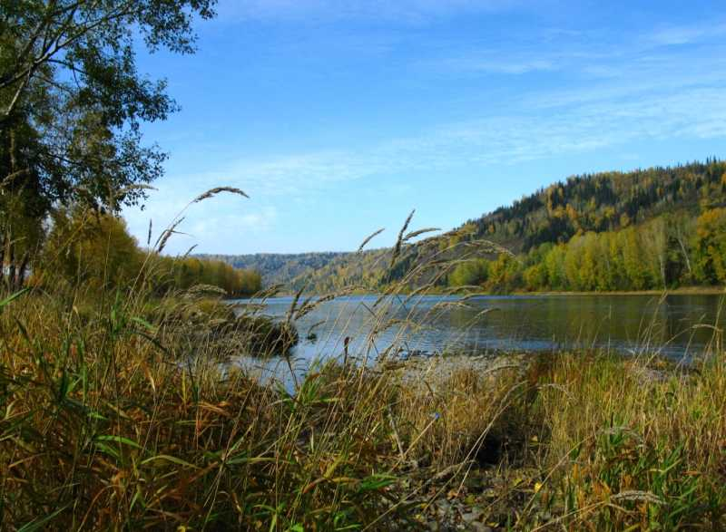
The river Tom
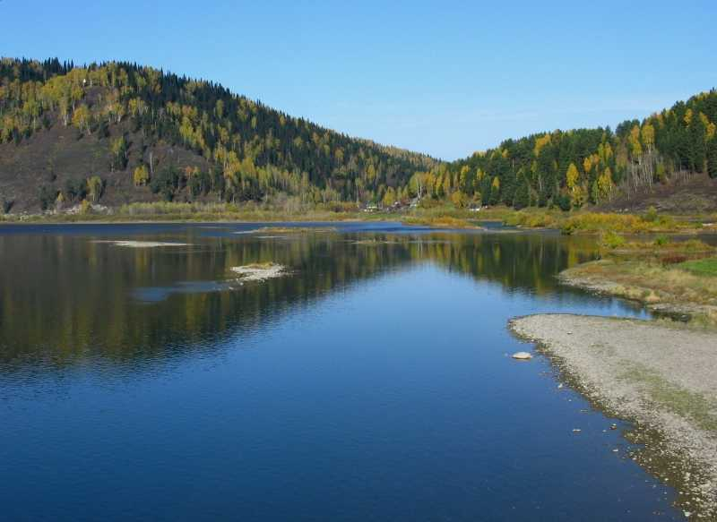
The river Mrassu

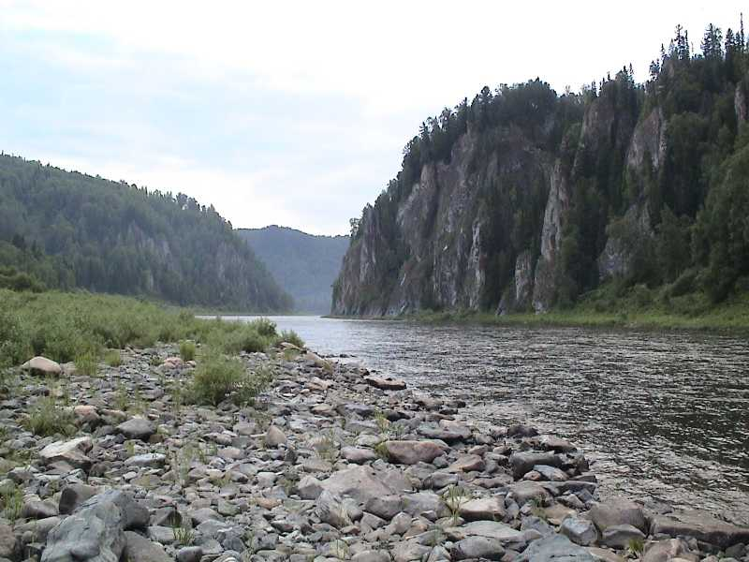
The Kija

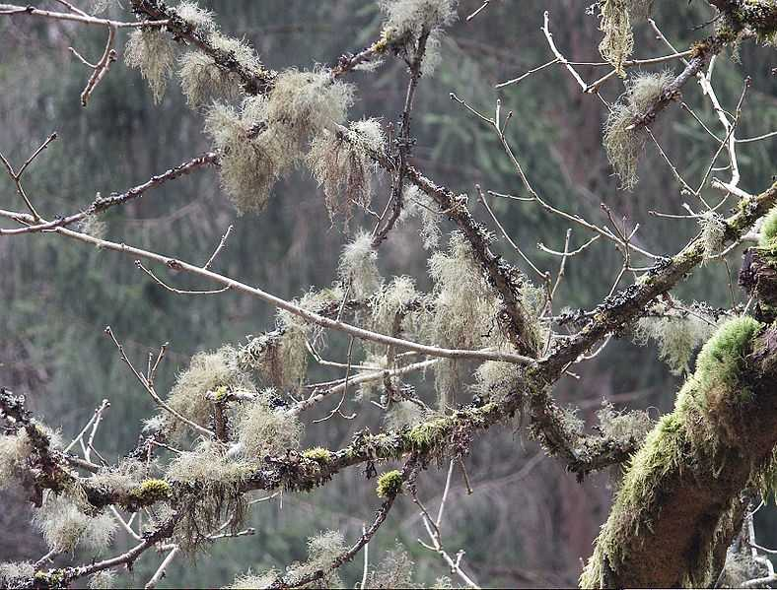
Lichen

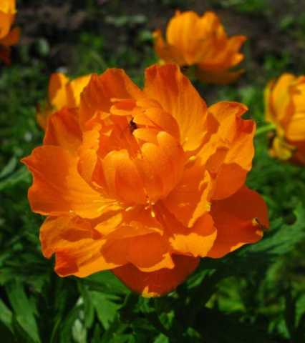
Glove - flower

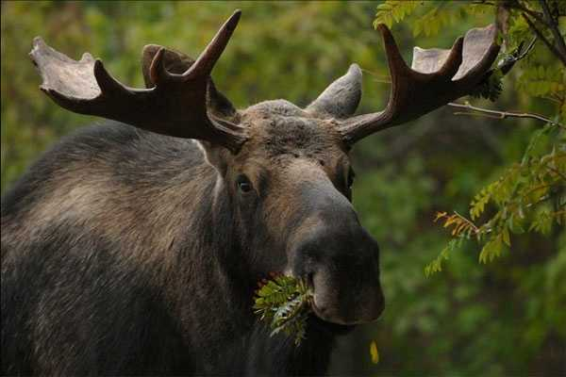
Elk

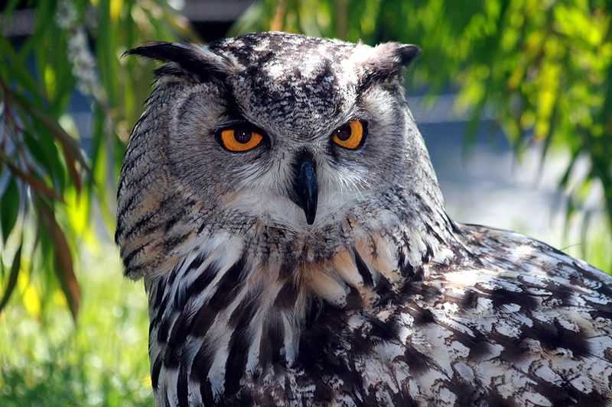
Owl

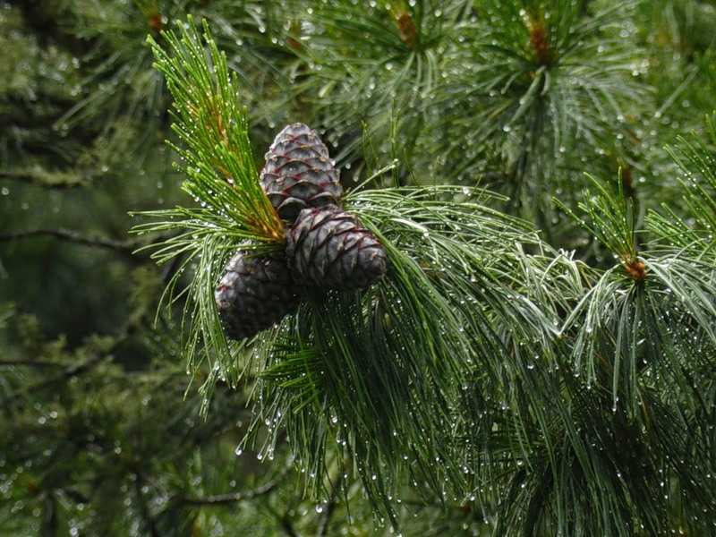
Cedar (Siberian pine)

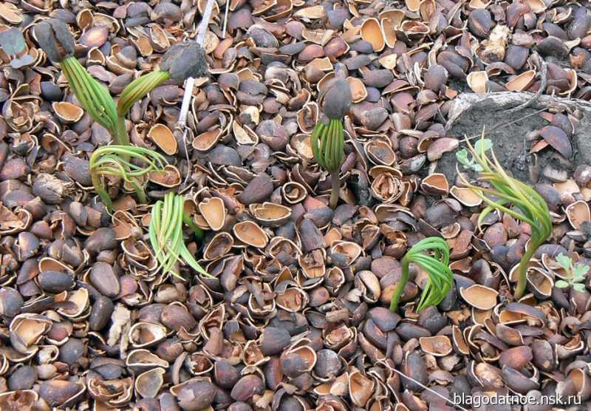
Cedars germinate

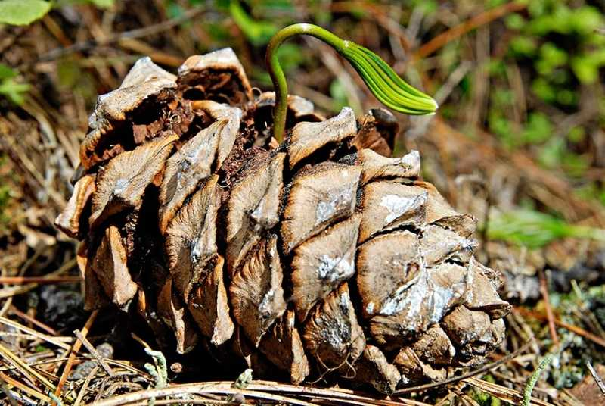
Cedar’s sprout

